R3
Earth Day Weekend Celebration 2012
“Green, isn’t about the green stuff”

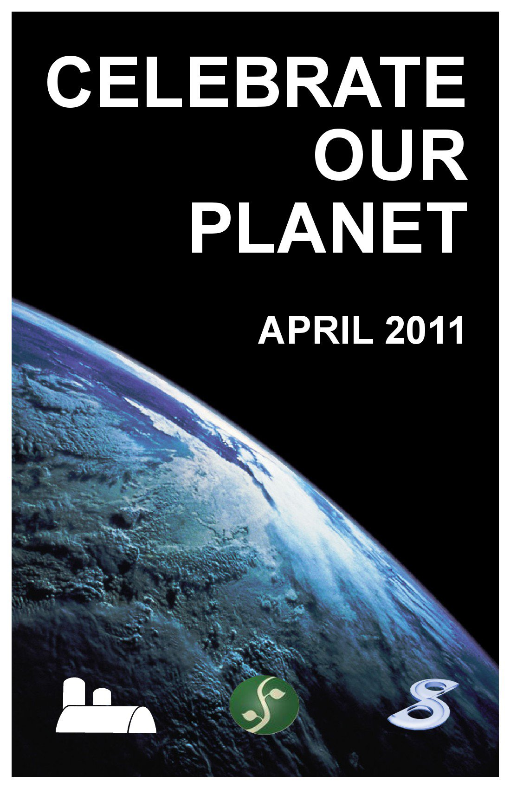
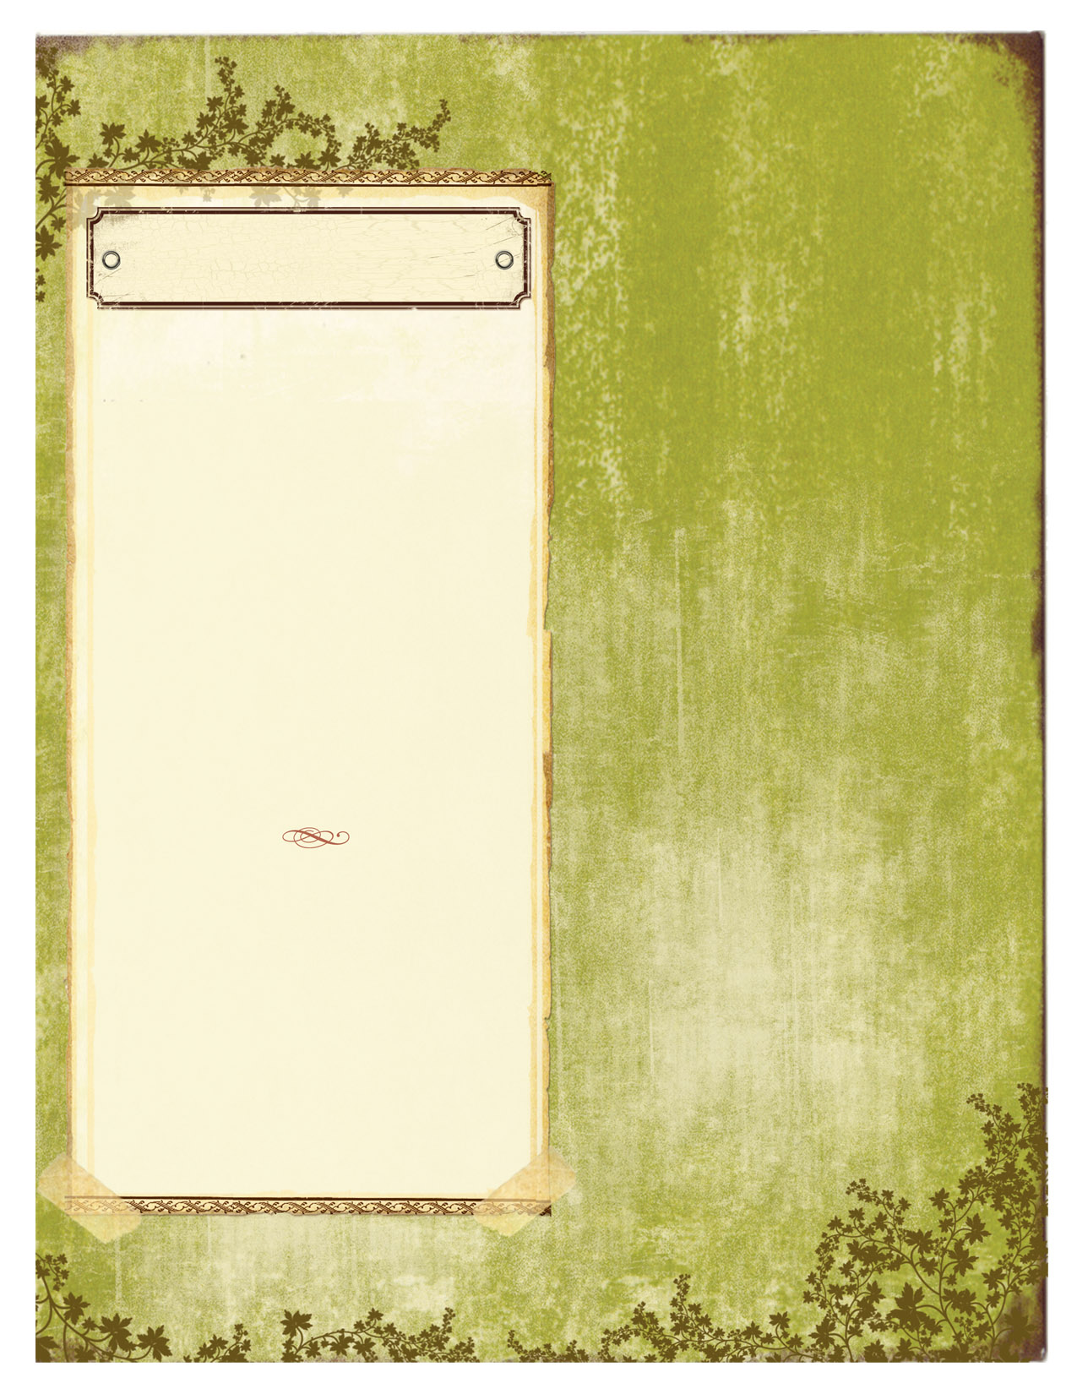
The R3 History & Cause

The R3 Earth Day is yearly information, and educational, organization created in 2011 by 3 environmentally friendly groups from the Hawkesbury, and Vankleek Hill area. This is one of the ways The R3 got its name. It also pays homage to the G3 music series created by Joe Satriani. As well as the ever famous 3R’s mantra: reduce, reuse, and recycle. We should employ this mantra as often as possible in our lives!!

Thaila Riden – Co-Founder
Thaila was a very active participant in creating this new grassroots community movement, we call The R3. Within a month he had donated his loft as the venue, pulled together artists, artisans, as well as environmental speakers. Having them all tell their stories to the community in a vast array of media formats.
These principals are integral to Thaila’s upbringing. His parents taught him he had to be responsible for his own actions, as well as appreciate the arts. Thaila has been actively aware of his footprint on our earth, and employs all that he can to reduce that print. He felt it most fitting to join these two areas of his life together to raise awareness. A self taught drummer and guitarist, Thaila uses the arts to speak of the pains of this earth through song. By being aware of his own footprint Thaila leads by example. Thus joining two important aspects of his life to show how we can be responsible global citizens, and connect with those that feel the same way.

At the tender age of 7 Thaila had already followed in his father’s footsteps with the arts, and became the youngest DJ.

“Green isn’t about the green stuff.” “Green isn’t about the green stuff.”
“Green isn’t about the green stuff.” “Green isn’t about the green stuff.”

April 2012

VOL. 1 ISSUE 1
The R3 Mission

Our mission is to raise awareness of, and the funding for teaching, those who want to learn how to sustain our earth using a greener approach. We chose to have it coincide with Earth Day, so that we may lend our voices to resonate on a global scale. The R3 accomplishes this by hosting our Eco-Fest grassroots community movement, at our campground which has survived on these principal bases for over 20 years.

“Green isn’t about the green stuff.”
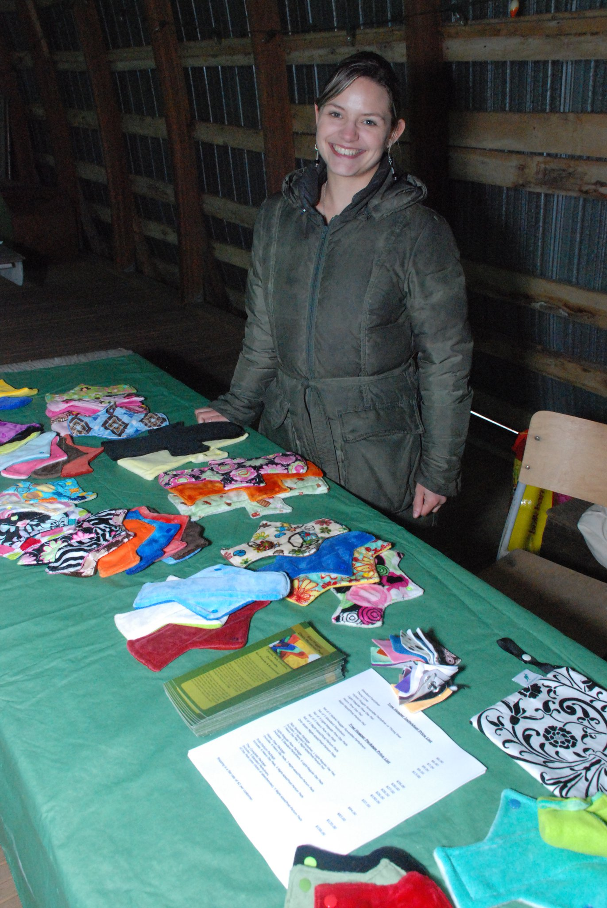
Delete box or place a caption here.
“Green isn’t about the green stuff.”
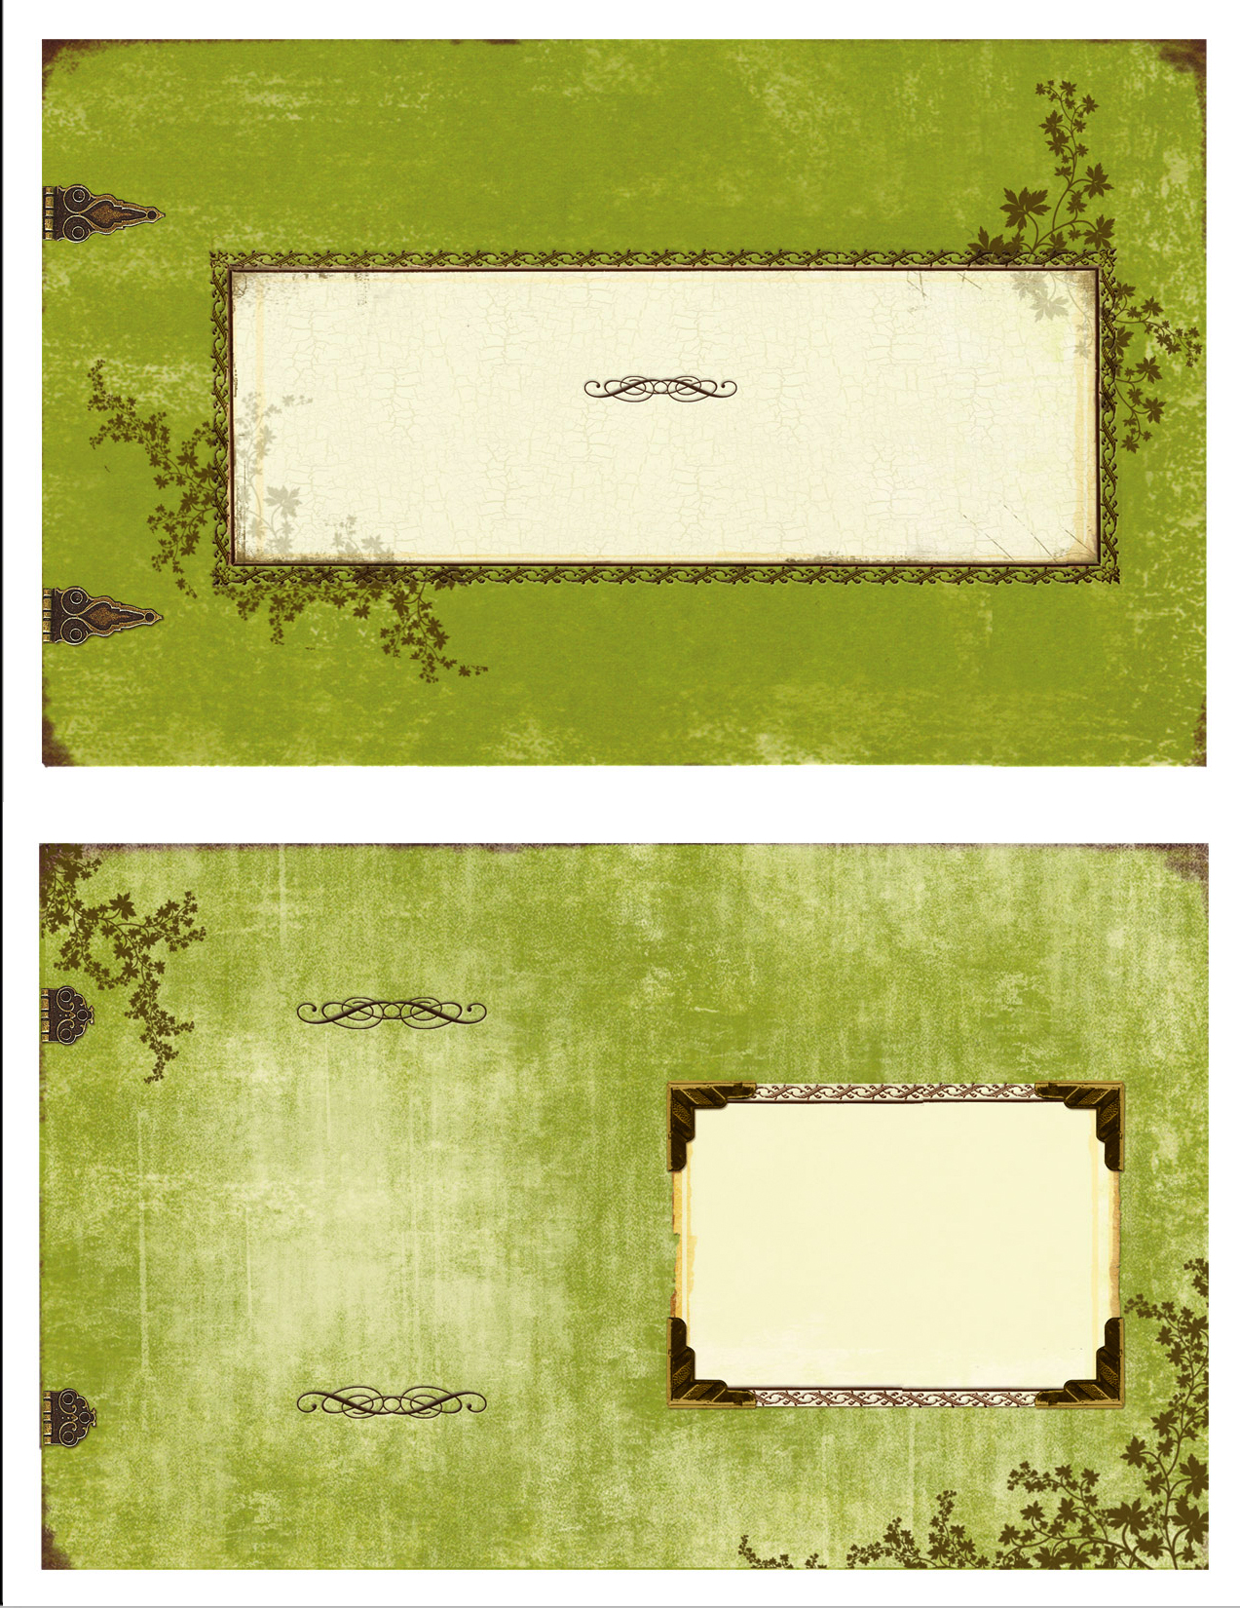
Saturday April 21, 2012

12-1pm
Lunch will be available (menu is coming)

1pm-2pm
R3 Opening Ceremony Jam (audience participation encouraged, so bring instruments!)
Thaila Riden & Concept

2pm – 6pm
Shawn Wylie – Information Session

Judd Muth
http://www.myspace.com/565205013

Daniel McKell
http://www.myspace.com/danielmckell/music

5pm - 8pm
BBQ (menu coming)

8pm- 11pm
Praise Junkies
http://www.myspace.com/thepraisejunkies

Madafakaz
http://www.myspace.com/madafakaz1

Concept
http://www.myspace.com/conceptpeterriden/music

Closing Jam (it goes as long as it has to)

Sunday April 22, 2012

12-1pm
Lunch will be available (menu is coming)

1pm-2pm
R3 Opening Ceremony Jam
Thaila Riden & Concept

2pm – 6pm

6pm

Closing Ceremony Jam
Cutting of Earth Day Cake

Festival Schedule:

“Green isn’t about the green stuff.” “Green isn’t about the green stuff.”
“Green isn’t about the green stuff.” “Green isn’t about the green stuff.”

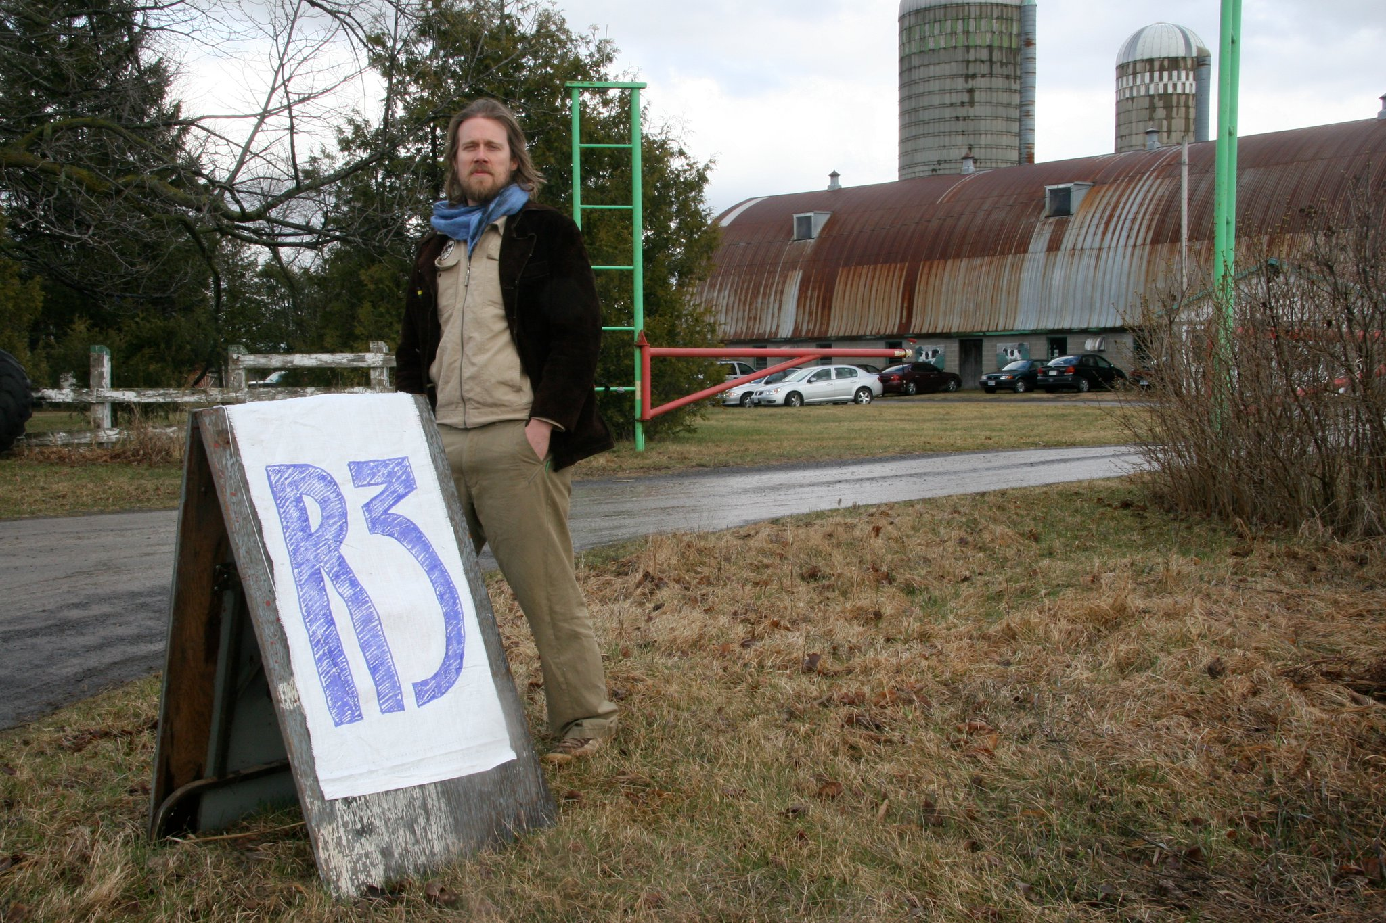
Continue newsletter text here. Continue newsletter text here. Continue newsletter text here. Continue newsletter text here. Continue newsletter text here. Continue newsletter text here. Continue newsletter text here. Continue newsletter text here. Continue newsletter text here. Continue newsletter text here. Continue newsletter text here. Continue newsletter text here. Continue newsletter text here. Continue newsletter text here. Continue newsletter text here. Continue newsletter text here. Continue newsletter text here. Continue newsletter text here Continue newsletter text here

Continue newsletter text here. Continue newsletter text here. Continue newsletter text here. Continue newsletter text here. Continue newsletter text here. Continue newsletter text here. Continue newsletter text here. Continue newsletter text here. Continue newsletter text here.

Continue newsletter text here. Continue newsletter text here. Continue newsletter text here. Continue newsletter text here. Continue newsletter text here. Continue newsletter text here. Continue newsletter text here. Continue newsletter text here. Continue newsletter text here. Continue newsletter text here. Continue newsletter text here. Continue newsletter text here.

Continue newsletter text here. Continue newsletter text here. Continue newsletter text here. Continue newsletter text here. Continue newsletter text here. Continue newsletter text here.

Continue newsletter text here. Continue newsletter text here. Continue newsletter text here. Continue newsletter text here. Continue newsletter text here. Continue newsletter text here. Continue newsletter text here. Continue newsletter text here.

Continue newsletter text here. Continue newsletter text here. Continue newsletter text here. Continue newsletter text here. Continue newsletter text here. Continue newsletter text here. Continue newsletter text here. Continue newsletter text here. Continue newsletter text here.

R3
Earth Day Weekend Celebration 2012
“Green, isn’t about the green stuff”

VOL. # 1 ISSUE #1

R3 Earth Day Celebration 2012
Green isn’t about the green stuff
3440 County Road 10
Vankleek Hill, ON K0B 1R0
Ph 613-678-3453

The R3
Earth Day Celebrations

April 2012

