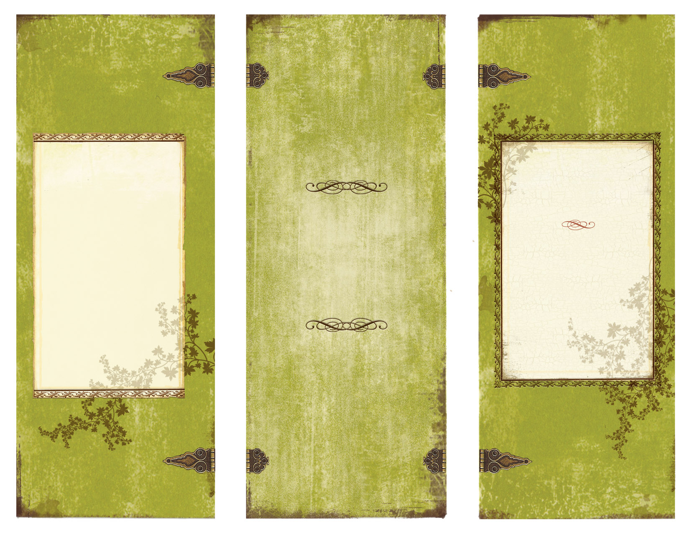
www.thegrandbarn.com


Our mission is to raise awareness of, and the funding for teaching, those who want to learn how to sustain our earth using a greener approach. We chose to have it coincide with Earth Day, so that we may lend our voices to resonate on a global scale. The R3 accomplishes this by hosting our Eco-Fest grassroots community movement, at our campground which has survived on these principal bases for over 20 years.
“Green isn’t about making the green stuff”

The R3 Earth Day Celebrations
2012

The R3 Earth Day Celebrations

Ph 613-678-3453
Vankleek Hill, ON
K0B 1R0
“Green isn’t about making the green stuff”

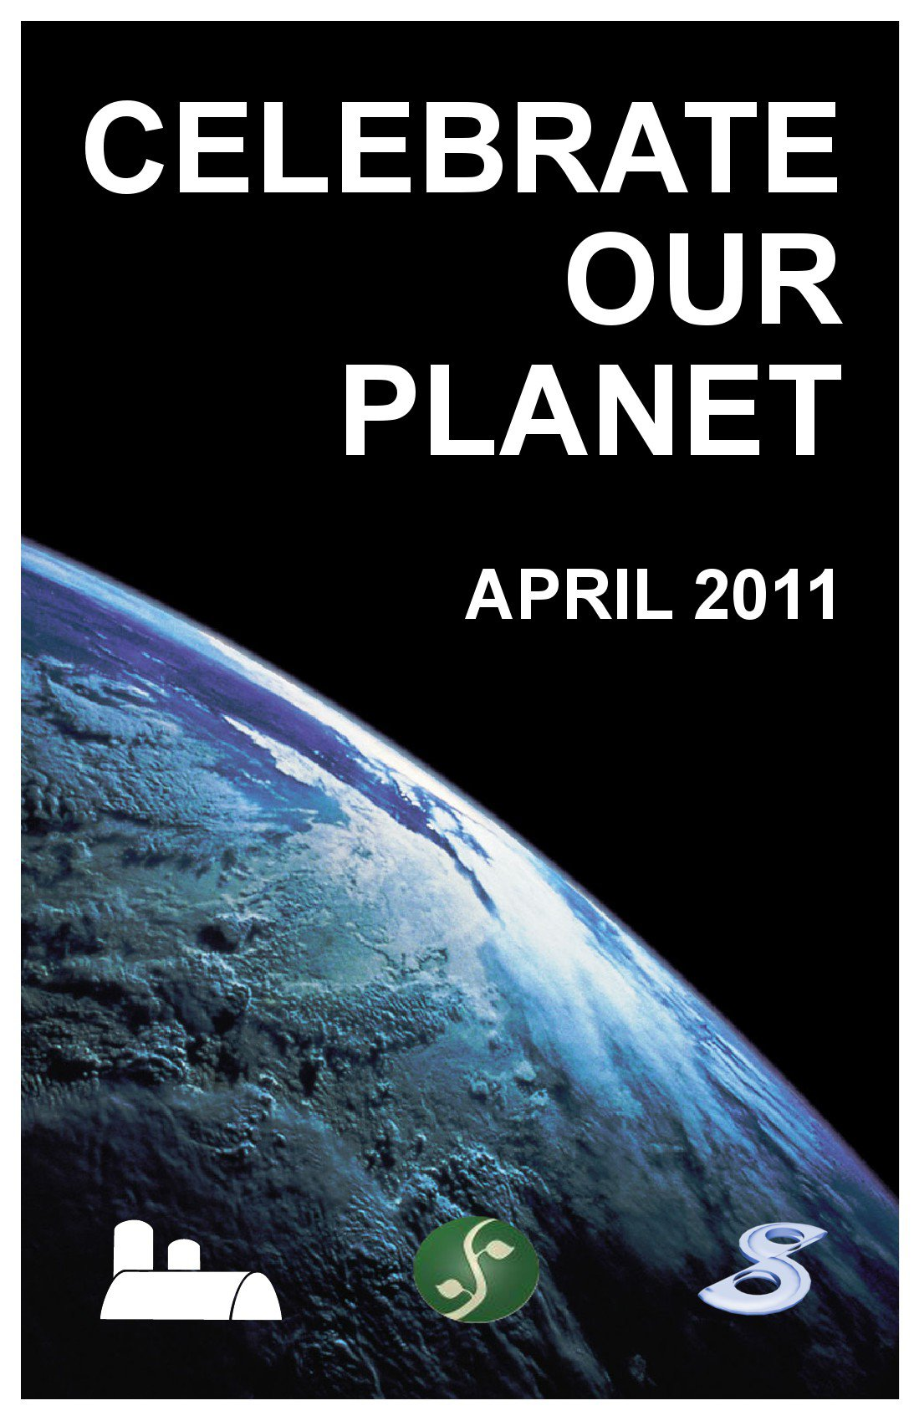
The R3 Earth Day Celebrations
The R3 Earth Day is yearly information, and educational, organization created in 2011 by 3 environmentally friendly groups from the Hawkesbury, and Vankleek Hill area. This is one of the ways The R3 got its name. It also pays homage to the G3 music series created by Joe Satriani. As well as the ever famous 3R’s mantra: reduce, reuse, and recycle. We should employ this mantra as often as possible in our lives!!

These principals are integral to how Thaila’s upbringing. His parents taught him he had to be responsible for his own actions, as well as appreciate the arts. Thaila has been actively aware of his footprint on our earth, and employs all that he can to reduce that print. He felt it most fitting to join these two areas of his life together to raise awareness. A self taught drummer and guitarist, Thaila uses the arts to speak of the pains of this earth through song. By being aware of his own footprint Thaila leads by example. Thus joining two important aspects of his life to show how we can be responsible global citizens, and connect with those that feel the same way.

Thaila was a very active participant in creating this new grassroots community movement, we call The R3. Within a month he had donated his loft as the venue, pulled together artists, artisans, as well as environmental speakers. Having them all tell their stories to the community in a vast array of media formats. At the tender age of 7 Thaila had already followed in his father’s footsteps with the arts, and became the youngest DJ.

“Green isn’t about making the green stuff”

