T1: Unknown make/model, $500
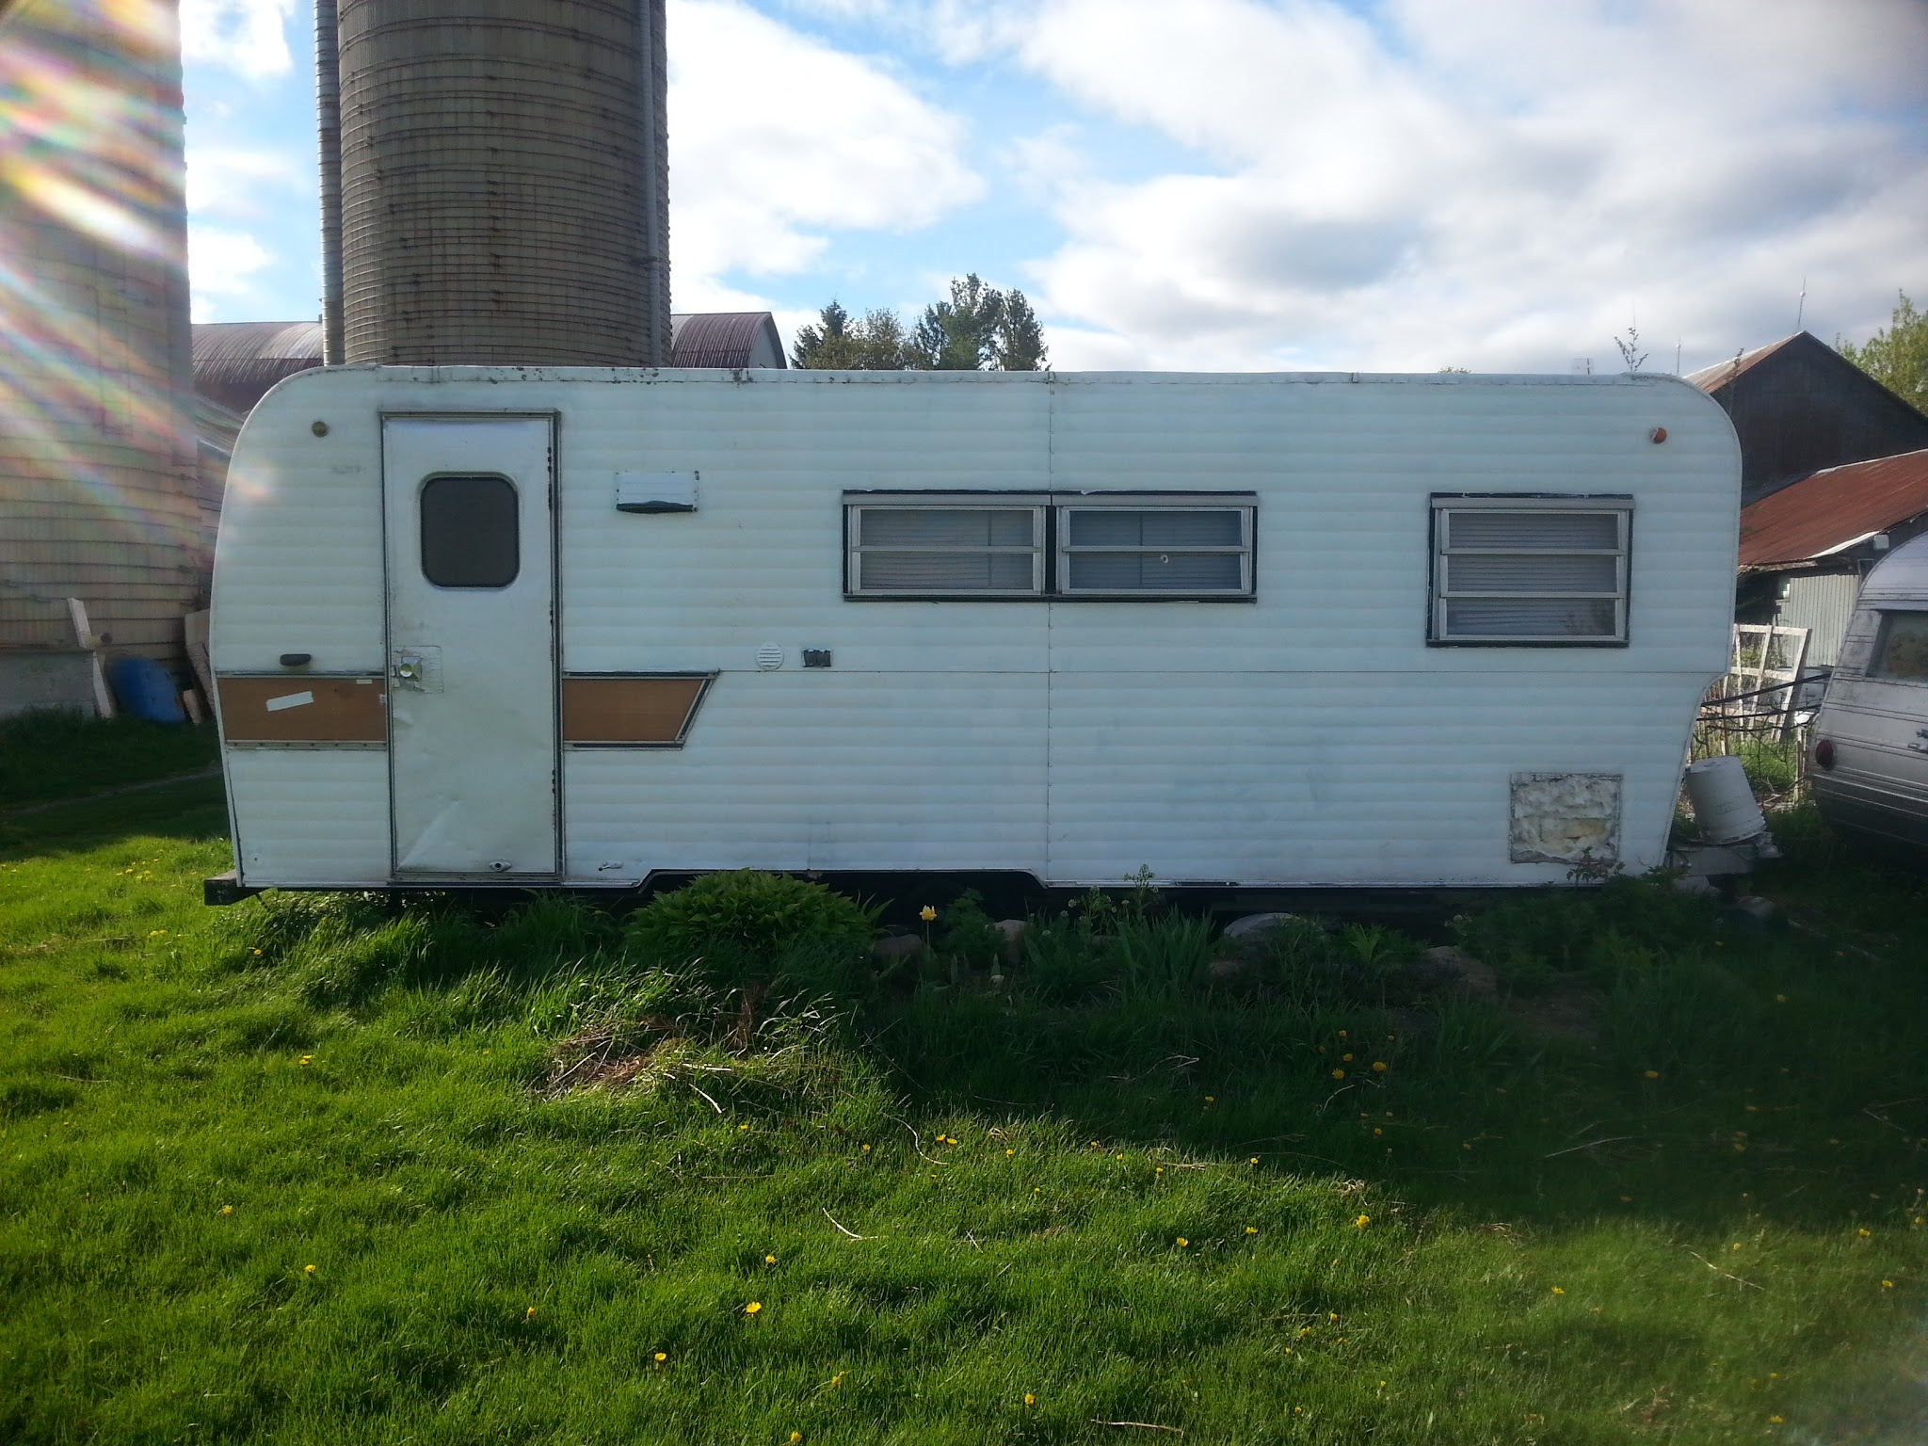
T2: Unknown make/model, $500
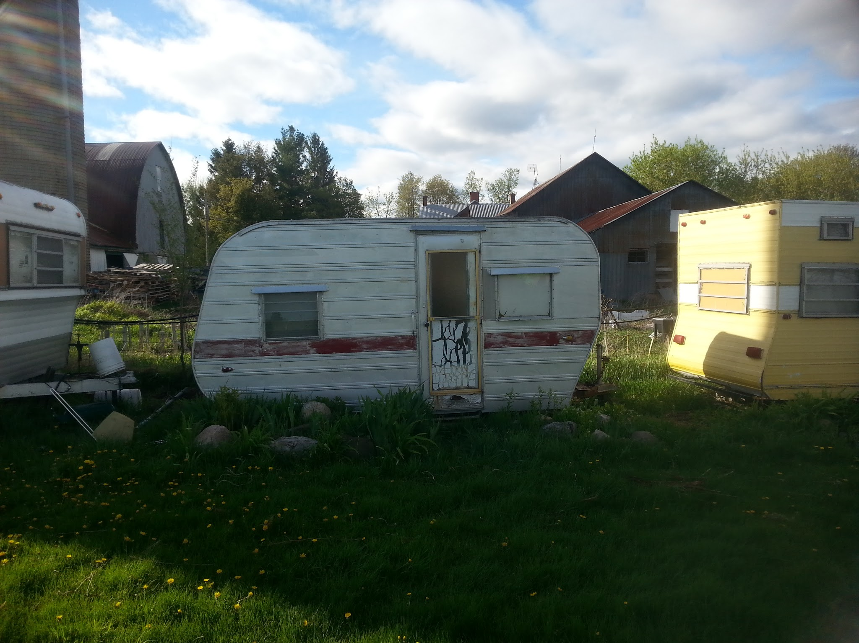

T3: Unknown make/model, $500
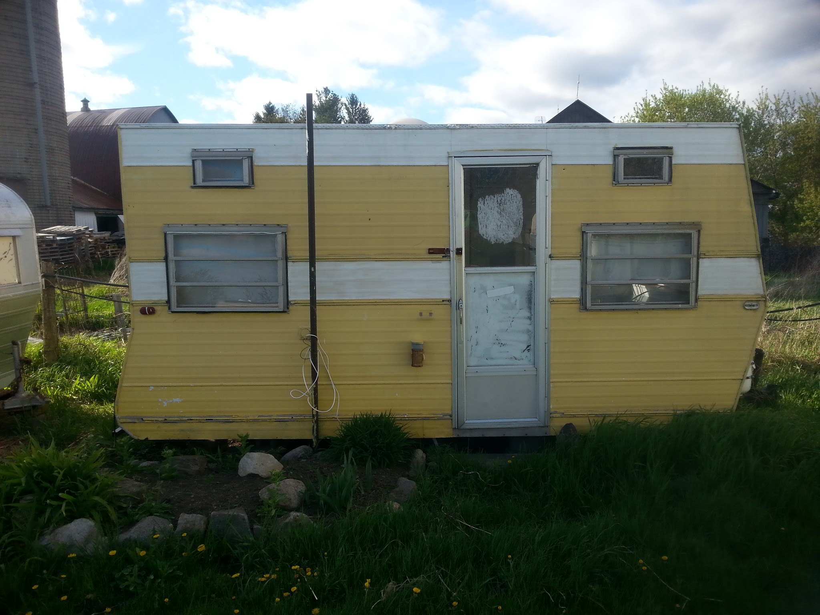
M5: Winnebago D24c, $1,000 NOTE: Model was recalled. Not sure if sellable
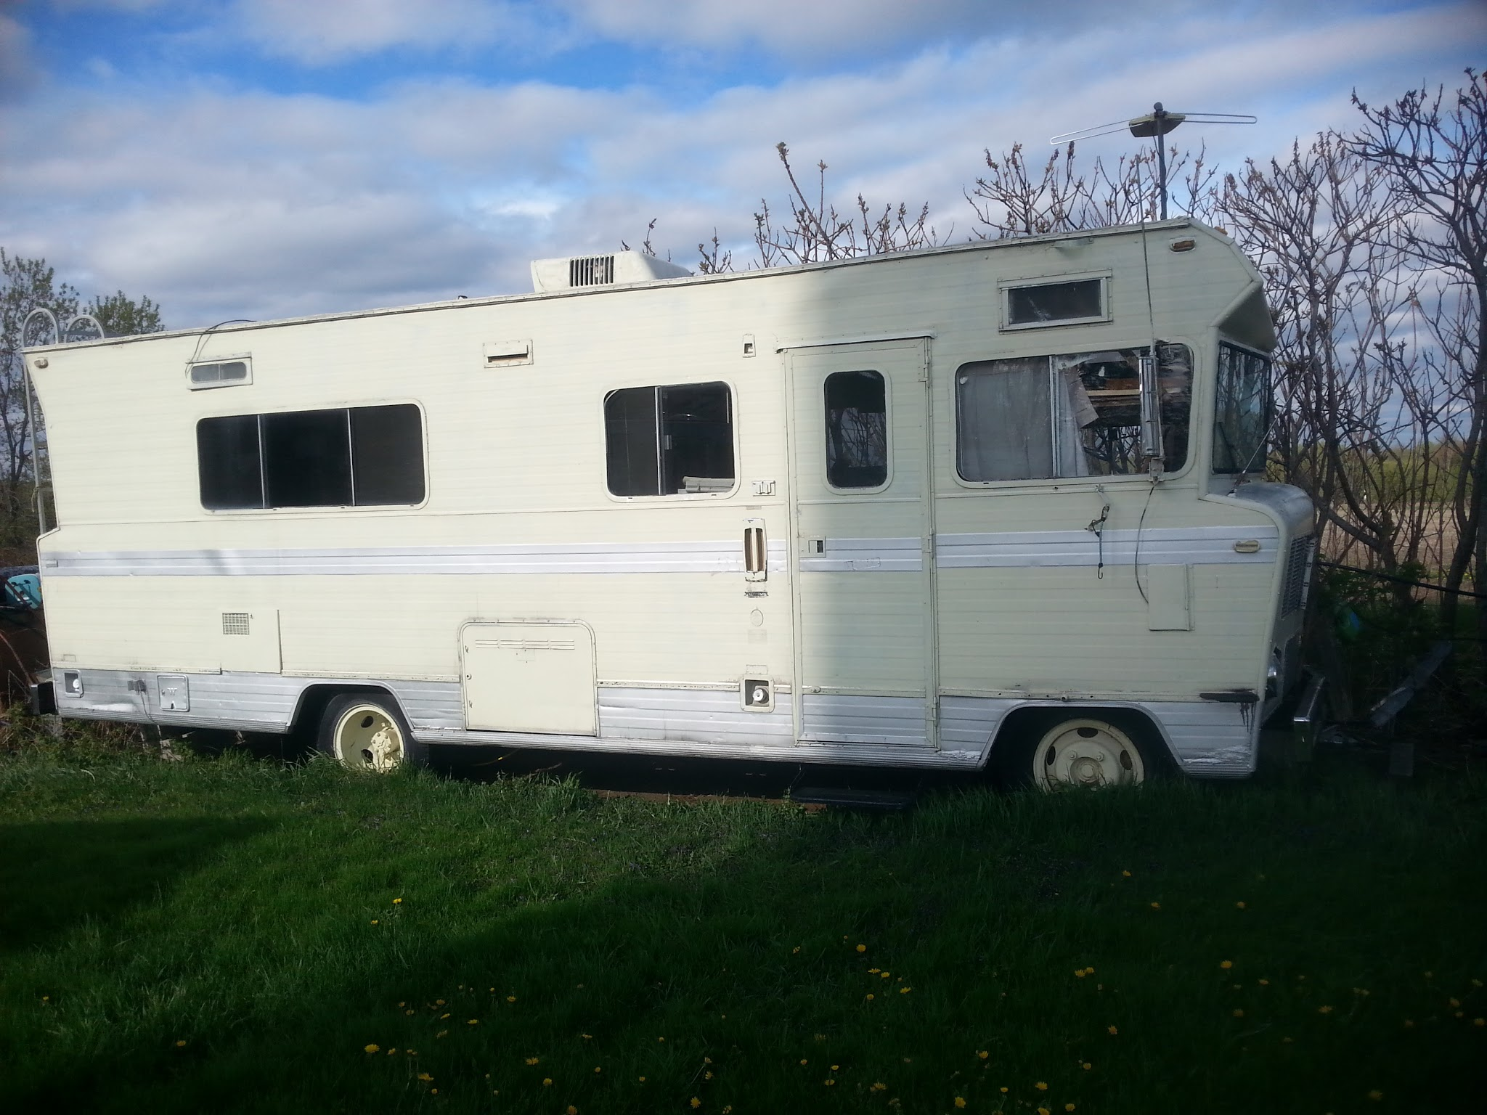

T6: Beachcomber, $3,000
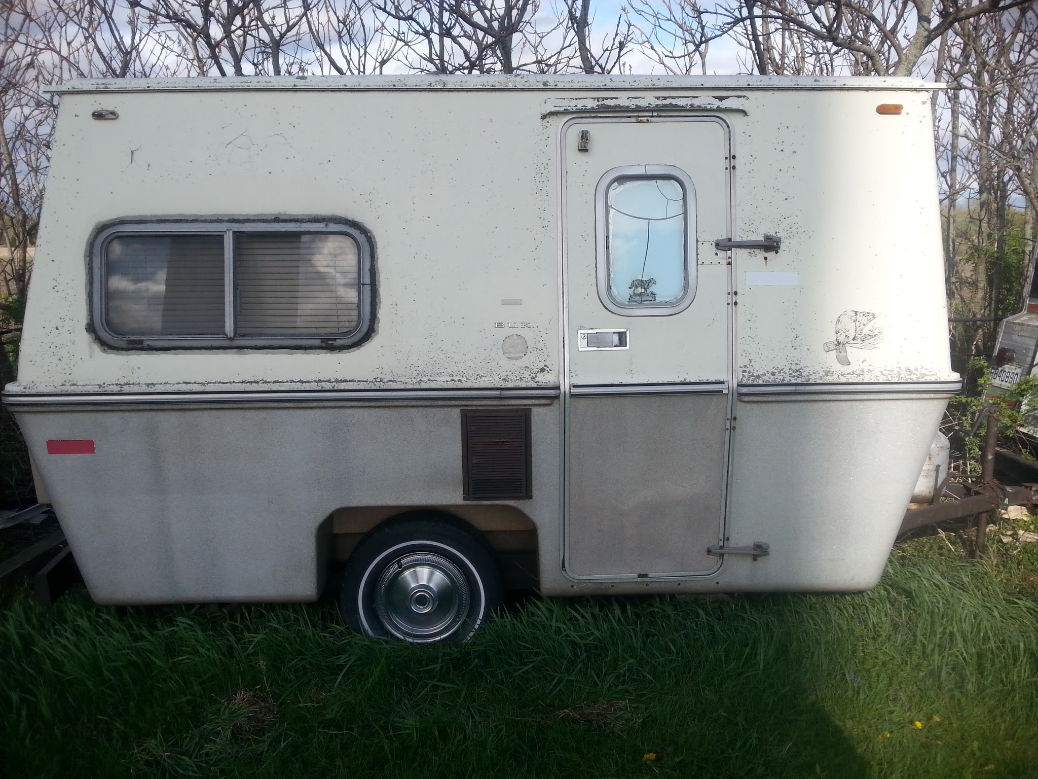
T7: Unknown make/model, $500
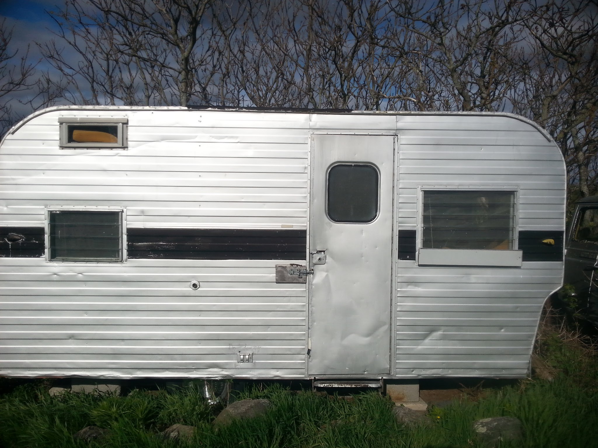

T10: Weekender 27, $10,000
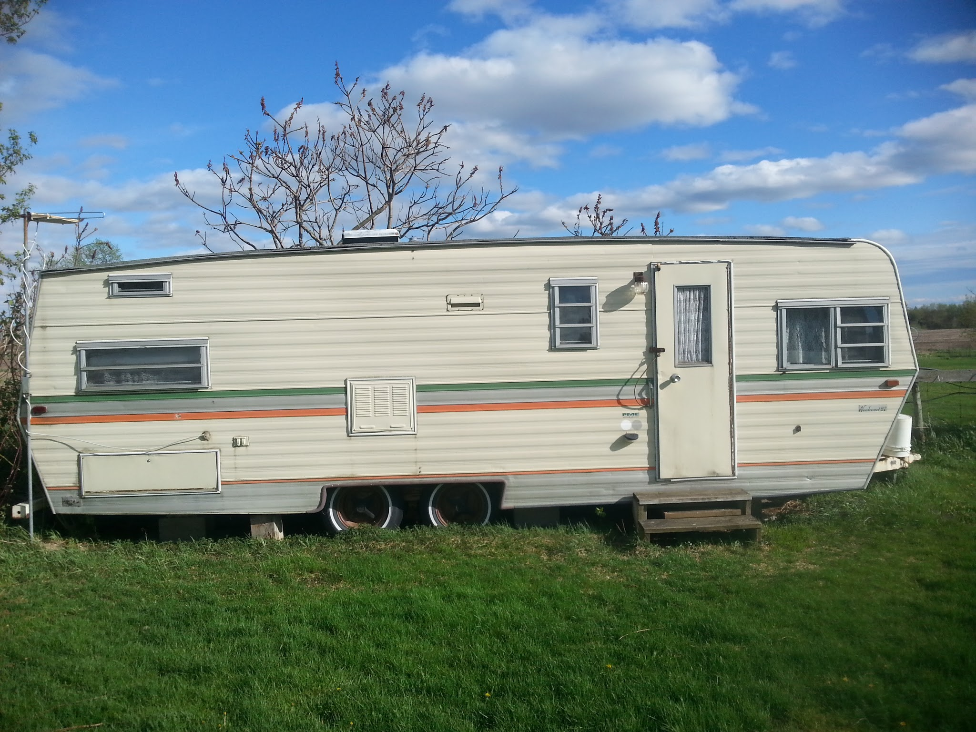
T17: Glendale Glendette, $4,000
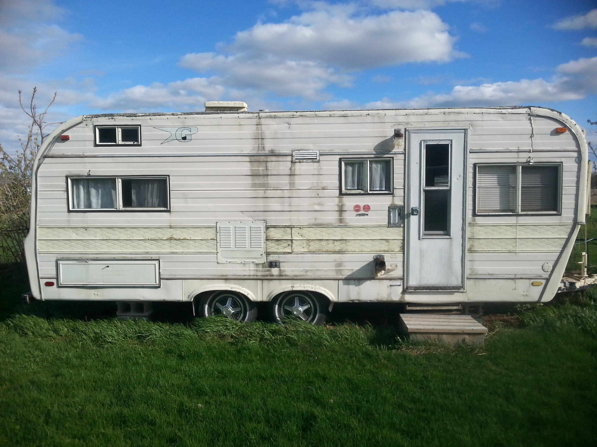

T37: Airstream Sovereign, $10,000
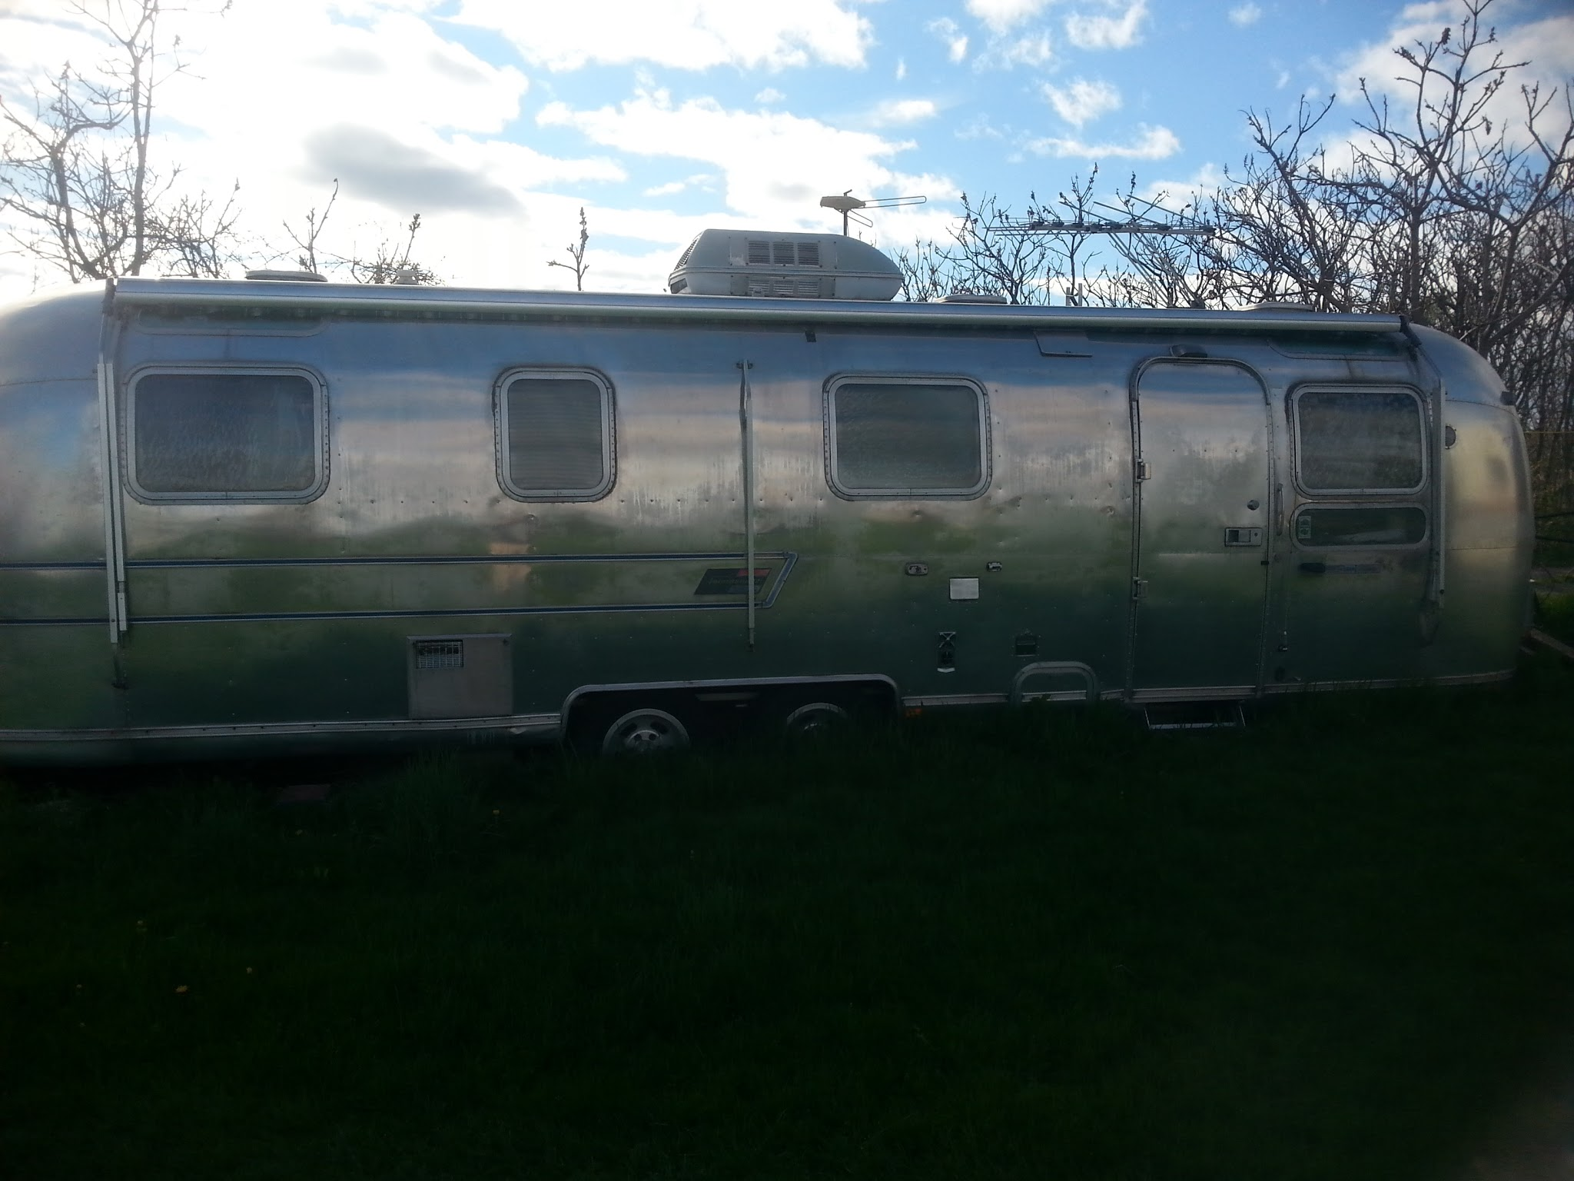
T43: Fleetwood Prowler, $500
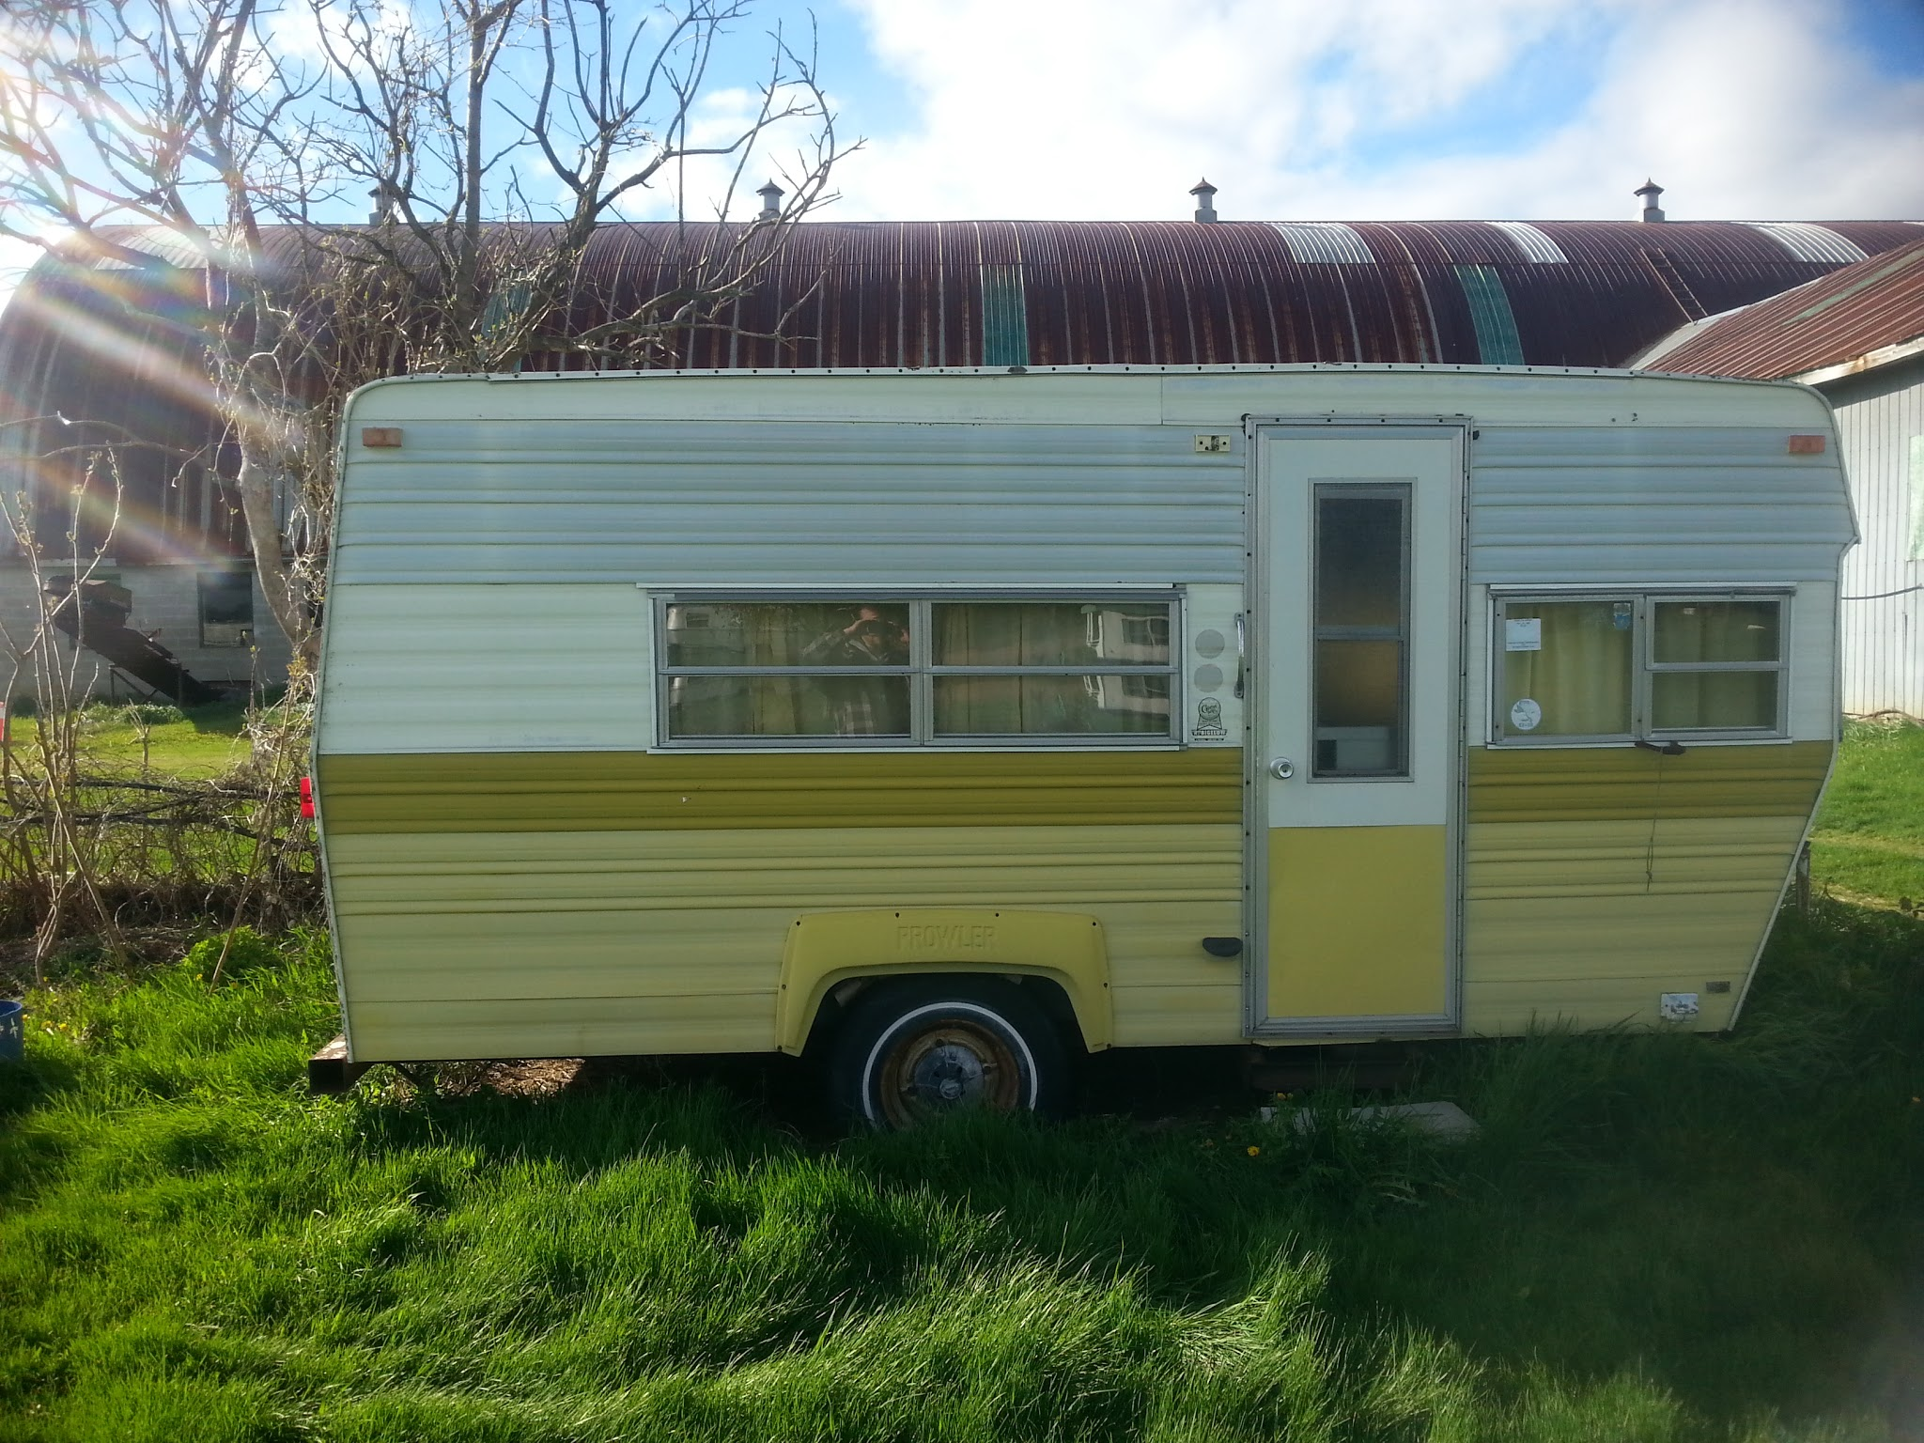

Avion LaGrande, $7,000
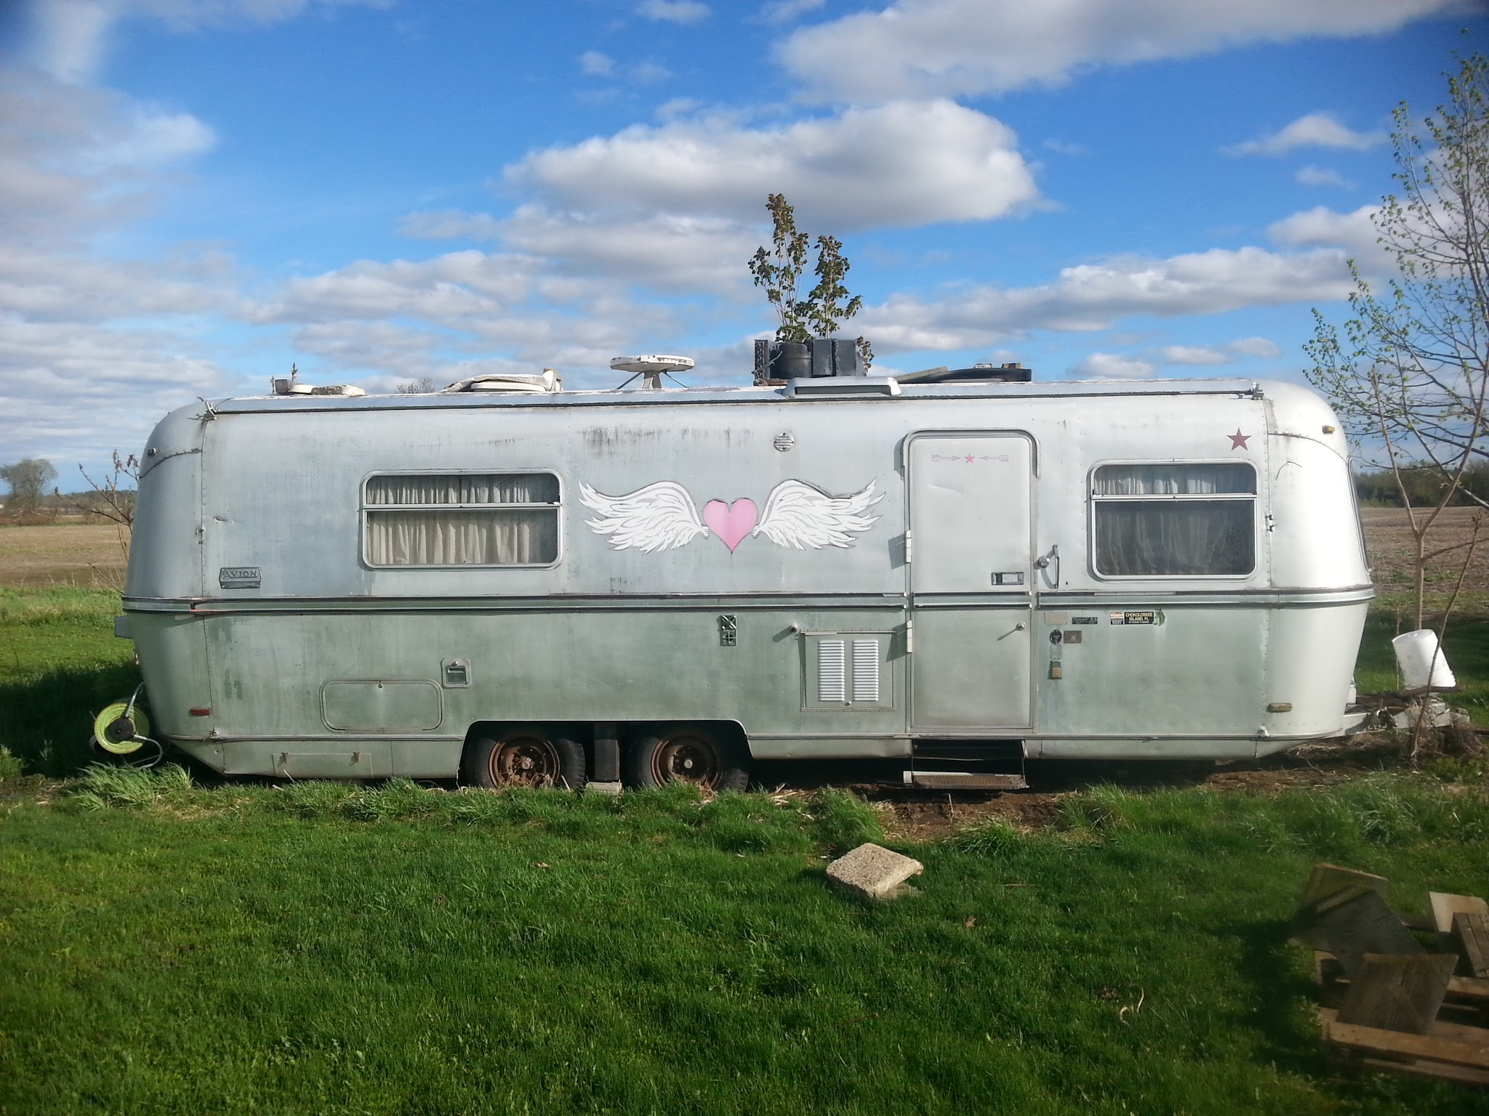

Ken's Trailer: Unknown make/model. $500
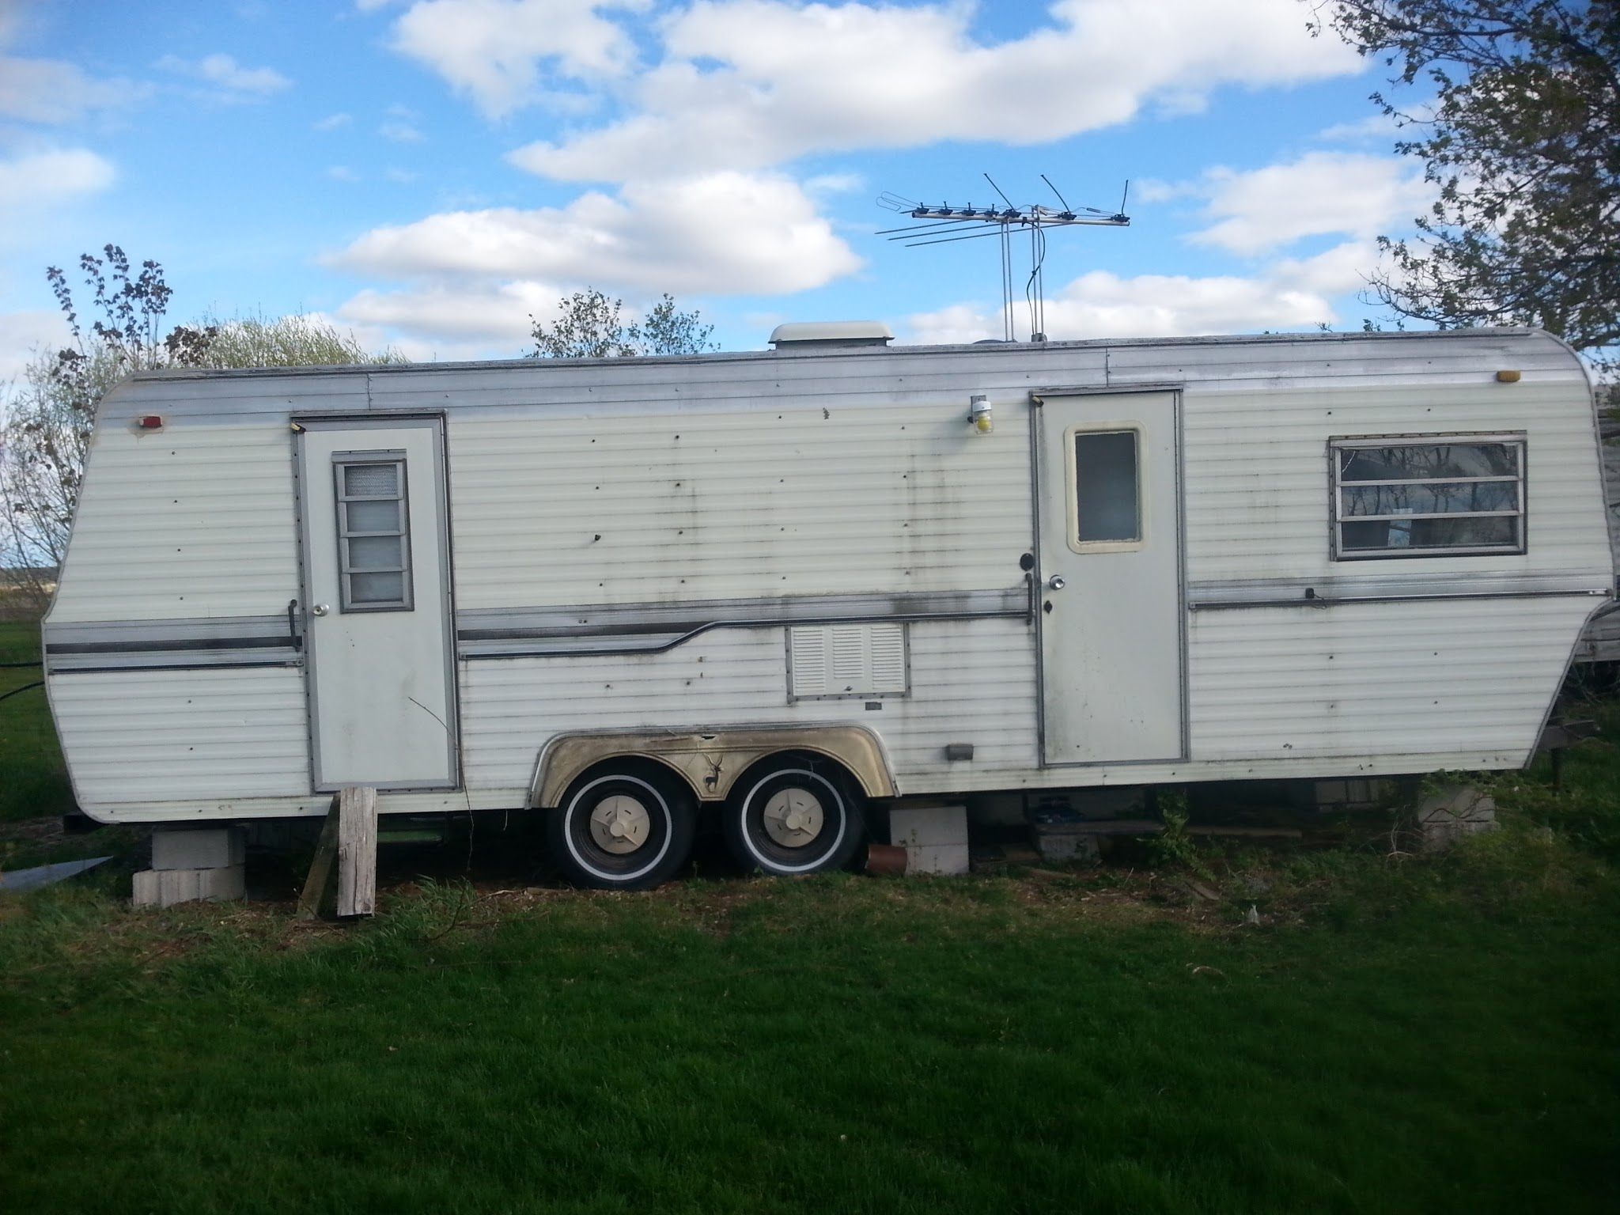
Brian and Susan's Motorhome: GMC Van Dura, $3,000
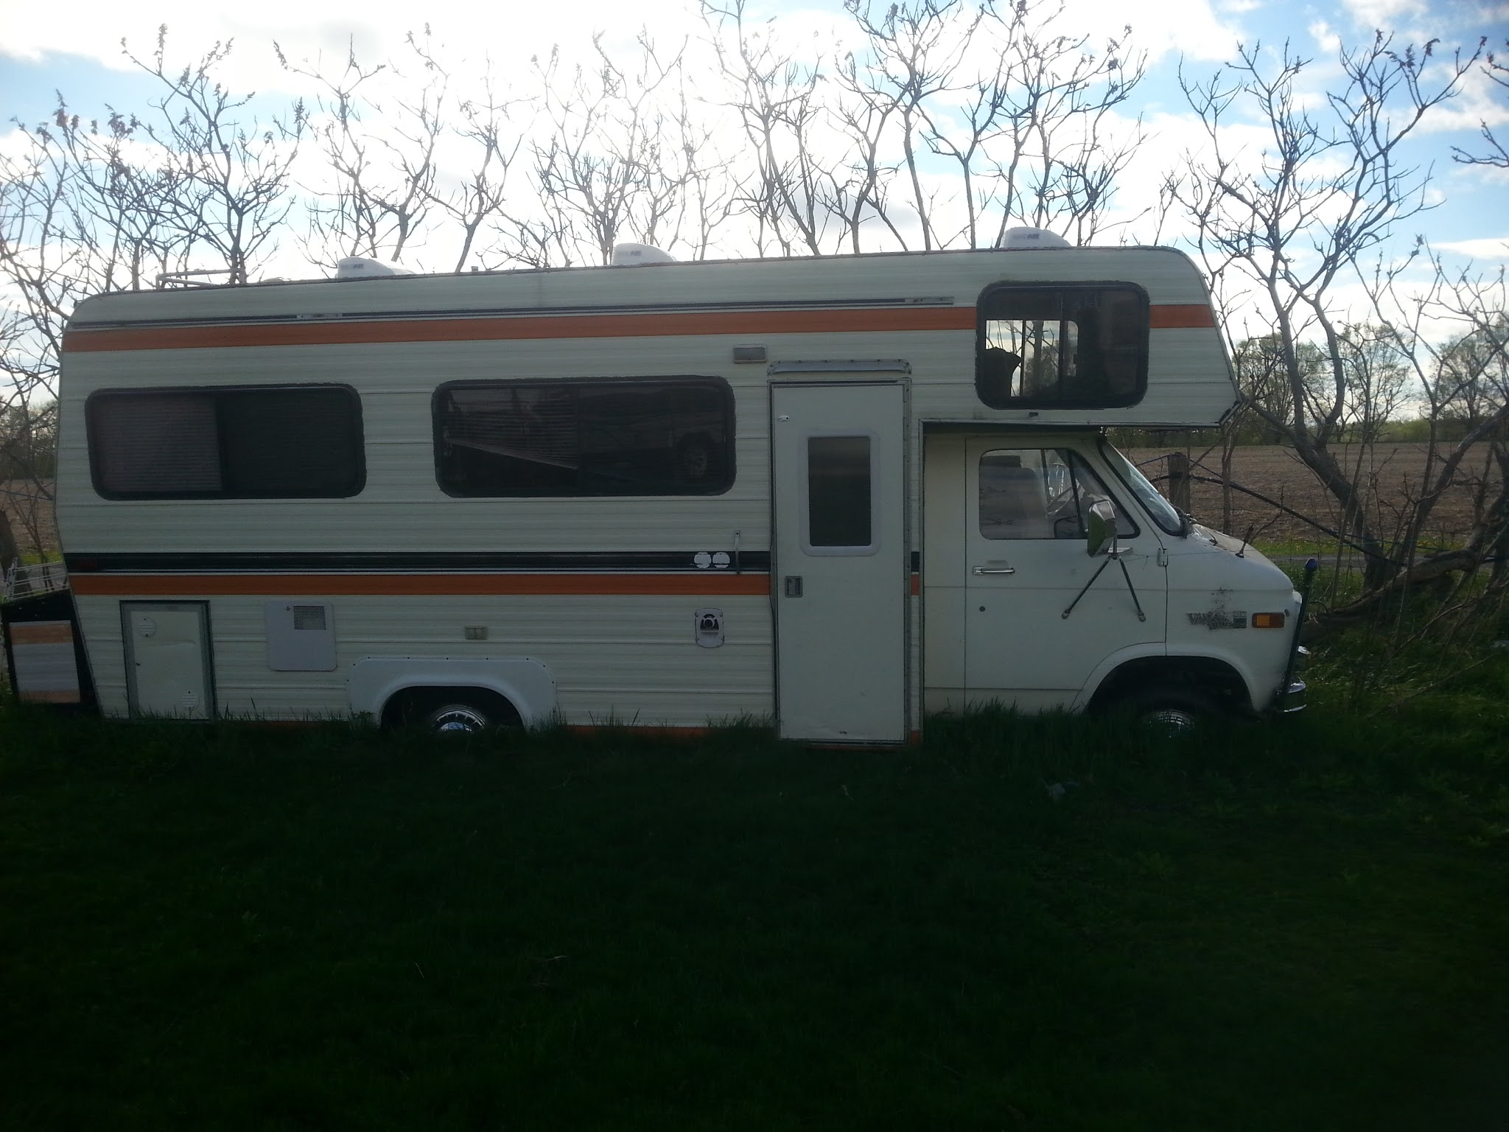
John R's Trailer: Fleetwood Terry Taurus, $2,000
(no photo)

