Benefits of a Comprehensive Ontario K-12 Curriculum Using an Online Learning Management System

Submitted By: Caitlin Ross

Submitted To: Rinni Reubens-Alege
in partial fulfillment of the requirements for ENL2019T

Computer Programmer
Algonquin College

March 14, 2021
Declaration of Sole Authorship

I, Caitlin Ross, confirm that this work submitted for assessment is my own and is expressed in my own words. Any uses made within it of the works of any other author, in any form (ideas, equations, figures, texts, tables, programs), are properly acknowledged at the point of use. A list of the references is included.

Digital Signature:

Date: March 14, 2021

Abstract
The arrival of a global pandemic exposed how reliant the Ontario education system is on being physically present. Many events can prevent students from attending classes in-person, which is why the Province of Ontario needs to update their education model to include virtual and distance classes. This report examines reasons why online learning using a Learning Management System (LMS) is a desirable addition to the current classroom environment and enumerates various challenges around implementing a virtual classroom. Furthermore, it compares several options currently available on the market and recommends <insert recommendation here> for the province to adopt.

Table of Contents
List of Figures and Tables v
Figure v
Table v
Glossary vi
Introduction 7
The LMS Solution 8
Background 8
Benefits 10
Challenges 11
LMS 1: D2L Brightspace 12
LMS 2: Blackboard 13
LMS 3: Canvas 14
Open Source Option: Moodle 15
Alternatives to LMS 16
Schedule 17
Costs 18
Qualifications and References 19
Next Steps 20
Conclusions 21
Recommendations 22
References 23

List of Figures and Tables

Figure
1. LMS Market Share in Canada 8

Table
1: Comparison of 4 LMS 18

Glossary
Curriculum: in this context, I am referring to a complete set of courses that have all the relevant content and structure included
Learning Management System: software used to create an online learning environment that students can access at home

Introduction
This report proposes a solution for the Province of Ontario to implement that would improve distance and virtual learning for public school students. Currently, distance learning is implemented haphazardly on a school to school basis, with varying degrees of support and success<turns out this is false, Ontario uses Brightspace as its virtual learning environment>. The arrival of the Covid-19 pandemic revealed how much the conventional education model relies on students being physically present in the classroom. Unfortunately, this isn’t always possible for all children.
The report will focus on the pros and cons of 3 commercial LMS options currently on the market and one open-source option, after explaining why using an LMS would be advantageous for Ontario education. The report will also outline situations where this model would not be ideal and list challenges of integrating virtual learning into the curriculum.

The LMS Solution

Background
Learning Management Systems (LMS) are becoming more and more prevalent as working from home and virtual education become a priority. As seen in Figure 1 [1], the four most popular LMS options for post-secondary education in Canada are Moodle, Brightspace, Blackboard Learn, and Canvas.
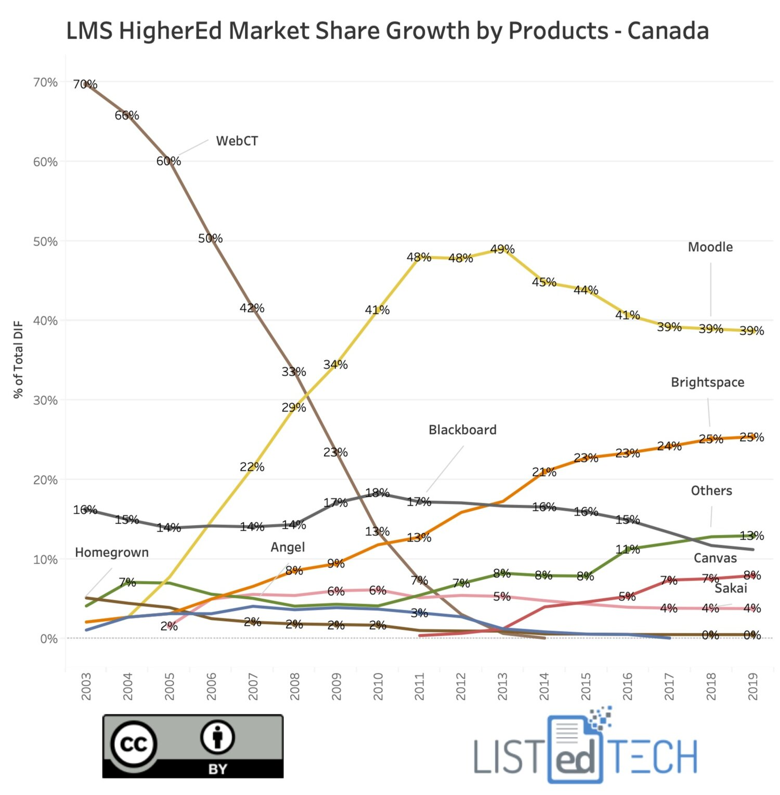

Figure 1. LMS Market Share in Canada. A graph showing the relative market share of various Learning Management Systems by year in Canada [1].
Due to their popularity, this report will focus on those 4 options (Brightspace, Blackboard Learn, Canvas, and Moodle) when discussing LMS for public school.
Typically, LMS software includes several components that integrate to create the e-learning environment. At it’s most basic, it provides the framework for course creation and allows the instructor to publish the course to students. In addition, the LMS normally allows the instructor to track enrollment and view student progress through quizzes and other assessments.

Benefits
-Broader access to education for children who are unwell, incarcerated, or remote
-Less disruption to education during pandemics or severe weather (snow days, etc.)
-Makes home schooling easier for parents, assuming relevant learning materials are provided along with access to the LMS
-The LMS could provide the province with detailed analytics on demographics, learning outcomes, and factors affecting success

Challenges
-Younger children may have a harder time with the user interface
-Kindergarten children can’t always read yet, so accessing the LMS would require a parent/guardian
-Certain courses require an in-class component (art, auto-shop, etc.)
-Access to reliable internet would need to be expanded throughout the province, particularly in remote and Northern communities
-Students with disabilities that make it difficult to focus on or use a computer may not be able to use this solution

LMS 1: D2L Brightspace

LMS 2: Blackboard

LMS 3: Canvas

Open Source Option: Moodle
Unlike the previous options, Moodle is open source and distributed under the GNU General Public License [2].

Alternatives to LMS
-Similar to the CUTV (Carleton University TV) model (does this even exist anymore?), have classes be broadcasted live (this has serious security concerns)
-Continue with the in-person-only model (dangerous in a pandemic, restricts access for certain groups)
-The province could create their own LMS from scratch (expensive, time-consuming)

Schedule

Comparison
Feature | Brightspace | Blackboard | Canvas | Moodle
Licensing Cost | By Quote | By Quote | By Quote | Free (self-hosted)/ By Quote (with Partner)
Location | Kitchener, Ontario, Canada | Washington, DC, USA | Salt Lake City, UT, USA | West Perth, WA, Australia
K-12 Solution | Yes | Yes | Yes | Yes
Cloud Option | Yes | No | No | Yes
Mobile App(s) | Yes | Yes | No | Yes
Table 1: Comparison of 4 LMS [3] [4] [5] [2]

Qualifications and References
-Dad is a project manager, has worked with the federal government (mostly Department of National Defense)
-I’ve used virtual learning through Algonquin
-My education was constantly disrupted by weather (ice storm, snow days), teacher strikes (same year as the ice storm) and illness (I had recurring tonsilitis as a child and would miss a week at a time several times a year)
-Seeing my 11-year-old nephew struggle sucks, MS Teams is not an intuitive solution for school

Next Steps

Conclusions

Recommendations

References

[1] | J. Menard, "Learning Management Systems in Canada," Listed Tech, 28 June 2020. [Online]. Available: https://www.listedtech.com/blog/learning-management-system-canada. [Accessed 13 March 2021].
[2] | Moodle, "Online Learning with the World's Most Popular LMS," Moodle, 2020. [Online]. Available: https://moodle.com. [Accessed 13 March 2021].
[3] | D2L, "D2L Creators of the Brightspace Learning Management System," D2L, 2021. [Online]. Available: https://www.d2l.com. [Accessed 14 March 2021].
[4] | Blackboard Inc, "North America Educational Technology Blackboard," Blackboard, 2021. [Online]. Available: https://www.blackboard.com. [Accessed 14 March 2021].
[5] | Instructure, "Instructure Educational Software Development," Instructure, 2021. [Online]. Available: https://www.instructure.com. [Accessed 14 March 2021].
[6] | Government of Ontario, "Ontario Schools, Kindergarten to Grade 12: Policy and Program," Queen's Printer for Ontario, Toronto, 2016.
[7] | B. Edmunds and M. Hartnett, "Using a learning management system to personalize learning for primary school students," Journal of Open, Flexible and Distance Learning, vol. 18, no. 1, pp. 11-29, 2014.
[8] | J. B. Kwon, K. Debruler and K. Kennedy, "A Snapshot of Successful K-12 Online Learning: Focused on the 2015-16 Academic Year in Michigan," Journal of Online Learning Research, vol. 5, no. 2, pp. 199-225, 2019.

