Brainstorming
Brainstorming refers to the process of generating as many ideas as you can (related to a topic) without censoring your thought process or stopping to organize your material. It is a free-flow of information. You can brainstorm on paper or on a computer, but make sure you’re recording your ideas. When you’ve finished brainstorming, look at what you’ve generated and search for ideas that connections and/or patterns relating to your main topic. Group similar ideas together and evaluate the usefulness of your information.

Mind Mapping
If you are a visual learner, you may find mind mapping a useful tool for generating ideas. When mind-mapping, record your main point or topic in the center of the page, and then work your way outward by plotting points that “branch” off from your main idea. You can use colours and images to define your ideas as well. This technique allows you to see, in a graphic representation, your thought process and differentiate main points from subordinate points. Consider the mind map below: 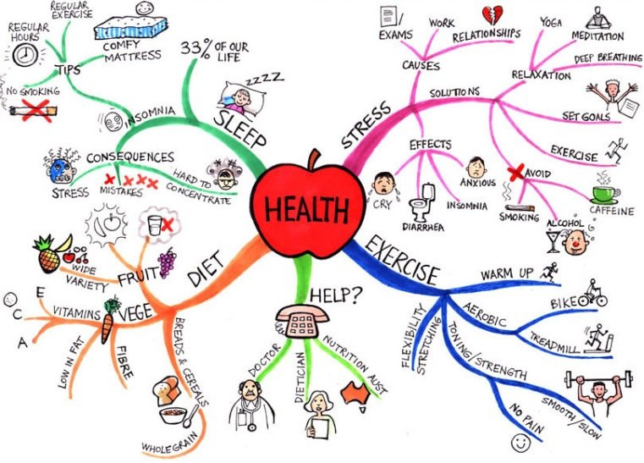
1 http://learningfundamentals.com.au/resources/
Watch the video below to see how mind-mapping works. While the video refers to a specific software program that enables mind maps, the concepts discussed are just as valid if you are hand-writing your mind map.
VIDEO http://www.youtube.com/watch?v=4wZ5wV5dPZc
There are various mind map software tools that you can use on your computer to assist in the creation of your mind map. Try a Google search to see what you can find.

Outlining
Using a template to generate your ideas can often be a useful tool for getting your writing started. Standard essay outlines ask you to identify and differentiate topic sentences from supporting sentences. View the outline titled “Essay Outline” for an example. Alphanumeric outlines and decimal outlines are familiar templates, as they use numbers or letters to identify each point and points of equal status as well as points of lesser significance.
View sample essay outline: https://owl.english.purdue.edu/media/pdf/20081113013048_544.pdf
INFORMATION SHEET: “Outlining Process”
For detailed instructions on how to generate an outline, visit the website below.
https://owl.english.purdue.edu/owl/resource/544/03/
The following video provides additional suggestions for generating ideas during the writing process.
VIDEO: http://www.youtube.com/watch?v=yAidvTKX6xM
You should always make an effort to plan your ideas before beginning the writing process. Take the time to record your thoughts, through brainstorming, outlining, mind mapping, or whatever other strategy you choose. It will help you to think about your topic, audience, and purpose in a more focused way.
It also allows you to group, evaluate, and vet your ideas to ensure that when you begin your writing, you’ve eliminated redundancies or irrelevant information. So you can concentrate on how to organize your information in the most effective way to deliver your message successfully.

