Reading for the main idea and being able to summarize what you have read is an essential skill for which there are some useful techniques. Being able to distinguish between what is essential and what is of secondary importance is the key to summarizing and to efficient reading. Your knowledge of topic sentences and structure-related links will help you locate the main and secondary ideas.

- Use a highlighter to identify important points, but do not to overdo its use; if most of the text is yellow, nothing stands out. Highlight the topic sentences and the links, and then look that over.
- Make notes as you go along – of the important points, not of every single point.
- Shorten the paragraph by putting brackets around inessential material like examples, comparisons, parentheses, anecdotal material, unimportant details, repetitions, redundancy, digressions, explanations of what is not being discussed, and so forth, so that you are left with the bare bones of the paragraph, which is what you want. If the writer is unnecessarily verbose, cross out the padding.

Example paragraph:
The downtown apartment building they were looking at had many great advantages and good features. It was very large and spacious, so they had lots of room. The living room, for example, was really big and roomy, and the master bedroom had lots of space for all their furniture and whatever else they might want to put in there. Jeannine thought of their present apartment, which was so small that they were always stepping on the cat. Pete said you couldn’t swing that cat if you wanted to. Another advantage was the fabulous view of the whole town, including the river and several parks in which they would be able to walk their dog. Not that they had a dog yet, but they were thinking of getting one as soon as they had room. Both of them had always liked dogs. Jeannine used to have a boxer called Cassius. Jeannine and Pete also liked what they had seen of the other tenants who seemed to be quiet and friendly. One elderly man told them about the bus routes, while a young red-haired woman told them about the super-store nearby. Unlike in their other apartment, there was no noise of quarrelling couples, crying babies, or booming stereos. Nor was there any smell of frying fish. The superintendent was very helpful and informative and told them all they wanted to know. Moreover, the rent, although admittedly higher than what they were currently paying, was within their budget when they considered the savings in travel that living downtown would bring. When all was said and done, at the end of the day, having thought over all the advantages of spaciousness, location, and atmosphere, Jeannine and Pete decided to leave their old apartment and move into this one.
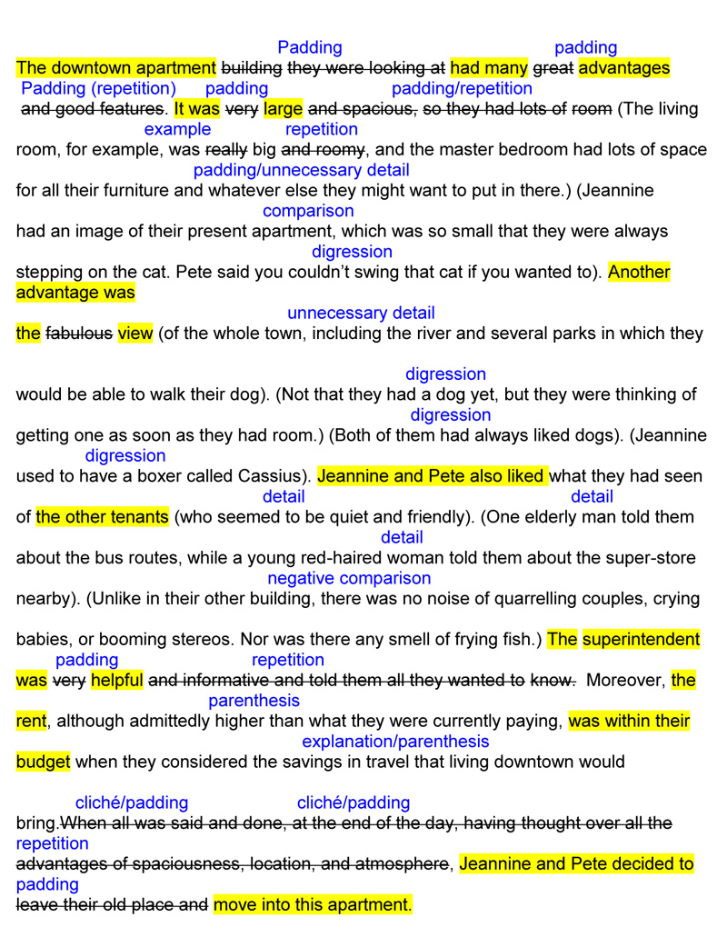

All this could be reduced to:

Jeannine and Pete decided to take the apartment because it was spacious, had a great view, and a pleasant atmosphere, and they could afford it.

On the other hand, don’t throw the baby out with the bath water. It could be that it would suit your purposes to develop their reasons for renting the apartment. In this case you might write:

Jeannine and Pete decided to take the convenient downtown apartment because the extra space would mean more room for their furniture and make it feasible for them to get a dog. They also loved the view, and the fact that there were parks in which to walk the dog. They felt that the building had a pleasant, friendly atmosphere, the superintendent was helpful, and the rent affordable.

You may have felt that most of the fun and interest of the paragraph lay in the concrete details that were scrapped. This is an interesting point and valid for creative and persuasive writing, but we are dealing here with straightforward workplace communications where timesaving is of the essence. Only include those details that will forward your purpose.

You will realize that there will be a crossover of these summarizing skills to your writing skills. Now that you have studied structure, and how to follow a line of thought, it will be easier for you to compose paragraphs with topic sentences, an orderly flow of thought, signpost words, and well-constructed sentences. You will also be able to revise your work more effectively with regard to what you must put in and what you should leave out.

