Example of a formatted Reference page

The image below is an example of a correctly formatted References page:
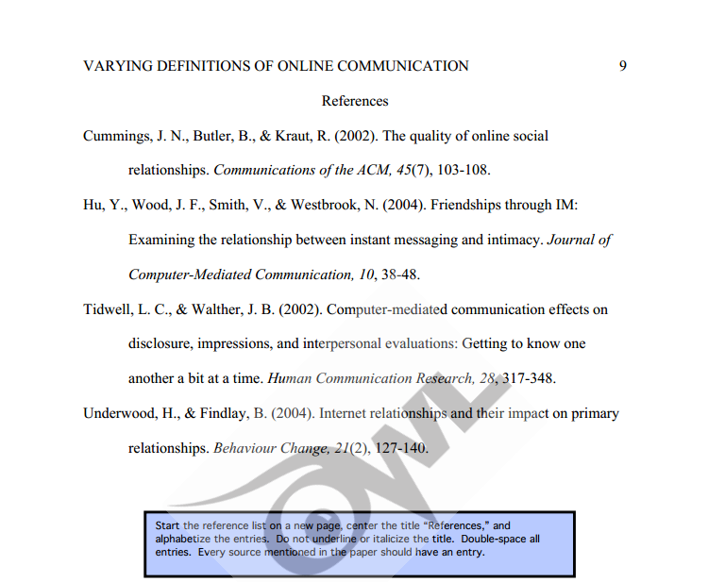

The following website provides detailed explanations regarding how to format each entry in your References depending on their type.
https://owl.english.purdue.edu/owl/resource/560/6/
VIDEO on Reference page creation: http://www.youtube.com/watch?v=mcervwkF-NY
Failing to complete an in-text citation and a reference entry for each source used results in plagiarism.

