Caitlin Ross
#040750891
DSN2100 Design Thinking
November 8, 2020

Design Thinking Journal Summary
Table of Contents
Introduction 2
Lesson 1 - Creativity and Innovation 3
Why did you score your creativity the way that you did? 3
What could you do to develop your creativity? 4
Lesson 2 - Human-Centred Design 5
What was the problem with the machine before an empathetic approach was applied? 5
What was better about the machine after looking at the problem with empathy? Why was it better? How can you use empathy to help solve problems? 6
How does this example help you understand the purpose of taking a human-centered approach? 7
Lesson 3 - Design Thinking: A Method for Solving Problems 8
How did each example apply Design Thinking to solve a problem? 8
Where could you use Design Thinking to solve a problem? For example, a small problem in your home, a neighbourhood or community issue, or a national problem that affects a large percentage of the population. 9
Which of these mindsets do you feel that you possess? Why? 12
Which of these mindsets do you feel that you need to work on? Why? 13
Which of these mindsets have you applied recently? Please describe the scenario. 15

Introduction

For the sake of clarity, I will be dividing up this assignment by the questions posted in Brightspace. First, I will include my original journal entry, then I will reflect on those entries and what (if anything) I would do differently now.
Images that aren’t mine have URLs in the captions, mine have a basic description. The URL for the cover page image is https://wakeup-world.com/2018/02/01/art-creativity-and-your-manifesting-prowess/

https://www.designindaba.com/articles/creative-work/us-digital-artist-talks-representation-minorities-graphic-design

Lesson 1 - Creativity and Innovation

Why did you score your creativity the way that you did?
I feel like I spend too much time mindlessly consuming social media and not enough just letting my mind wander. I remember hearing that boredom spurs creativity and imagination, which reminds me of playing pretend as a child.

I still feel like this is true but I also think that I’ve improved on this aspect. I spend far less time on social media now (mostly due to screen-induced headaches), because spending too much time in the virtual world makes my depression worse. I end up feeling like I wasted so much time that could have been spent on more productive hobbies (like weaving or crochet). While I would like to say that I now spend more time just letting myself be bored, I would be lying. I now spend that time reading or thinking my way through various weaving problems (like how to manage twist buildup when tablet weaving).
https://blog.zonealarm.com/2014/09/privacy-security-risks-of-social-networks/

What could you do to develop your creativity?
Less time on social media, more time just daydreaming, or letting my mind wander. Also keeping a notebook handy to write ideas down.
I feel like there should be more to this. I do agree with what I wrote, but there should be more. I do need to start keeping a notebook handy for various reasons and I have already reduced my social media use. Boredom is difficult for me, especially factoring in the societal pressure to be busy all the time. There’s this idea that outside of work we should either be working on a “side hustle” or working on self-improvement in some way. In many cases it’s a sales tactic to convince people to buy subscriptions or courses, but the concept is widespread enough to cause stress.
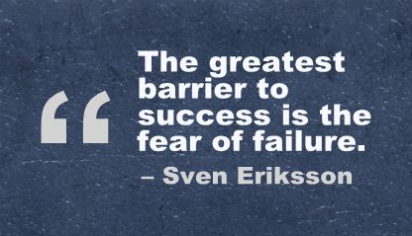
I think that the “more” that I mentioned earlier would be to let go of my perfectionism. My fear of failure has been central to my anxiety disorder and continues to hold me back when it comes to trying new things. If I could find a way to embrace mistakes, I would probably learn so much more about my crafts. Beyond that, the reduction in stress would benefit me health-wise.
https://quotesgram.com/fear-of-success-quotes/

Lesson 2 - Human-Centred Design

What was the problem with the machine before an empathetic approach was applied?
The machine was big and scary for kids. The design was based on what made sense for the adults making it, possibly even the healthcare workers using it, but not for the patients being subjected to it.
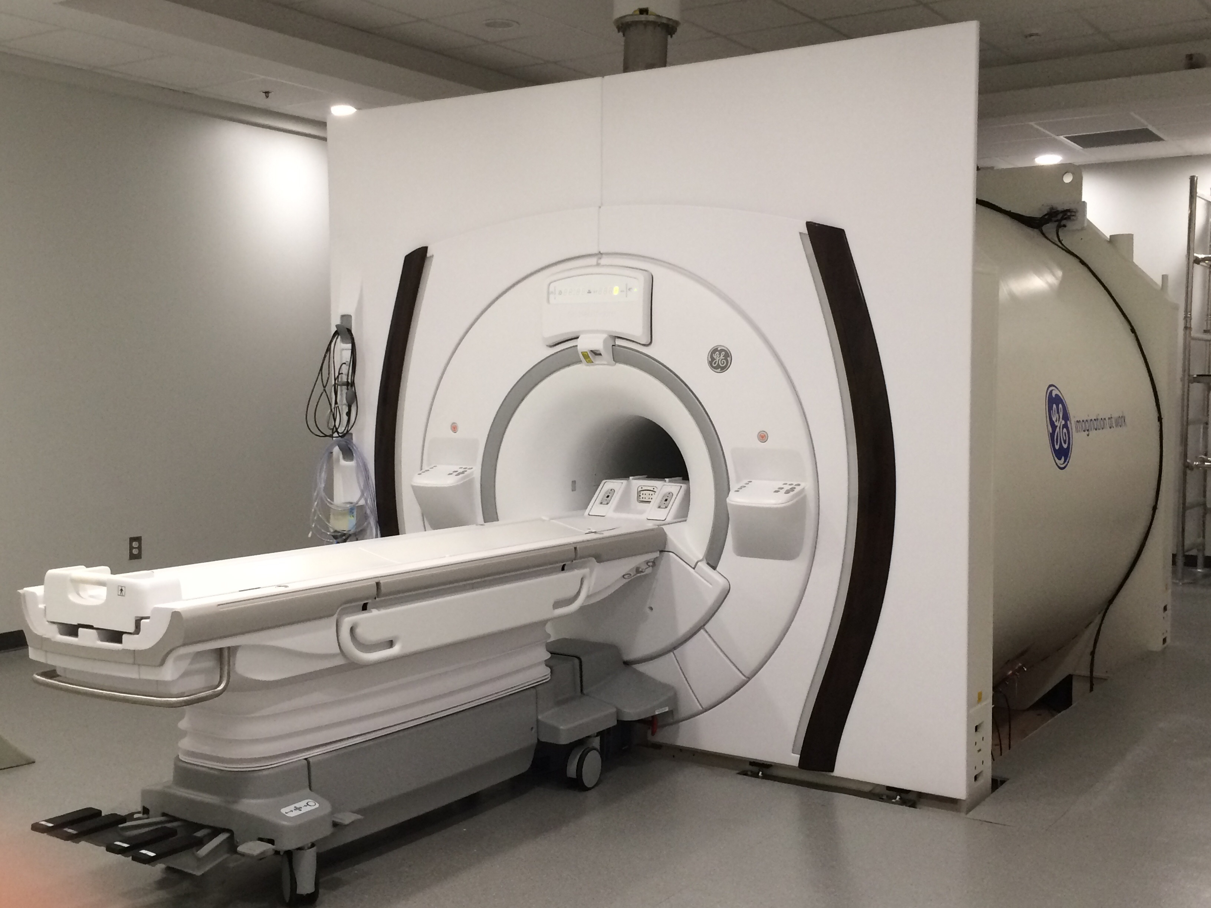
There’s more nuance to this. For adults, there wasn’t necessarily a problem with the MRI machine. I assume that staying still in a noisy, claustrophobic machine is still difficult for adults, but redesigning the whole machine may not be cost-effective for health care facilities. However, it seems that there was a clear problem for pediatric situations. Children have far less emotional control than adults do, so encountering a situation like this is far scarier. Controlling their fear and anxiety is much harder, so keeping still becomes much harder as well. This makes getting a clear image trickier and means that the odds of having to re-do the image are that much higher. Not only is the whole experience distressing for children, but it increases the costs for the health care facility.
https://medicine.uiowa.edu/mri/news-events/research-facility-news-archive

What was better about the machine after looking at the problem with empathy? Why was it better? How can you use empathy to help solve problems?
Using empathy made the MRI machine less scary and more friendly for the children. It became a component of a fun experience, rather than the culmination of a scary one. This made the patients less anxious, which in turn made it easier for the healthcare workers to get a good scan the first time.
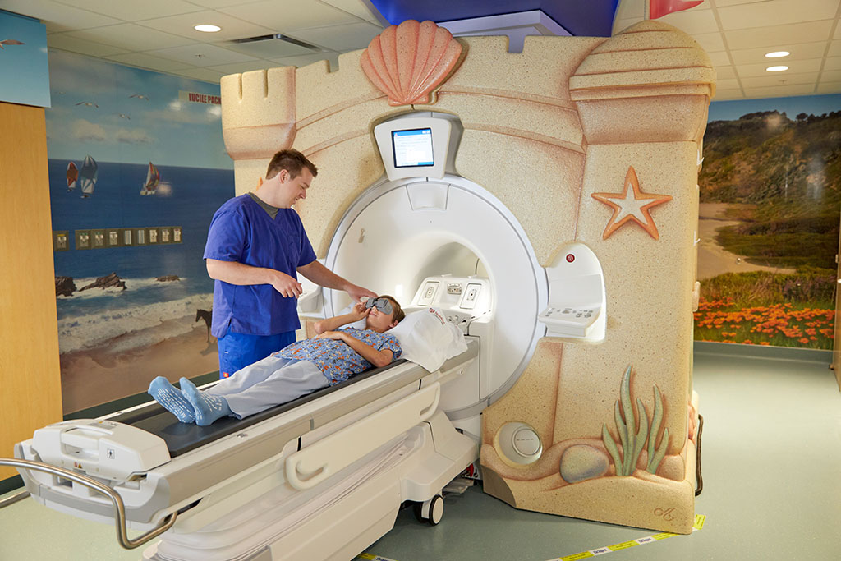
While my original response was correct, it may have been too brief. Approaching a problem with empathy forces designers to put themselves in the shoes of the users. I can’t imagine that any sane person would be proud of a design that causes stress and anxiety. While I can understand that budget, skill, or time constraints may cause a design to fall short, using empathy can help designers prioritize the user’s experience over other factors. The redesign was better because it added the children as a priority instead of focusing on the mechanics of getting an image.
http://med.stanford.edu/news/all-news/2018/08/how-stanford-research-is-making-mri-scans-safer-for-kids.html
As for how to use empathy, talking to the children was a great example. Watching them go through the process of getting an MRI done and asking them about their experience was extremely valuable in this redesign. Essentially, he treated the children as important and included their perspective as a design consideration.

How does this example help you understand the purpose of taking a human-centered approach?
It showed me that taking a human-centred approach isn't just about using surveys to get marketing data or creating focus groups, it's about actually collaborating with the users in order to solve real problems in meaningful ways.
Surveys and focus groups are actually a part of the solution. They may not be the whole solution, but they are tools used by designers to foster empathy for the user. While I understand what I was getting at with this response (it’s about the people, not numbers), the way I wrote it was incorrect. These specific tools are useful, but it’s important to keep the human element in mind when continuing through the design process. It’s not enough to just do the surveys and then completely forget that the users are people with thoughts, dreams, challenges, and opinions. The user and their experience need to be kept at forefront of the entire process from beginning to end.

https://boasc.wordpress.com/2014/08/14/video-analysis-2/

Lesson 3 - Design Thinking: A Method for Solving Problems

How did each example apply Design Thinking to solve a problem?
I'm unsure which examples are in question here, so I'll talk about the Apple mouse from the David Kelley video and the MRI machine from lesson 2.
The Apple mouse that David Kelley designed used Design Thinking by focusing on what the user needed instead of what was easiest for the manufacturers. Rubberizing the trackball was technically difficult, and wasn't strictly necessary to function, but the impact it made on user experience and satisfaction meant that it was a priority for the designers.
As for the MRI machine by Doug Dietz at GE, the original design worked just fine for adults. Theoretically it should work just fine for children as well, but in reality, the children were already overwhelmed by the environment, so the big white machine was just too scary. Empathy was the key factor here and talking with both the children and their parents. The design requirements went from being "what does the machine need in order to create a scan" to also including "how can the machine be less scary for children".
I’m still unsure where to find the examples that the question referred to. My only note here would be that just because there are fewer issues for adults using the MRI machine doesn’t mean that it’s “just fine”. For people with claustrophobia or sensory disorders it must be incredibly distressing to have an MRI done.

Where could you use Design Thinking to solve a problem? For example, a small problem in your home, a neighbourhood or community issue, or a national problem that affects a large percentage of the population.
We (my husband and I) are currently using Design Thinking to revamp our heating system in our house. The house is quite old (built in 1875) and has no ductwork. We had a woodstove in the living room that had such a small firebox it needed to be fed 2-3 times per hour. As a backup, we have a propane space heater in the kitchen, and electric baseboard heating in all other rooms. As you can imagine, winters are quite expensive, and keeping the stove fed all winter takes quite a bit of our time. Not only that, but the house is as far from open concept as you can get. Every room that isn't the living room or kitchen is quite cold.
When our insurance company required us to re-install the woodstove to code, we opted to remove it entirely. Right now, we are having air-source heat pumps installed that are far more efficient than the baseboard heaters, don't take nearly as much of our time as the wood stove, and are more environmentally friendly than the propane heater. Not only that, but we don't need to install ductwork throughout the house, which would be expensive and would hurt the character of the house.
On a related note, the house only has insulation in the roof. The walls themselves are 3-4 layers of brick, with almost no gap between and plaster and lathe on the interior. Blowing in insulation would be pointless, due to the lack of air gap. Not only that, but blown-in insulation is prone to mold, and adding insulation to the interior of the walls would cause the exterior and structural bricks to deteriorate quickly. However, in the interests of efficiency, I want to find a way to insulate our house.
The solution I've come up with is several years away (due to finances) but would hopefully balance our desire for an eco-friendly solution with our need to keep the house as structurally sound as possible. We hope to insulate from the outside using hempcrete. We may need to supplement with a foam board (or other type of insulation) but using hempcrete would actually be carbon-negative since the material actually draws carbon out of the air over time. Not only that, but it has a decent R-value. It's typically used in France to restore heritage buildings and to improve their thermal performance (Wikipedia).
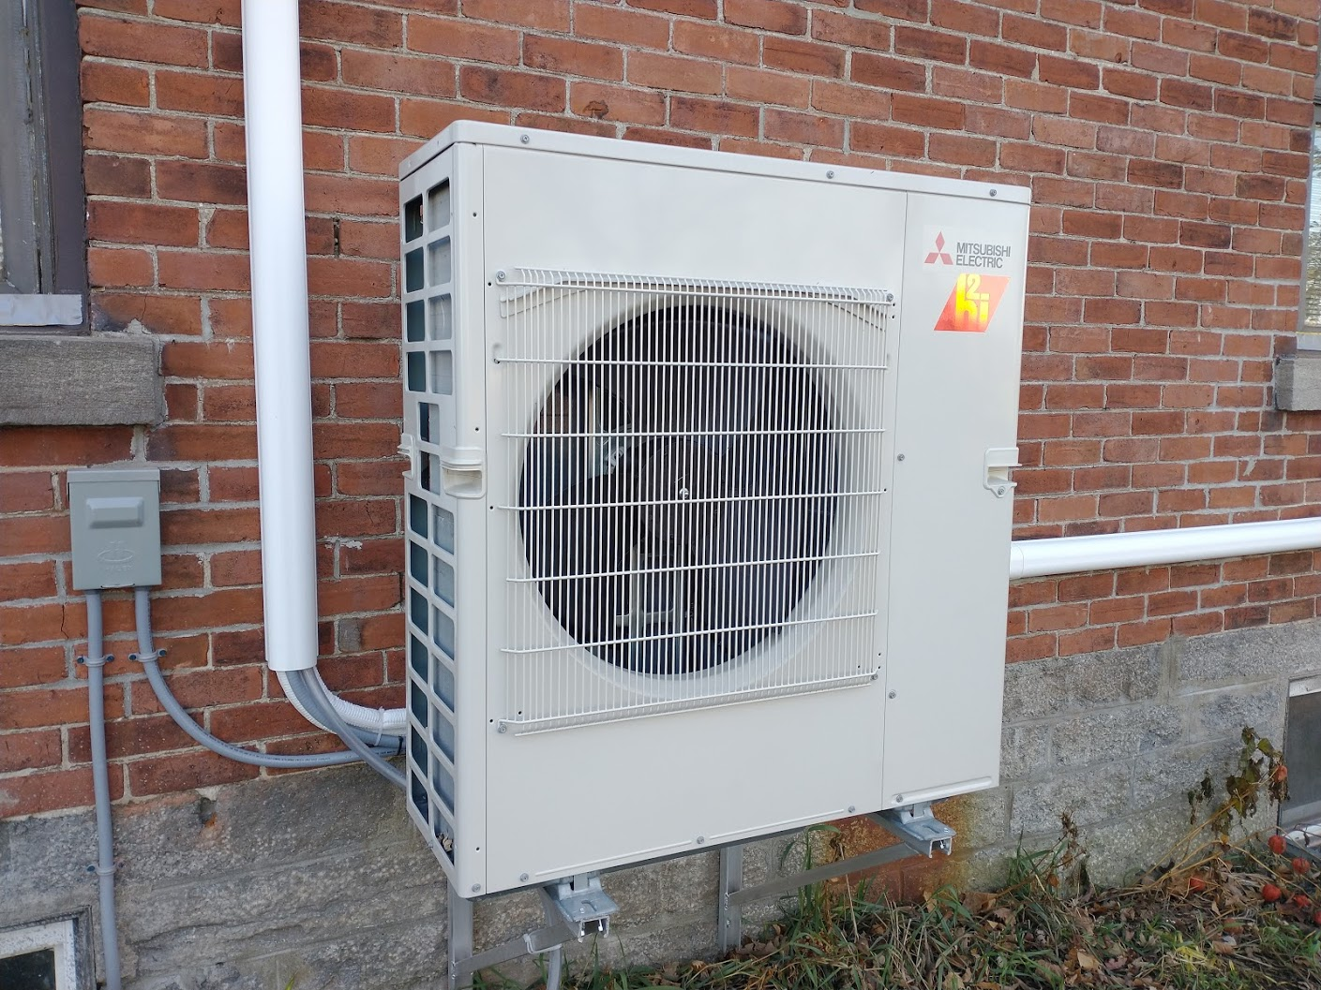
Having put in the mini splits by now, I feel that it was a great example of design thinking. Not only did this solution have the smallest impact on the structure of the house and our electricity/propane bills, I have a feeling of freedom from not having to constantly monitor a woodstove. We managed to balance several factors here, including cost (both up-front and continuing), adding holes to the house, comfort, and convenience. Originally, we had hoped to install a ground-source heat pump because they’re even more eco-friendly and efficient, but we had to compromise due to the up-front cost (as well as digging up the yard for the ground loop and adding ductwork to the house).
Photo of the heat pump
As for the hempcrete insulation, I’m still hoping to do that eventually. It would be horrifically expensive but being eco-friendly and efficient is a priority for my husband and me.
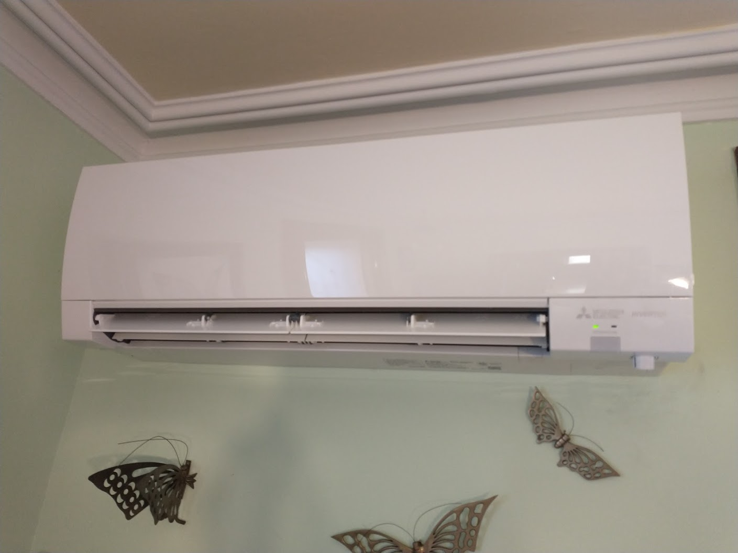
Photo of one of the four interior units that blow warm air

Which of these mindsets do you feel that you possess? Why?
I feel that I already embrace the "show, don't tell" mindset simply because explaining something (problem, process, idea, whatever) can usually take far longer than just showing someone. Most people learn by doing and can understand a picture far easier than a textual description.
Crafting clarity I think I also have, since I need to be able to define the problem clearly (and thoroughly) before I can craft an effective solution.
Embracing experimentation I definitely use, both in my weaving and in my coding. In both, I need to experiment with what's possible to find out what works.
I still agree with my assessment. The “show, don’t tell” mindset is due to understanding how people tend to learn. While I can usually grasp a concept through verbal media, many (if not most) people learn better with visual or tactile media. The clarity part is mostly due to my father having explained project management (particularly requirements documents) ad nauseum over the years. One of the major themes was to wait until the problem is well-defined before devising a solution and wait until the solution is well-defined before trying to implement it.
Experimentation is one that I enjoy, but I probably don’t use it quite as much as I thought. I’m a little too afraid of failure to use it to the fullest extent, but I do use it in smaller ways. For example, a while ago I tried making a sampler band of various tablet weaving techniques in order to learn how they looked.

Which of these mindsets do you feel that you need to work on? Why?
I need to work on focusing on human values. Most of my projects have elements of it (like choosing colours for a weaving gift that the recipient will enjoy), but I tend to fall back on processes that I'm familiar with (like using a slide buckle on a belt because it's easiest to add, even though it's harder to use).
Being mindful of process is something I haven't really looked into. I'll have to consider that one in more depth.
Radical collaboration is hard for me. Most of my projects at the moment are personal, so consulting other people feel odd to me. I do it to a certain extent, where I ask for people's opinion on certain elements, but not as much as I should.
Bias towards action is another hard one for me. My anxiety disorder centres around a fear of failure and judgement, so this is something I've been working on for a while. Thinking and planning are what I'm comfortable with, but I'm slowly getting out of my comfort zone and taking more action.
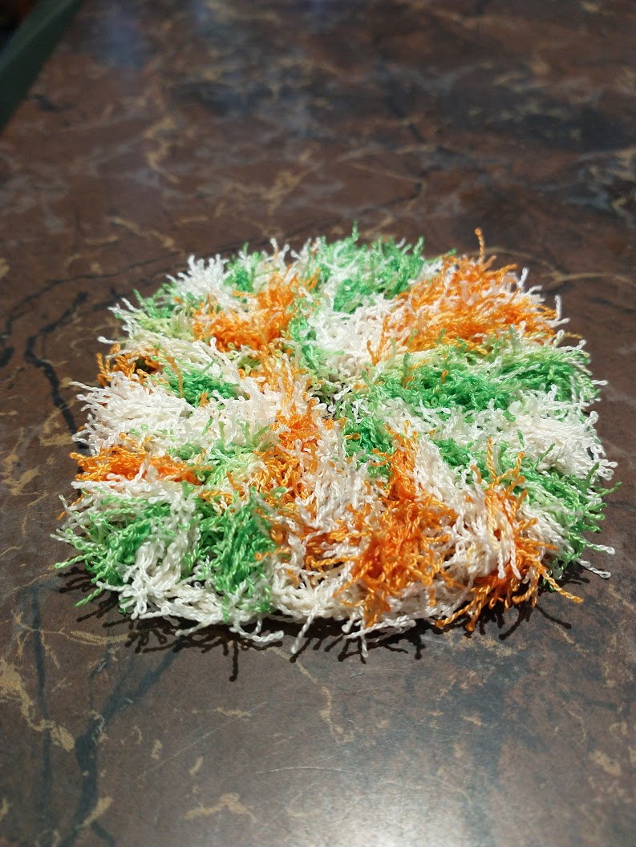
I think I’m getting better about focusing on human values. I’m continuously trying to improve certain crochet designs to make them more usable for the recipients. For example, I made dish scrubbies a while ago using a specialized polyester yarn. When I found out that there was a cotton version I wanted to switch over to the new yarn entirely, but after trying out a cotton prototype I realized that it wasn’t suited to dishwashing. The scrubby compacts in odd ways when wet, and the cotton is prone to mould growth. While I prefer the idea of natural materials, I had to acknowledge that polyester was a better fit for this project. Luckily, I found a way to make the process easier for myself while also making a better scrubby by learning a new stitch (cluster stitch).
I still need to look at being mindful of process. I’m starting to take better notes while weaving and crocheting, but I’m certain there’s more to it than that.
Photo of a (new) polyester scrubby
By nature, most of the projects I do right now don’t lend themselves to collaboration. I’ve been asking for feedback on certain weaving and crochet projects, but I’m not entirely certain if people are being too kind to tell me the truth. On the other hand, the scrubby example worked well. I don’t do the dishes in my household, but the people who do were able to give constructive feedback on the various designs I asked them to test. On a related note, I have recently taken on a new (collaborative) project to create a website for people to come together as a community to tackle food insecurity. This project will involve collaboration on many levels, especially since its purpose is to foster community and collaboration.
Bias toward action will probably be something I will always have to work on. I currently have my anxiety disorder under control, but taking action is particularly difficult for me. Every time my anxiety starts rearing its ugly head, I need to remind myself that taking action (whether it’s specific self-care measures or just forcing myself to do my homework) will help.
N.B. I realize that I went in an odd direction with the action towards bias, but it’s a useful parallel for my situation.

Which of these mindsets have you applied recently? Please describe the scenario.
The "show, don't tell" mindset I applied earlier this week when designing a guitar strap for my father-in-law. I'm currently weaving a belt for him for his birthday, but the design didn't come out quite how I wanted. I came up with a different design and tried to explain how it would look to my husband. Describing the design was difficult and showing the weaving draft wasn't helpful (drafts make more sense to weavers), so I drew a mock-up of how it would look for him. At that point he could say "yes, that's going to look good".
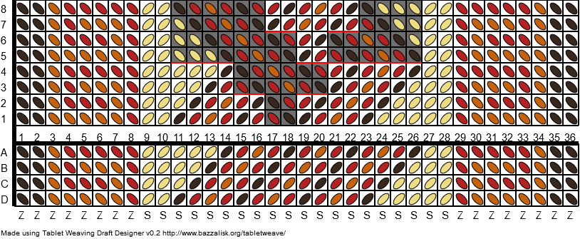
I’m still proud of my attempt to draw what the weaving would look like. My drawing skills are limited, and the image isn’t the best, but it illustrates the sense of how that design would look. Expanding on that, I recently found software that would allow me to design a tablet weaving draft in my browser and create a mock-up of the finished weaving based on the parameters given. This has made it easier for me to come up with new designs, especially since it takes less time and paper.
Example of a tablet weaving draft using https://jamesba.github.io/tabletweave/

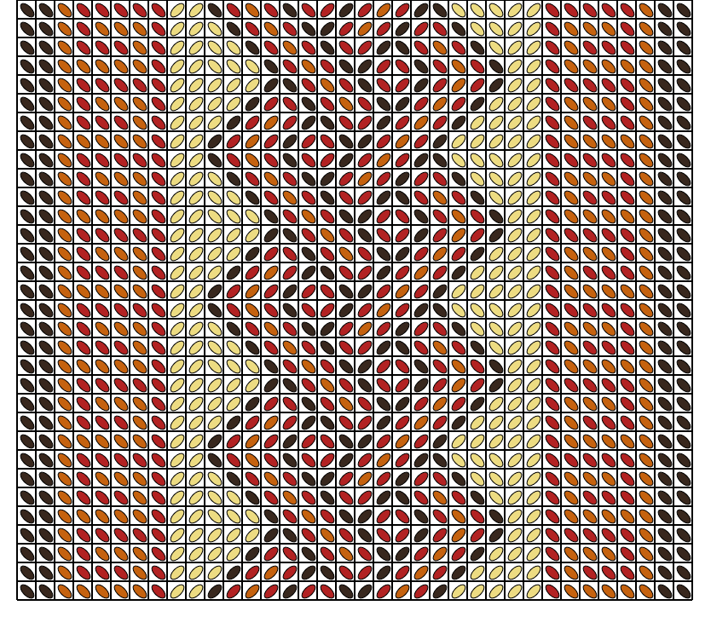
Mock-up of the same draft on https://jamesba.github.io/tabletweave/

