Assignment-5 Inheritance and Interfaces [Weightage: 15%]
This assignment relates to the following Course Learning Requirements:
CLR 4: Implement inheritance hierarchy and polymorphism where derived classes implement specialized behavior using polymorphic methods.

Objective of this Assignment:
The objective of this Assignment is to:
- Able to solve given programming statements by applying Inheritance Concepts.
- Able to think the different scenarios and successfully complete the missing programming steps.
Pre- Assignment Instruction:
To complete this assignment successfully read the module content and follows the given links and given video tutorials to solve the theory and programming questions.

Assignment Tasks:
- You will complete the following theory questions, practical assignment and quiz.
- You have to complete this assignment in 1 hour.
- You can solve the questions randomly.
- All the questions are compulsory.

Assignment:
- Suppose s is an object of the class Student. Based on the inheritance diagram in
- lesson, where will you find the definition of the method used in the following
- invocation? Explain your answer.
- s.setStudentNumber(1234);
- Suppose s is an object of the class Student. Based on the inheritance diagram in
- lesson, where will you find the definition of the method used in the following
- invocation? Explain your answer.
- s.setStudentNumber(1234);
- Suppose s is an object of the class Student. Based on the inheritance diagram in
- lesson, where will you find the definition of the method used in the following
- invocation? Explain your answer.
- s.setStudentNumber(1234);
- What is Inheritance in Java?
In Java, inheritance is a feature where a “child” class (subclass) can have characteristics of a “parent” class (superclass) by using the keyword “extends”. This allows the subclass to have the methods and data members of the superclass.
- What are different types of Inheritance supported by Java?[just name]
Java supports single inheritance, multi-level inheritance, hierarchical inheritance and hybrid inheritance (through interfaces).
- Why multiple Inheritance is not supported by Java?
Java doesn’t support multiple inheritance because it causes ambiguity when a subclass has inherited a method contained in two (or more) parent classes. This is typically called the “diamond problem” and over-complicates the code. For example, if a subclass “Amphibus” inherits (but doesn’t override) a non-abstract “Go” method from both “Boat” and “Bus” parent classes, which method is called?
- Why Inheritance is used by Java Programmers?
Inheritance is used by Java programmers in order to create reusable code. It allows programmers to create child classes for a new situation instead of re-writing the original class for each new situation. It also reduces redundancy, for example putting standard “vehicle” behaviour into a parent class and having each type of vehicle (car, bicycle, truck, train, etc.) inherit that behaviour.
- What is the difference between Inheritance and Encapsulation?
Inheritance is where a child class can have methods and fields from a parent class, whereas encapsulation is where the details of how a class works is hidden from the user. Inheritance is a key part of Polymorphism, where Encapsulation is its own object-oriented concept.
- What is the difference between multiple and multilevel inheritance?
Multi-level inheritance is where a class can be both a child and a parent class at the same time, whereas multiple inheritance is where a child class can have more than one parent class.
- Why use Java Interface?
Java interfaces play a key role in Abstraction, as well as allowing multiple inheritance in Java.
- Can a class implement more than one interface in Java?
Yes, classes (and interfaces) can implement more than one interface in Java. This is how multiple inheritance is achieved.

Practical:
- Create a class with a method that prints "This is parent class" and its subclass with another method that prints "This is child class". Now, create an object for each of the class and call
1 - method of parent class by object of parent class
2 - method of child class by object of child class
3 - method of parent class by object of child class

Main method:
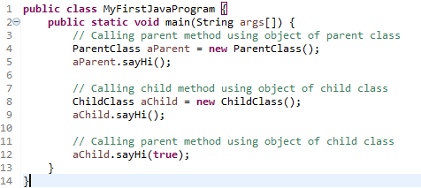
Parent class:
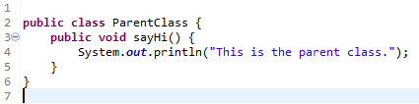
Child class:
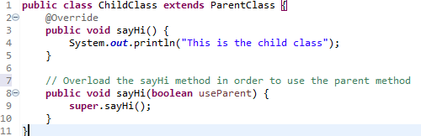
Output:
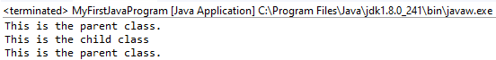

- Create a class named 'Member' having the following members:
Data members
1 - Name
2 - Age
3 - Phone number
4 - Address
5 - Salary
It also has a method named 'printSalary' which prints the salary of the members. Two classes 'Employee' and 'Manager' inherits the 'Member' class. The 'Employee' and 'Manager' classes have data members 'specialization' and 'department' respectively. Now, assign name, age, phone number, address and salary to an employee and a manager by making an object of both of these classes and print the same.
Normally I would add getters and setters, as well as overloading the constructor to make the code more robust. However, in the interests of keeping it simple, I coded just what was asked.

Member class (includes main method):
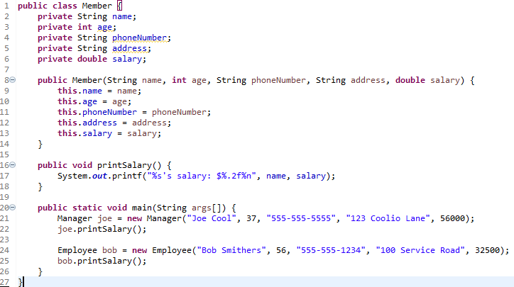
Manager class:
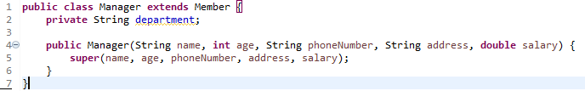

Employee class:
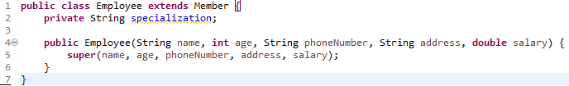
Output:


- Create a class named 'Shape' with a method to print "This is This is shape". Then create two other classes named 'Rectangle', 'Circle' inheriting the Shape class, both having a method to print "This is rectangular shape" and "This is circular shape" respectively. Create a subclass 'Square' of 'Rectangle' having a method to print "Square is a rectangle". Now call the method of 'Shape' and 'Rectangle' class by the object of 'Square' class.
Shape class (includes main method):
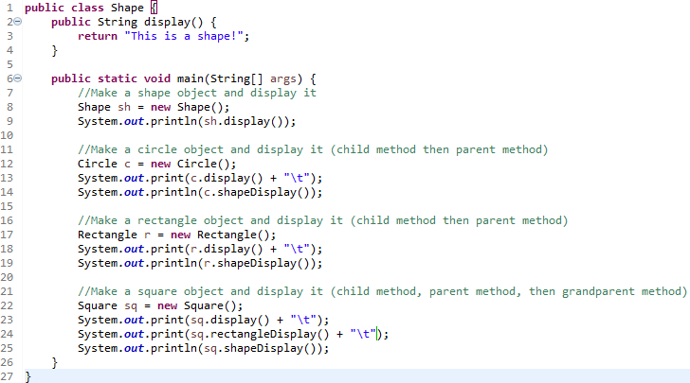
Circle class:
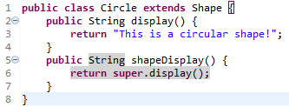
Rectangle class:
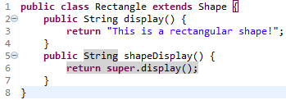

Square class:
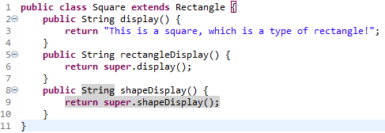
Output:
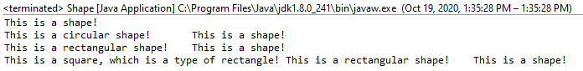

- Create an application with java interface concept and generate the correct output.
I used both parent classes and an interface to simulate a factory’s employees.
Employee class (includes main method):
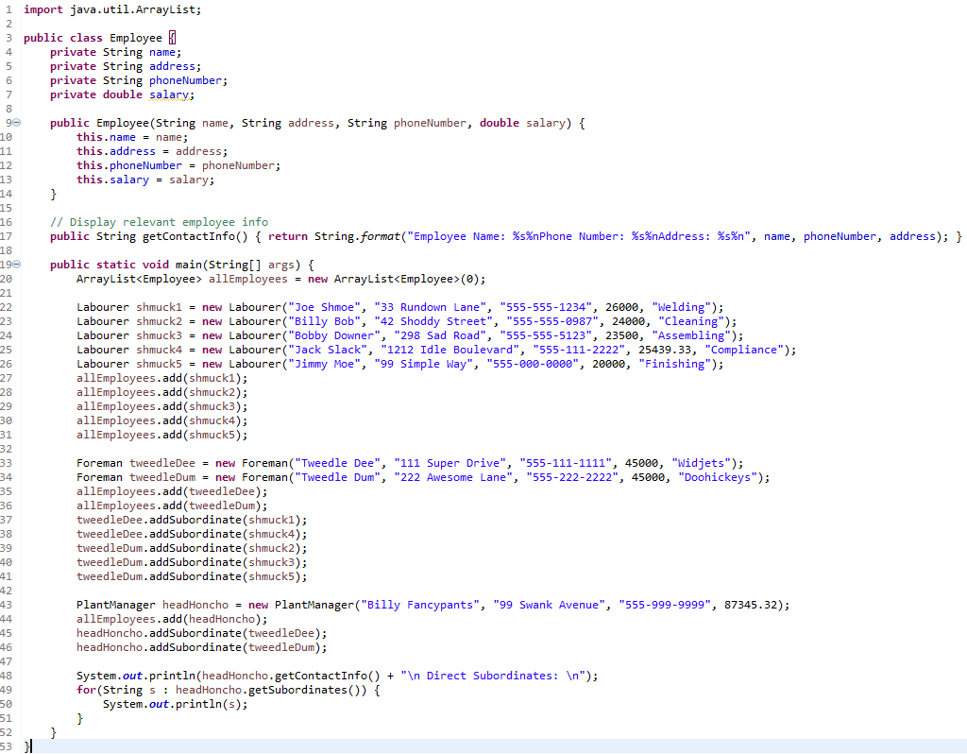
Labourer class (child of employee):
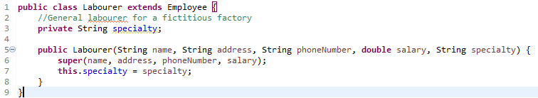
Supervisor interface:
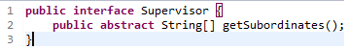

Foreman class (child of employee, implements Supervisor):
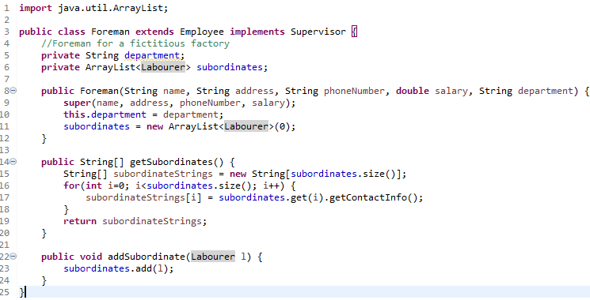
PlantManager class (child of employee, implements Supervisor):
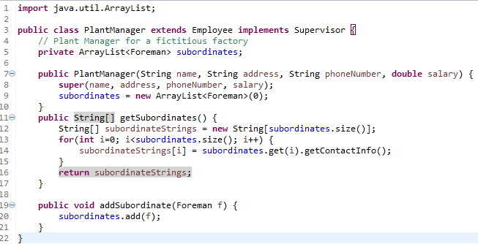

Output:
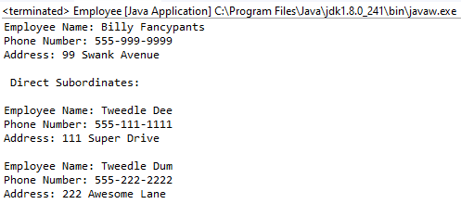

1: Complete the missing programming steps

class Base {
public void Print() {
System.out.println("Base");
}
}

class Derived extends Base {
public void Print() {
System.out.println("Derived");
}
}

class Main{
public static void DoPrint( Base o ) {
o.Print();
}
public static void main(String[] args) {
Base x = new Base();
Base y = new Derived();
Base z = new Derived();
DoPrint(x);
DoPrint(y);
DoPrint(z);
}
}

Output: Base
Derived
Derived

2: Consider the following example code and generate the output. Give your explanation about generated output.

class Base {
public void foo() { System.out.println("Base"); }
}

class Derived extends Base {
private void foo() { System.out.println("Derived"); }
}

public class Main {
public static void main(String args[]) {
Base b = new Derived();
b.foo();
}
}
Output:
Derived

3: Look at the below programming code and complete the missing parts to generate the given output.

Output: “Interface Method Implemented”

interface Pet{
public abstract void test();
}
class Dog implements Pet{
public void test(){
System.out.println(“Interface Method Implemented”);
}
public static void main(String args[]){
Dog p = new Dog();
p.test();
}
}

