Assignment #4: Control Structures in JAVA [5%]
This assignment relates to the following Course Learning Requirements:
CLR 2: Write Java program code to solve a problem, based on a description of the problem context, including UML diagrams, using object-oriented techniques.
CLR 11: Identify appropriate strategies for solving a problem.

Objective of this Assignment:
The objective of this Assignment is to ensure students:
- Understand the concept of Entry Control and Exit Control loops in Java.
- Able to understand the concept about looping structures in Java.
- Able to execute Java statements for branching structures.

Pre- Assignment Instruction:
To complete this assignment successfully read the module content and follow the given links and given video tutorials to solve the theory and programming questions.

Assignment Tasks:
- You will complete the following theory questions, practical assignment and review.
- All questions must be answered on this document and uploaded into brightspace when complete

Questions:
- Write down syntax for if, else…if & nested if...else statements in java.
If-else if-else:
if (condition1) {
Statement(s)1;
}
else if (condition2) {
Statement(s)2;
}
else {
Statement(s)3;
}
Nested if-else:
if (condition1) {
if (condition2) {
Statement(s)1;
}
else {
Statement(s)2;
}
}
else {
if (condition3) {
Statement(s)3;
}
else {
Statement(s)4;
}
}
- Explain the usage of Switch statement in java.
Switch statements are used similarly to an if-else-if-else statement, but instead of having a condition coded into the statement, it checks for specific values (constant or literal) that match the given variable. It can only be used with int, char and enum data types, since it only checks for exact matches.

- What are the benefits of break and continue statements? Explain with example.
Break and continue statements can be used to bypass either the remainder of the loop (break) or the current iteration (continue).
Break example:
//Output: 1, 2, 3, 4,
for (int i=0; i<10; i++) {
if (i==5) {
break; //Stops the loop when i is 5
}
System.out.print(i + “, “);
}

Continue example:
//Output: 1, 2, 3, 4, 6, 7, 8, 9,
for (int i=0; i<10; i++) {
if (i==5) {
continue;
}
System.out.print(i + “, “);
}

- What is for…each loop in java? Explain with example.
A for-each loop is used to iterate through an array without using an extra variable for the iteration. Added benefit of not needing to know the length of the array ahead of time.
Example:
//Prints each name on its own line
String classList[] = {“Mary”, “Johnny”, “Alice”, “Sammy”, “Dawn”);
for (String name : classList) {
System.out.println(name);
}

Practical:
- Write a Java program to get a number from the user and print whether it is positive or negative.

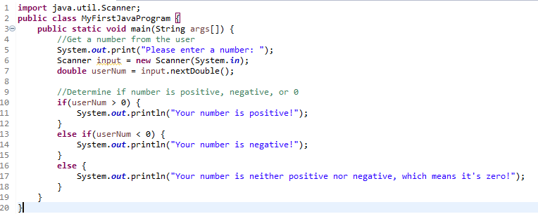

- Write a Java program that keeps a number from the user and generates an integer between 1 and 7 and displays the name of the weekday.

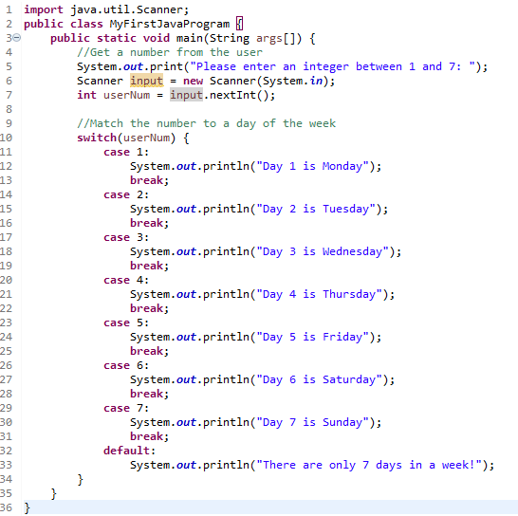

- Write a Java program that takes the user to provide a single character from the alphabet. Print Vowel or Consonant, depending on the user input. If the user input is not a letter (between a and z or A and Z), or is a string of length > 1, print an error message.

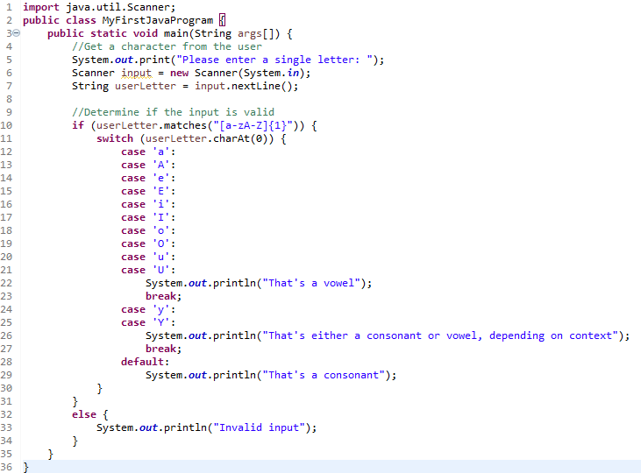

- Write a program in Java to input 5 numbers from keyboard and find their sum and average.

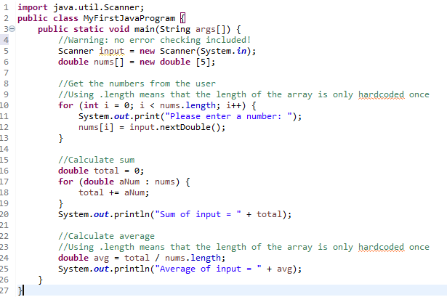

- Write a program in Java to make such a pattern like right angle triangle with a number which will repeat a number in a row. The pattern is as follows :
1
22
333
4444

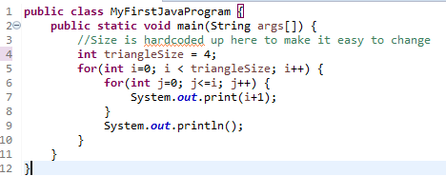

Review:
- How many choices are possible when using a single if-else statement? 2 options are possible, assuming no nested conditionals or else-ifs.
- For ( int x=0 ; x<10; x= x+3) statement ; will be executed 4 times.
- In switch type of structure/loop should you always provide break statements(s).
- The while loop repeats a set of code while the condition is not met? True/False False, it repeats while the condition is true
- Do-while loop will execute the body of loop even when condition controlling the loop is initially false.

