Assignment #2: Overview of Java Programming [5%]
This assignment relates to the following Course Learning Requirements:
CLR 1: Install and use the Java Development and Runtime Environment and documentation libraries. Install and use the Eclipse Integrated Development Environment.
CLR 2: Write Java program code to solve a problem, based on a description of the problem context, including UML diagrams, using object-oriented techniques.
CLR 9: Prepare program documentation using prescribed program specifications.
CLR 11: Identify appropriate strategies for solving a problem.

Objective of this Assignment:
The objective of this assignment is to ensure students have:
- Learn how to write and execute the simple java programs.
- Implement constructor and its types in java application.
- Understand about classes and objects.
- Understand Accessor and Mutator concepts.
- Draw UML class and object diagram for given problems.
Pre-Assignment Instruction:
To complete this assignment successfully read the module content very carefully and refer to the given links and videos in the module [including UML class and object Diagram Link]. Execute all the programs in Eclipse and verify the output. For better understanding of any content you can refer the links given in the reference section of module.
Assignment Tasks:
- Complete the following Short Answer, Fill in the Blank and True and False Questions.
- Once you have completed the following word document with answers, please submit this document in to brightspace.

Questions:
- ________ is a declaration for the main method in java program? public static void main(String args[]) { //code }
- Objects are characteristics of ________language types? Object-Oriented
- Attribute of an object can include information about_______. The state of the object
- __________method is used to initialize the instance variable of a class? A constructor
- Is statement “Constructor initializes an object immediately upon creation” true or false? True
- How many arguments does parameterized constructor contain? One or more
- In Java, main () method returns a value of type_____. Void
- Is the following statement: “Class can have only member functions with no data members“ True or False? Give your reasons. False, classes are the blueprint to describe objects that can have both member functions (behaviour) and data members (attributes).
- What is the meaning of return datatype “void”? Void means no data is returned by the method

Answer the following questions - You must take screen shots of your program and its output.
- Write Java code to print “Hello World”. 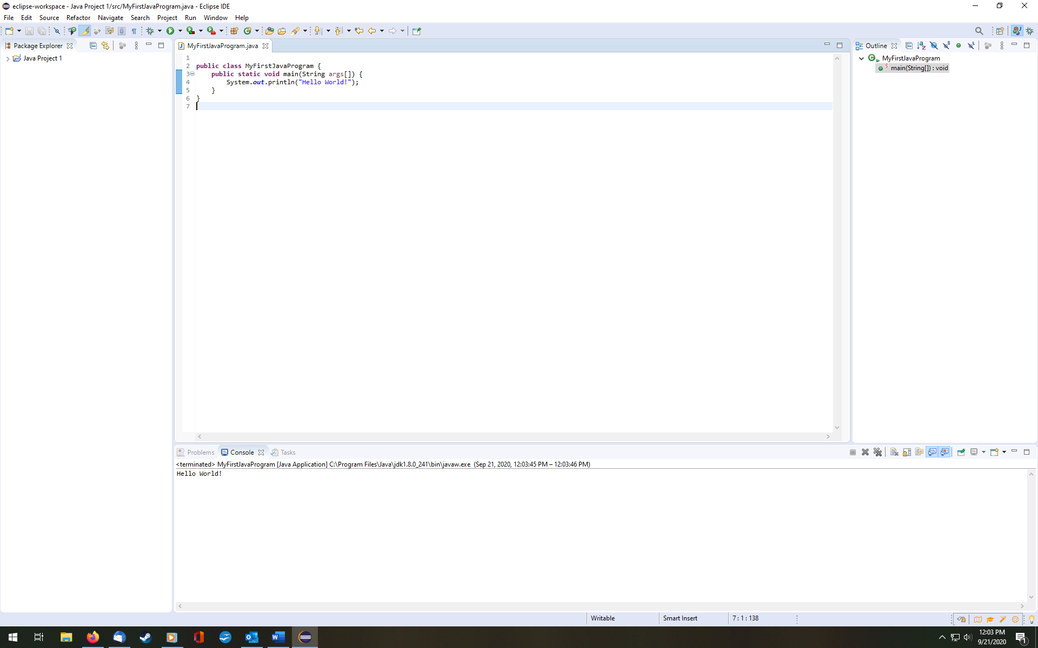

2. Create class to illustrate the concept of default parameter and parameterized constructor. 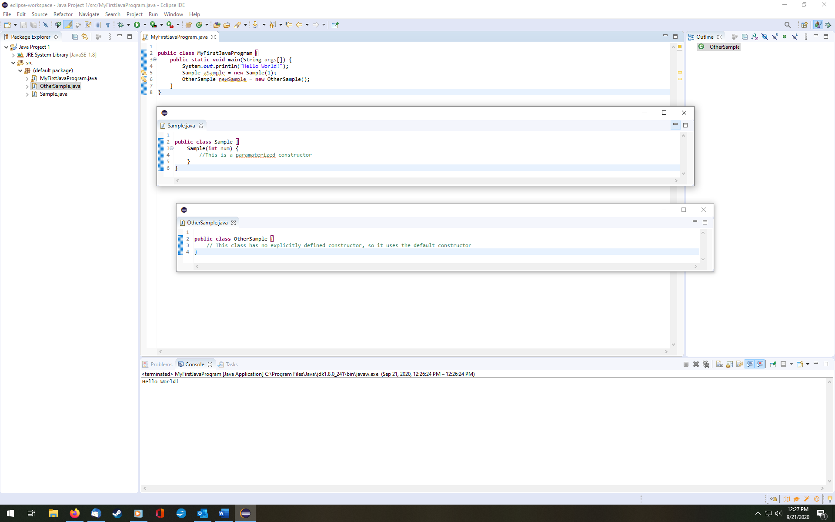

3. Create Java Program to illustrate the concept of Accessor and Mutator. 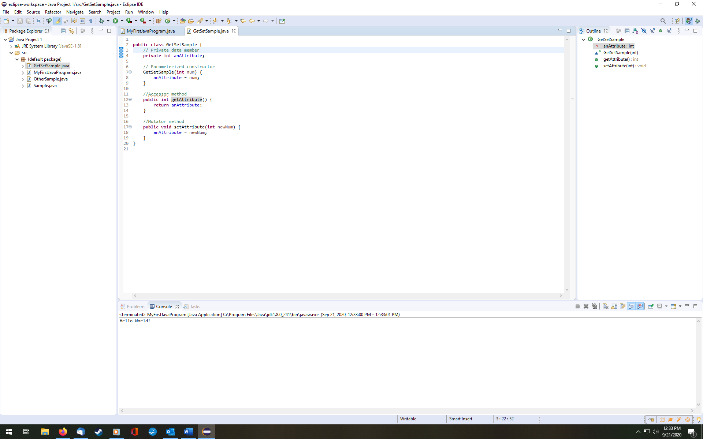

4. Create UML Class Diagram for Student Class having attributes Name, Age and Department and create object diagram for the same. 