Lab 07 – JOINS
This Lab relates to the following Course Learning Requirements:
CLR 1: Follow lab policies and procedures for etiquette, software licensing requirements and lab submissions
CLR5: Use basic SQL SELECT Statements to perform inner joins, outer joins and subqueries

Objective:
The objective of this lab is to make sure that you know how to use different join statements and use subqueries.

Pre-Lab Instructions:
- Read Module 7 & 8
Lab Tasks:
- Import the Lab07DB.sql in the workbench and refresh the schemas.
- You will execute some commands to get information out of the database. Each bullet point represents an individual task.
  - Select all students and order by there program.
  - Left (OUTER) join professor from student and display everything with common programs.
  - Right (OUTER) join professor from student and display student first name, professor name, student program and professor program with common programs. Why are some fields null in the Right and Left Joins?
- Your lab is to be submitted in 3 SQL files
NOTE: To save the SQL command. Save the SQL code written to Insert, update and delete in previous steps.
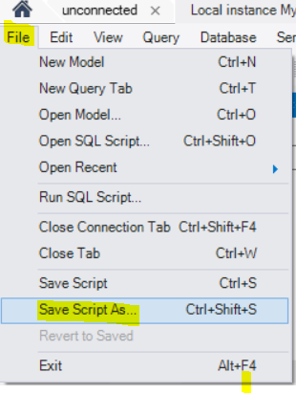
  - LastName_Left_Outer.sql
  - LastName_Right_Outer.sql
  - LastName_OrderBy.sql

Lab Grading Rubric (3%)

LastName_Left_Outer.sql | /1
LastName_Right_Outer.sql | /1
LastName_OrderBy.sql | /1
Total | /3
Comments

