Lab 06 – Data Definition Language
This Lab relates to the following Course Learning Requirements:
CLR 1: Follow lab policies and procedures for etiquette, software licensing requirements and lab submissions
CLR4: Use Data Definition Language (DDL) to add, modify and delete database objects, i.e. tables.
CLR5: Use Data Manipulation Language (DML) to insert, update, select and delete data
Objective:
The objective of this lab is to make sure that you know how to use Data Definition Language .

Pre-Lab Instructions:
- Read module 6
Lab Tasks:
- Firstly, import the data (student.sql) in database.
- Using the different DML commands answer the following questions.
  - SELECT – Number of students enrolled?
  - SELECT WHERE – Number of students in Computer Science Program?
- Using INSERT add a student George Smith (cell - 887258963) to database who has taken Computer Technician course and is 25 years old and save this SQL as LastName_INSERT.sql
- UPDATE the course name from Computer Science to Computer Science Engineering for every student enrolled in Computer Science and save the SQL as LastName_UPDATE.sql.
- DELETE the students Anita Arora and Frank Tribiani and save the SQL as LastName.DELETE.sql.
- Your lab is to be submitted in two parts
  - MS word for the two questions:
    - On the header have the course code and course name, the lab number, your student ID, your name, the instructor’s name, and the date the lab is submitted.
    - Put the question and answer to it.
  - SQL files for INSERT, UPDATE and DELETE statements needed.
NOTE: To save the SQL command. Save the SQL code written to Insert, update and delete in previous steps.
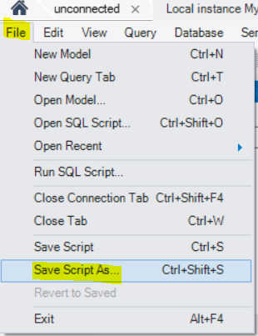
    - LastName_INSERT.sql
    - LastName_UPDATE.sql
    - LastName_DELETE.sql

Lab Grading Rubric (3%)

Lab Submission (MS word) | /1.5
Lab Submission (SQL) | /1.5
Total Points | /3
Comments

