Lab 05 – Create DB, Create Table based on ERD
This Lab relates to the following Course Learning Requirements:
CLR 1: Follow lab policies and procedures for etiquette, software licensing requirements and lab submissions
CLR2: Use workplace tools to model database design using ER diagrams
CLR3: Map an ERD to a Relational Database
CLR3: Create database backups
Objective:
The objective of this lab is to make sure that student can analyze the ERD and relate it to Relational Database.

Pre-Lab Instructions:
- Read Module 5.
Lab Tasks:
- The Lab 5 is built on top of lab 4. Make sure you are connected to database.
- Look at the ERD and add the two new tables to the car_fuel database created in Lab 4.

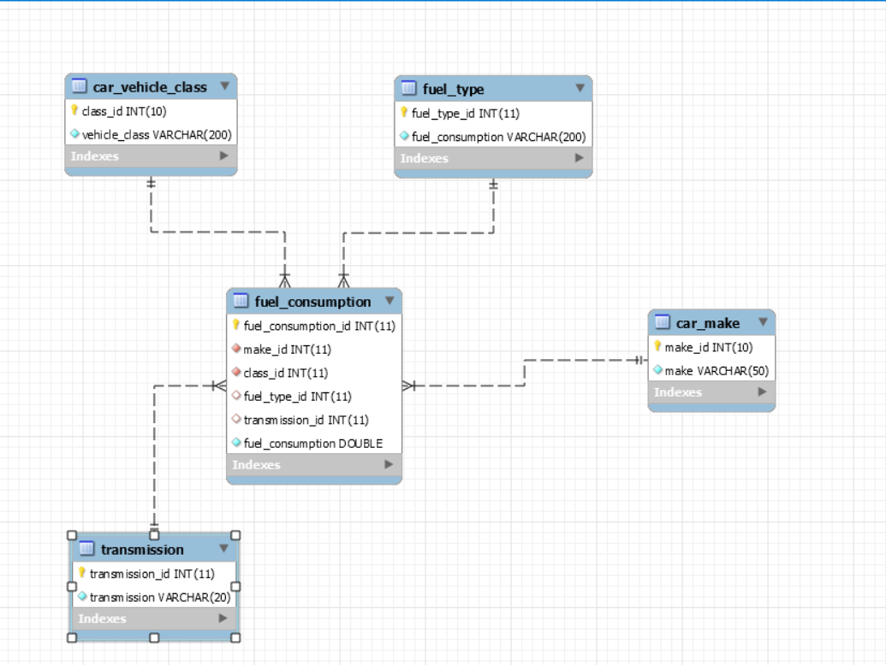

- First lets create two new tables fuel_type and transmission
  - fuel_type
    - Create table with the following attributes and column name.
      - fuel_type_id int unsigned primary key auto_increment,
      - fuel_consumption varchar(200)
  - transmission
    - Create table with the following attributes and column name.
      - transmission_id int unsigned primary key auto_increment,
      - transmission varchar(20)
- Add two columns in table fuel consumption.
  - Transmission_id int unsigned
  - Fuel_type_id int unsigned

- After the tables are created and new columns are added. Create two relationship by creating foreign keys.
Run the following code in new query tab to create transmission_id as foreign key. Change the code and do similar thing for Fuel_type_id.

ALTER table car_fuel.fuel_consumption
ADD FOREIGN KEY transmission_id(transmission_id)
REFERENCES transmission(transmission_id)
ON DELETE NO ACTION
ON UPDATE CASCADE;

- When creating foreign keys make sure the key you are referencing to has same attributes.
NOTE: If you created tables and relationships using ERD make sure you forward engineer to have the changes reflected on database.
- Your lab is to be submitted in database backup.
  - Server -> Data Export ->(Select the database) -> Export Progress -> Start Export (Export to self-contained file)
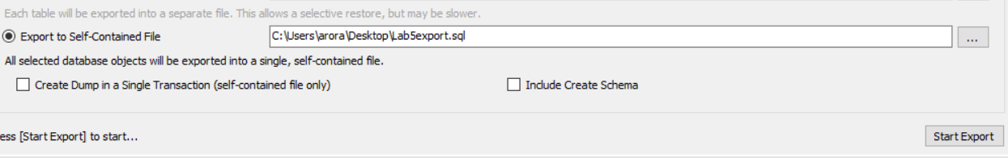
Lab Grading Rubric (3%)

Database backup | /3
Total | /3
Comments

References
The dataset used in this lab is taken from the below resource:
Open Government. (n.d.). Fuel consumption ratings. Retrieved from https://open.canada.ca/data/en/dataset/98f1a129-f628-4ce4-b24d-6f16bf24dd64
Contains information licensed under the Open Government Licence – Canada ( https://open.canada.ca/en/open-government-licence-canada )

