Lab 04 – Restoring Database and Reverse Engineering
This Lab relates to the following Course Learning Requirements:
CLR 1: Follow lab policies and procedures for etiquette, software licensing requirements and lab submissions.
CLR3: Reverse engineer a database schema to reveal an ERD.
CLR3: Restore a database from a given backup

Objective:
The objective of this lab is to make sure that you have proper knowledge to restore database from backup and reverse engineer database to reveal ERD.

Pre-Lab Instructions:
- Read Module 4.
Lab Tasks:
- Go to the MySQL workbench File -> New Query Tab
- Once you have the diagram screen open. You should connect to the database. Just like lab 03. 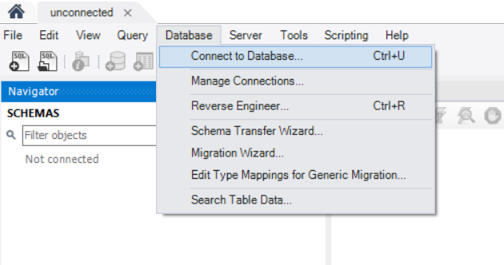
- Next step is to import the database. Go to Server -> Data Import
- There are two tabs on the screen:
  - Import from Disk:
    - Go to import from self-contained file and search for Lab4.sql file.
    - Next go to default target schema and click new and name the schema car_fuel.
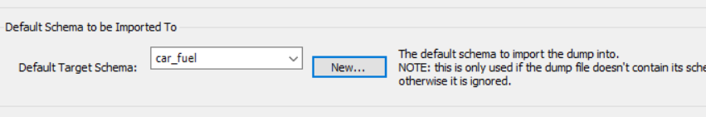
  - Import progress:
    - Click start import and make sure the import was successful.
- Now go to the navigator to the left of the WB and click refresh.
- You will see car_fuel database created with three tables under it.
- Right click each table and select rows – limit 1000.
- Take a screenshot snippet of the table data (save screenshots of every table from Step 7 for submission).
- After you have made sure you have all the tables, we will work on creating the ERD using Reverse Engineering.
- Click Database -> Reverse Engineer
- Keep the default setting and click next.
- Select the car_fuel database and click next.
- Make sure retrieval is successful
- Execute the import of three MySQL statements.
- Click finish.
- You will see an ERD take a screenshot (save this screenshot for submission).
- Your lab is to be submitted in MS WORD format. It should be submitted with the following guidelines:
  - On the header have the course code and course name, the lab number, your student ID, your name, the instructor’s name, and the date the lab is submitted.
  - Paste the screenshot on the word document from Step 8 and Step 16

Lab Grading Rubric (3%)

Lab Submission (Correct screenshot attached to the word document) | /1
Importing the database successfully | /1
Lab Structure (Submission guidelines) | /1
Total Points | /3
Comments

References
The dataset used in this lab is taken from the below resource:
Open Government. (n.d.). Fuel consumption ratings. Retrieved from https://open.canada.ca/data/en/dataset/98f1a129-f628-4ce4-b24d-6f16bf24dd64
Contains information licensed under the Open Government Licence – Canada ( https://open.canada.ca/en/open-government-licence-canada )

