Lab 04

Step 8 Screenshots – Car Make Table
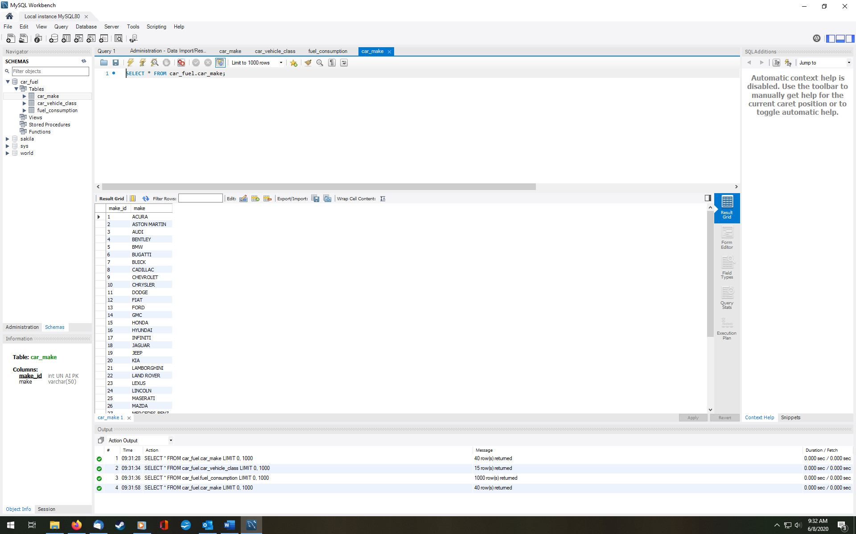

Step 8 Screenshots – Fuel Consumption Table
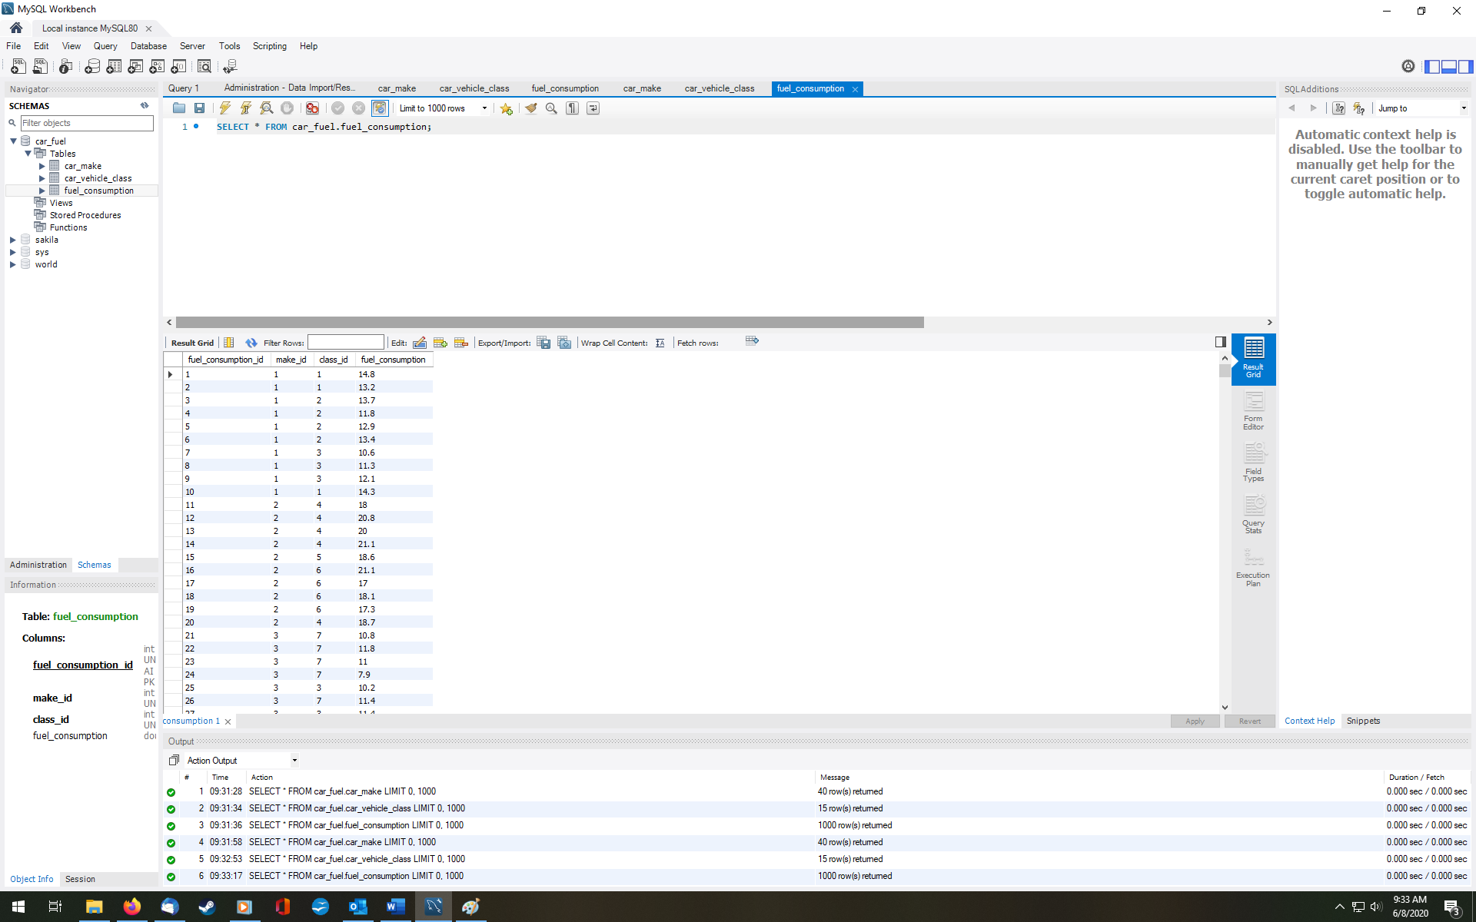

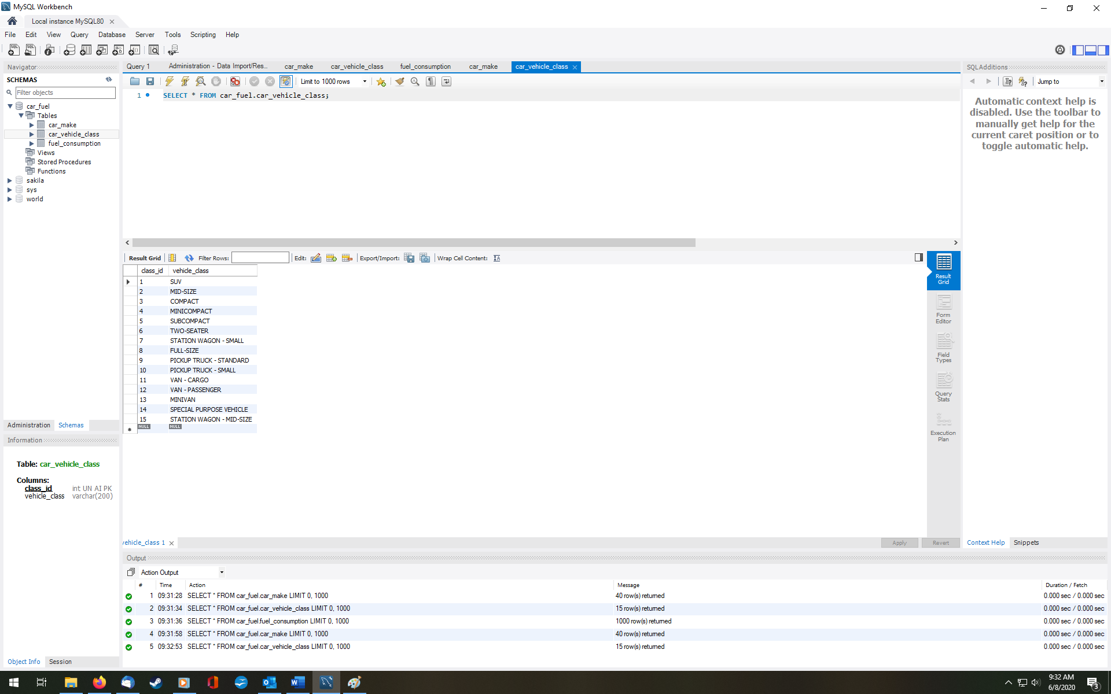
Step 8 Screenshots – Car Vehicle Class Table

Step 16 Screenshot - ERD
