Lab 03 – Creating ER diagram using MySQL
This Lab relates to the following Course Learning Requirements:
CLR 1: Follow lab policies and procedures for etiquette, software licensing requirements and lab submissions
CLR2: Use workplace tools to model database design using ER diagrams
CLR3: Create database backups
Objective:
The objective of this lab is to get used to MySQL workbench modelling tool and create the backup of the model.

Pre-Lab Instructions:
- Read Module 3
Lab Tasks:
- Go to MySQL workbench. To know the steps to open workbench, go back to Lab 01.
- Click File -> New Model -> Add Diagram
- Once you have the diagram screen open. You should connect to the database.
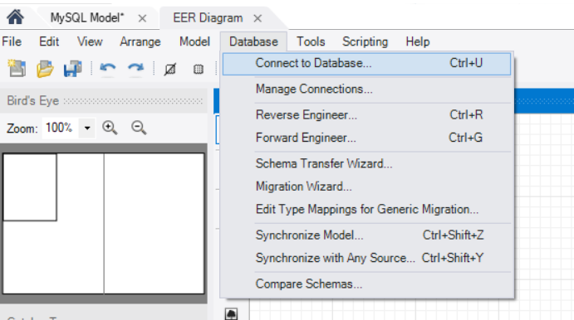
- Left toolbar displays different items that can be used to draw model.
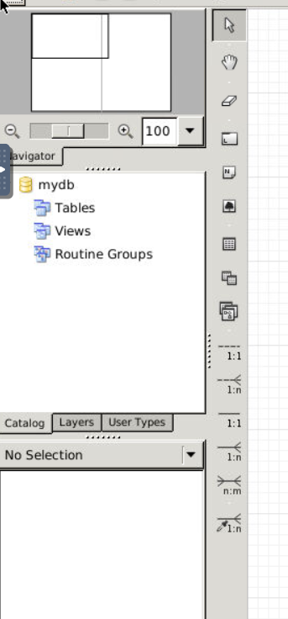

- Click place table and place three tables.
- Double click each table and rename them to car, customer, car_customer.
- In the three tables define the columns as follows
  - Car – idcar, model name, model year, price.
    - idcar (INT,PK, NN, UN, AI)
    - model_name (VARCHAR(45), NN)
    - model_year (INT, NN)
    - price (DECIMAL, NN)
  - Customer- customer id, name, phone, address
    - idcustomer (INT,PK, NN, UN, AI)
    - name (VARCHAR(45), NN)
    - phone (INT, NN)
    - address (VARCAHAR(400), NN)
The table below creates the relation between above two tables.
- Click 1:N and then click the car_customer table and then car table.
- Click 1:N and then click the car_customer table and then customer table.
(See below on the image for 1:N button)
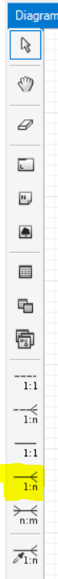
  - Car Customer – car customer id, car id, customer id, date car bought.
    - car_customer_id (INT,PK, NN, UN, AI)
    - rename the id created from car table to idcar
    - rename the id created from car table to idcustomer
    - date_purchased (DATE, NN)
- After you have your table created. Save the model and name it as FirstName_LastName_Lab03.mwb
- Export it as FirstName_LastName_Lab03.png
- Your lab is to be submitted with FirstName_LastName_Lab03.mwb and FirstName_LastName_Lab03.png
(example: Vishal_Arora_Lab03)

Lab Grading Rubric (3%)

Lab Submission (correct file names) | /1
Correct column names | /1
Correct relation and solution | /1
Total Points | /3
Comments

