Assignment #3
This assignment relates to the following Course Learning Requirements:
CLR 1: Define, analyze, and document the logic of a solution to a given problem.
CLR 2: Implement the solution to a given problem by writing the appropriate code in a high-level language (Java).
CLR 4: Install and use the Java Development, Runtime Environment, and documentation libraries.
CLR 7: Create documentation and a Java solution for programming problems that adhere to the submission standard identified within the timeframe given in the problem description.

Objective of this Assignment:
The objective of this assignment is to write a Java application to calculate the shipping costs of two packages using the cost formula and output a comparison of the two costs.

Pre-Assignment Instructions:

- To prepare you for this assignment, read the module 3 content and follow the embedded learning activities.
- Access this assignment in Brightspace. You may complete the assignment locally on your machine in a plain text editor.

Assignment Steps:
- Create a Java class named Package.
- Package should have three private instance variables of type double named length, width, and height.
- Package should have one private instance variable of type Scanner named input, initialized to System.in.
- No-args (explicit default) public constructor which initializes all three double instance variables to 1.0.
- Initial (parameterized) public constructor which defines three parameters of type double, named length, width, and height, which are used to initialize the instance variables of same name.
- Public copy constructor, with a parameter of type Package, used to duplicate an existing Package object.
- Three public void methods named inputLength, inputWidth, and inputHeight. Each method will prompt the user for the appropriate property, and input a double value using the Scanner object input to initialize the instance variable.
- A public void method named displayDimensions which prints the dimensions as length X width X height (each value separated by a “ X “).
- A public method of type double named calcVolume that calculates the volume and returns the result as a double value.
- Create a class named Shipment.
- The program must ask for two packages to ship.
- The program must calculate the cost difference using the difference in volume,
i.e. The base price for a package with volume <=1 is $3, for every unit increase in volume ,the cost increase is $1
eg1: a parcel with volume 4, the cost is $3+ $1 +$1 +$1 = $6
eg2: a parcel with volume 2.5, the cost is $3 + $1.5 = $4.5
- Give the following (in order of priority):
- If there is no difference, display the costs are the same
- If the cost of one is less than twice the other, display that it is “slightly more than”
- If the cost of one is less than three times the other, display that it is “twice”
- If the cost of one is less than four times the other, display that it is “triple”
- If the cost of one is less than five times the other, display that it is “quadruple”
- otherwise, display that it is the calculated multiple
- The program must indicate the costlier Package (if not same cost) and by how much
- The program must calculate and display the appropriate message (including proper dimension and cost format)
- Your code also does NOT (YET) need to worry if the user inputs an invalid value for the input (example: invalid length). We will implement this in a future assignment.
- The output of your code must match the samples.
- You must change the title i.e. Welcome to John Doe’s shipping calculator!

- UML Class Diagram (for reference)
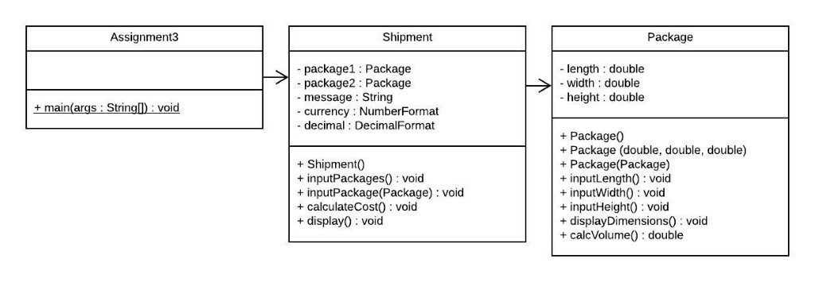

- Sample Output
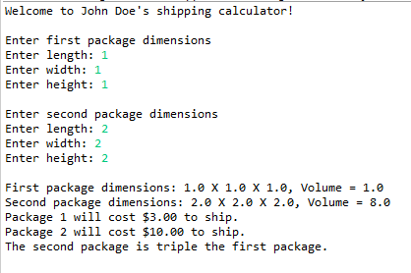
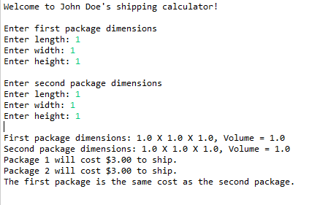
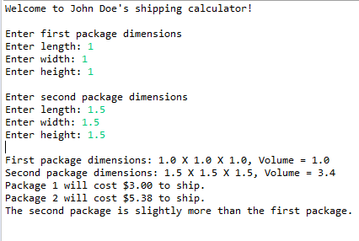

- Your assignment is to be submitted on Brightspace as Java files. It should be submitted with the following guidelines:
- Include the file header using the template provided in every java file submitted.
- Follow expected style guidelines:
- Use “Egyptian” style braces for all classes and methods.
- Indent your code using 4 spaces (no tabs).
- Follow naming conventions for all class, variable, and method identifiers.
- Use appropriate whitespace for readability.
- Comment your code (no less than one comment per class, and one per method).
- Files must be named Package.java and Shipment.java. Your main function can be in Shipment.java file or in third file called Assignment3.java(preferably within Shipment.java).
- Method names must match those in the requirements above, exactly.

