Assignment #1 – Ubuntu Linux Installation [3%]
This assignment relates to the following Course Learning Requirements:
CLR 1: Install operating systems and applications
CLR 3: Work with GUI and command-line interfaces

Objective of this Assignment:
The objective of this assignment is to install Ubuntu 20.04.1 LTS on a VMWare virtual machine.

Pre-Assignment Instructions:
- It is important to follow these assignments tasks as this will ensure the successful completion and downloading required for this course and other assignments.
Assignment Tasks:
- Download Ubuntu 20.04.1 LTS (1.9GB)
https://ubuntu.com/download/desktop
- Follow these instructions to install Ubuntu on a new Virtual machine:
  - Launch VMWare workstation that was previously installed.
  - Select - Create a new virtual machine. The following prompt will appear:

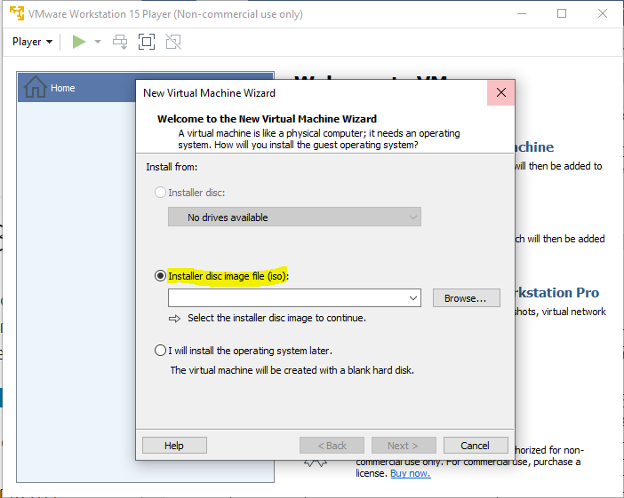

  - Select option: Installer disc image file (iso) and browse to the location of the downloaded iso file. Select the iso file that was downloaded in Step 1.

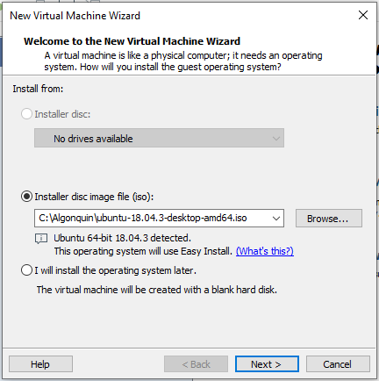
  - Click next and enter the user credentials.
  - Enter you User name (it must be lowercase!)
  - Enter your password twice. Do not forget your password!

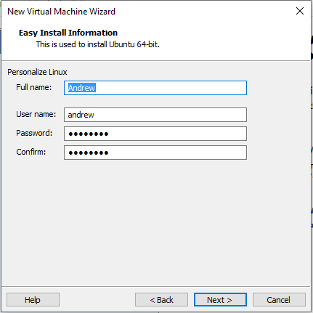
  - Click Next

  - Choose a new folder on your disk (The Virtual machine manager will create many files).
  - For example, C:\Algonquin or C:\UbuntuVM
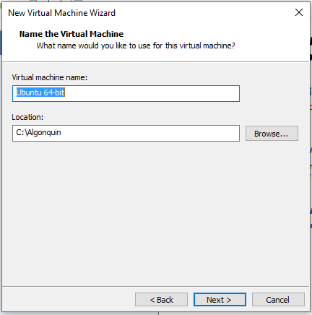

  - Click Next

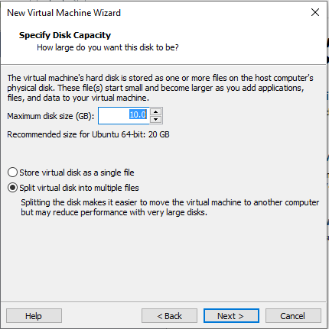

  - Click Next

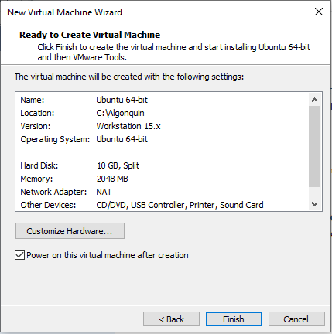

  - Click Finish. (The installer will run on its own)

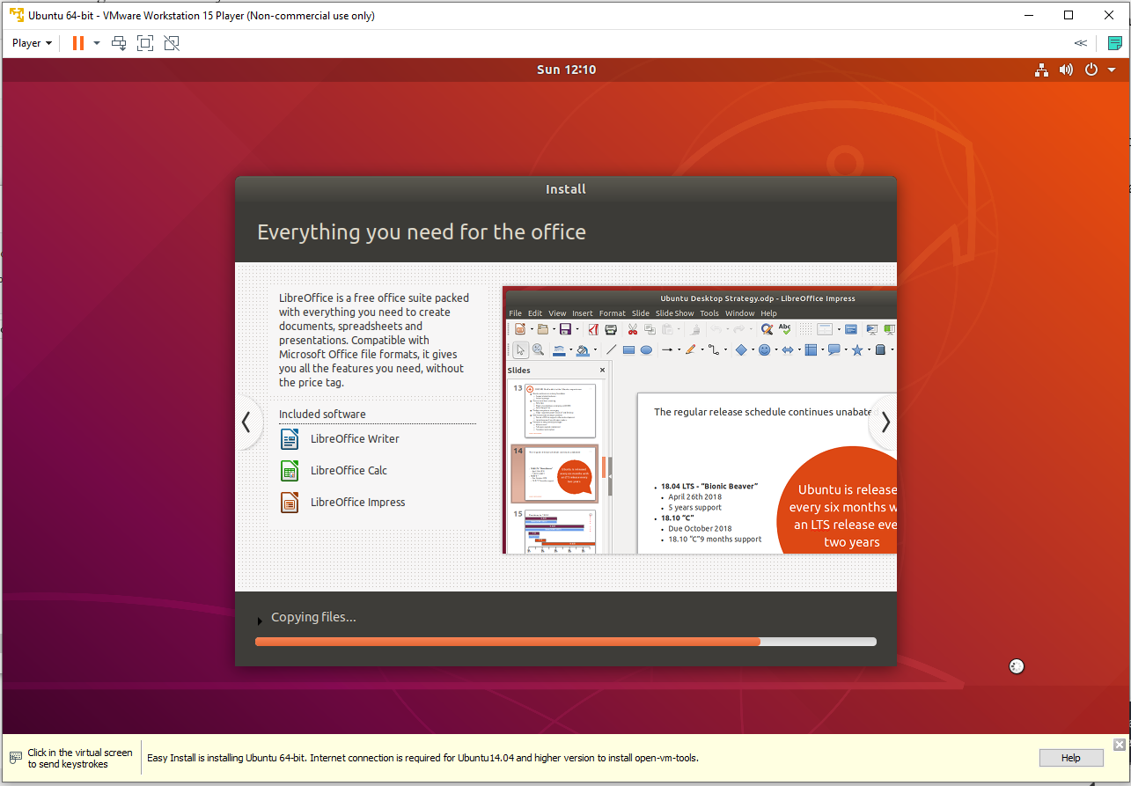

- Once completed, the system will reboot and you will be greeted with a login screen. Select the account name you supplied in the VMWare workstation window.

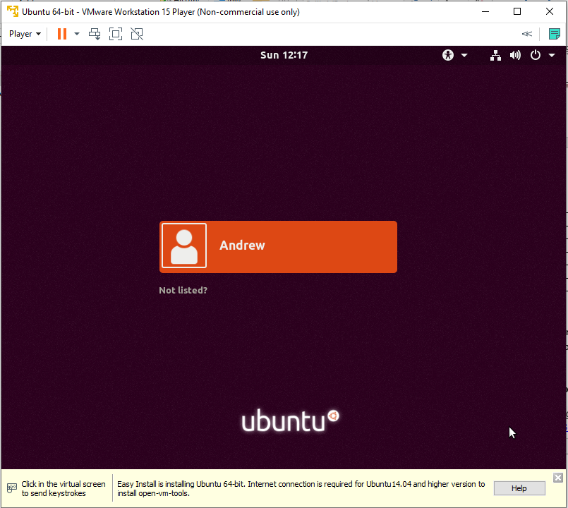

  - Double-click to log in and enter the password you supplied to the VMWare workstation.

- You’re done installing Ubuntu OS!

- Next, we will open the Linux Terminal
  - Click on the Applications icon in the bottom-left corner.
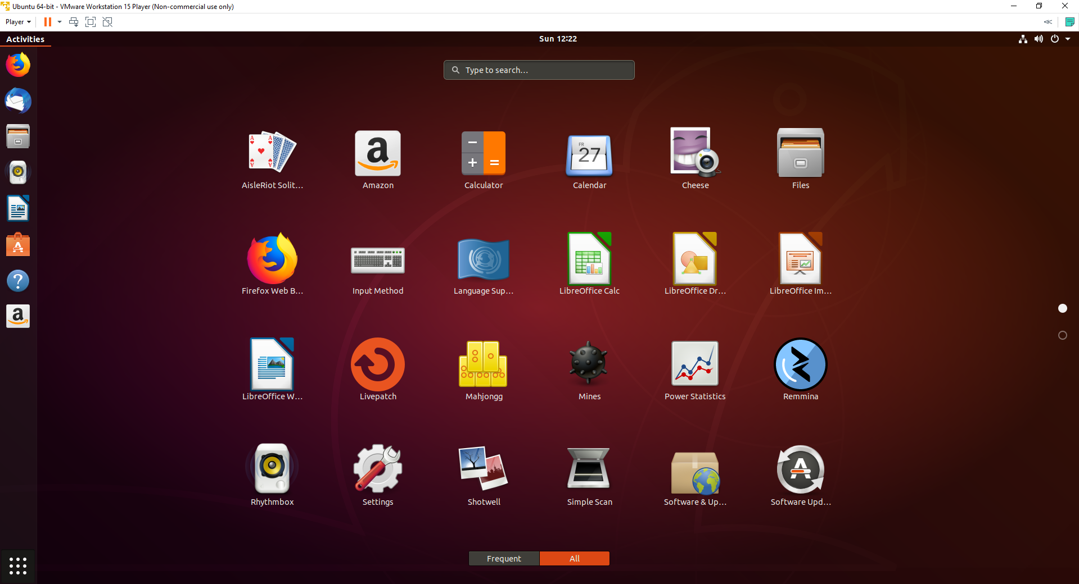

  - Scroll down and double-click on the Terminal icon to open the Terminal window.

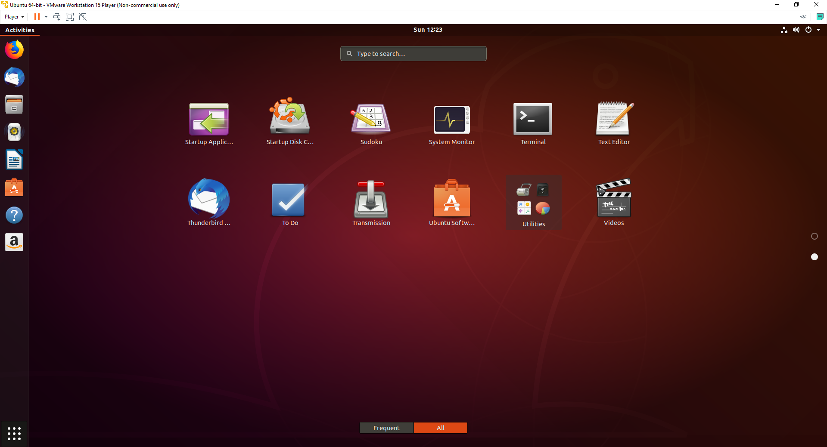

  - terminal window will open and will be ready to receive commands. We will use the terminal window throughout the course so pinning it to the menu bar on the left would be very convenient.
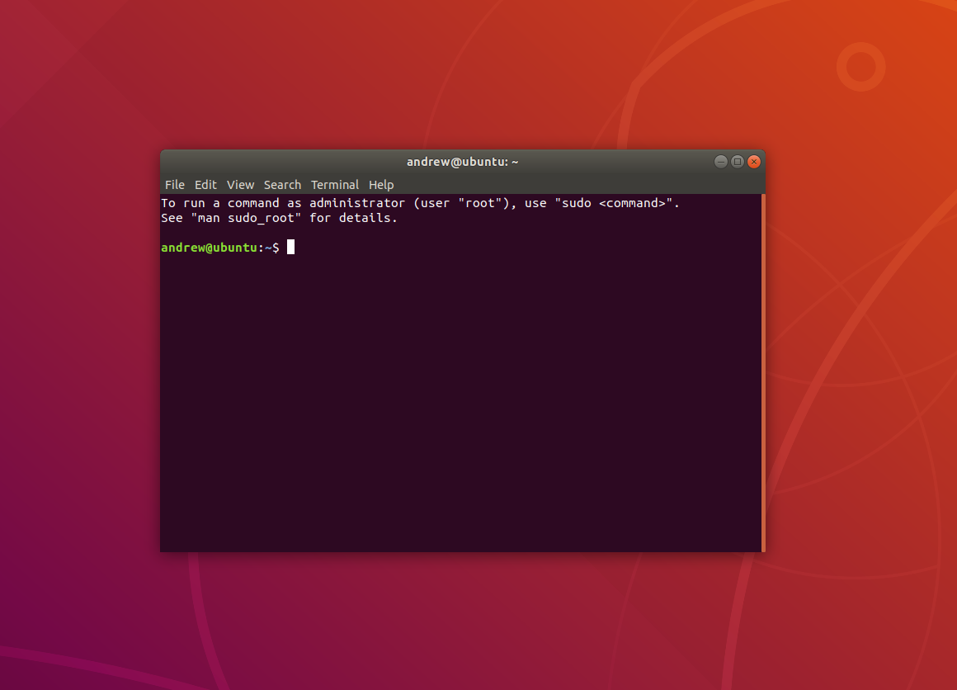

- Set root user password with the command in terminal windows (Press <Enter> to execute the command):
You will be prompted to enter the root password. Don’t forget this password either! It may be best to store it somewhere safe.
  - sudo passwd root

- Install vim (the Linux editor to be used in future labs) with the following command:

- sudo apt-get install vim
- Once completed, type “clear” in the terminal window and type your student ID. Take a screen shot of the VMWare Workstation and upload it to Brightspace.

