Lab 4b

Ubuntu Version
I have installed Ubuntu 18.04.4, Bionic Beaver.

Problems/Issues
No problems, but slight confusion when the prompt for keyboard layout came at the beginning of the Ubuntu install instead of near the end like I expected based on the assignment instructions. That is probably due to me using 18.04.4 rather than 16.04.6.

Screenshot A: Showing that I enabled CPU virtualization

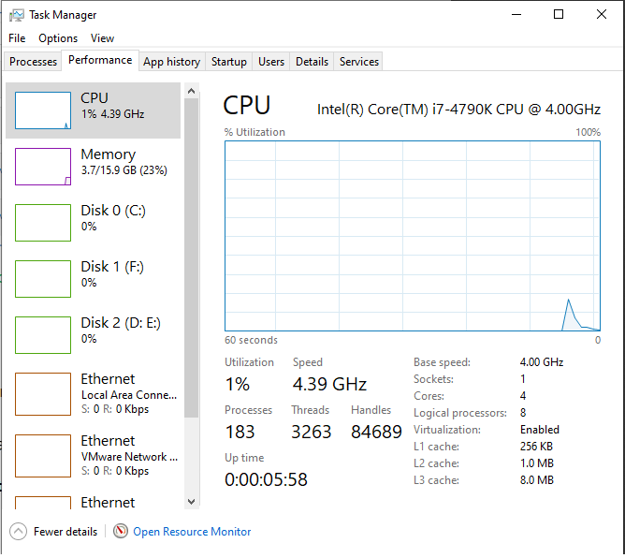

Screenshot B: Showing that I created a restore point

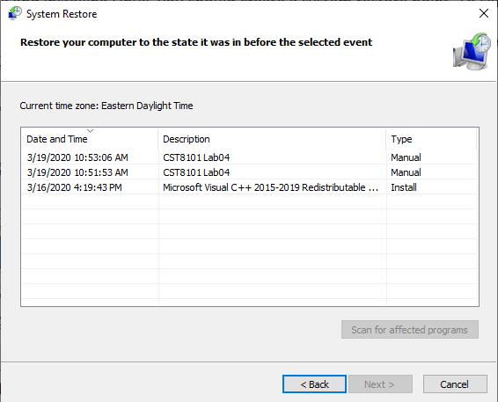

Screenshot C: Showing my system’s information
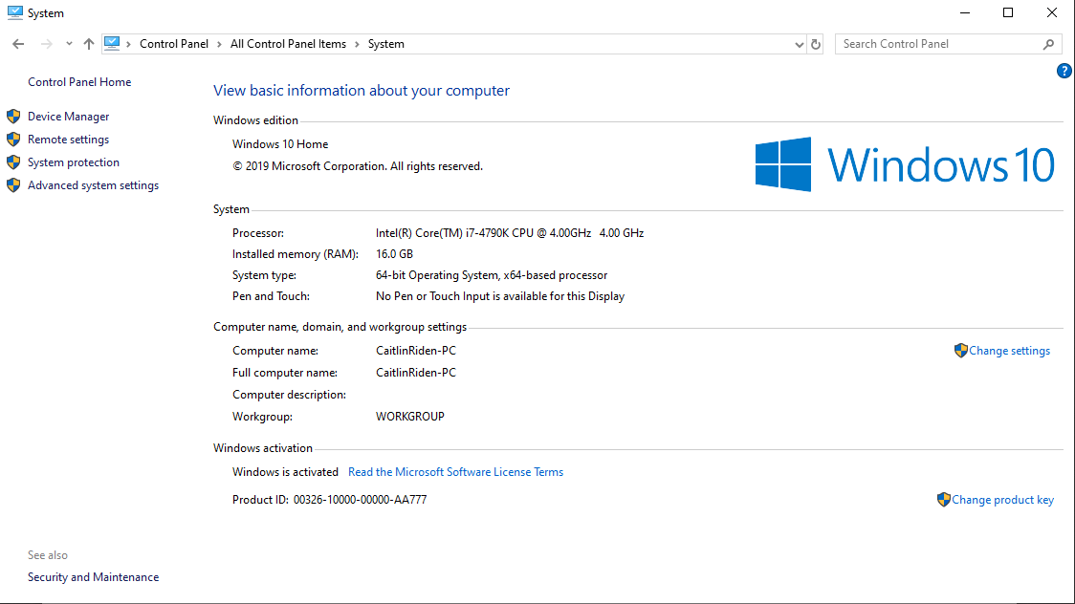

Screenshot D: Showing which OS will be installed on the VM

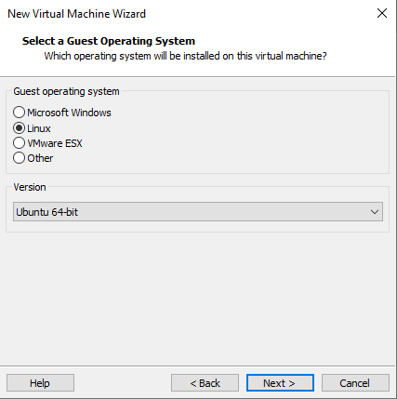

Screenshot E: Showing the memory allocated for the VM

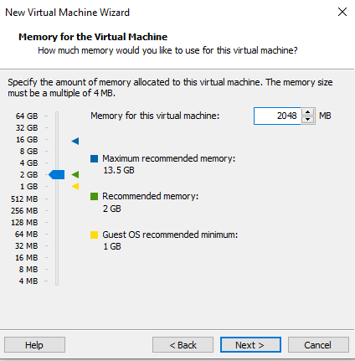

Screenshot F: Showing that a new virtual disk will be created

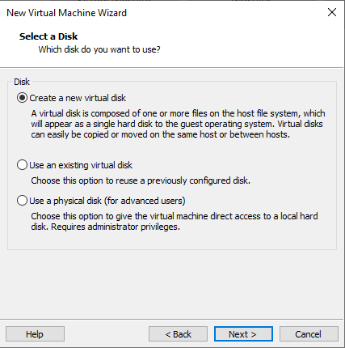

Screenshot G: Showing the verification screen of the VM

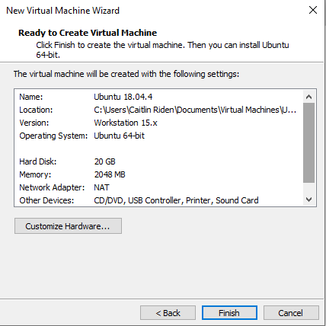

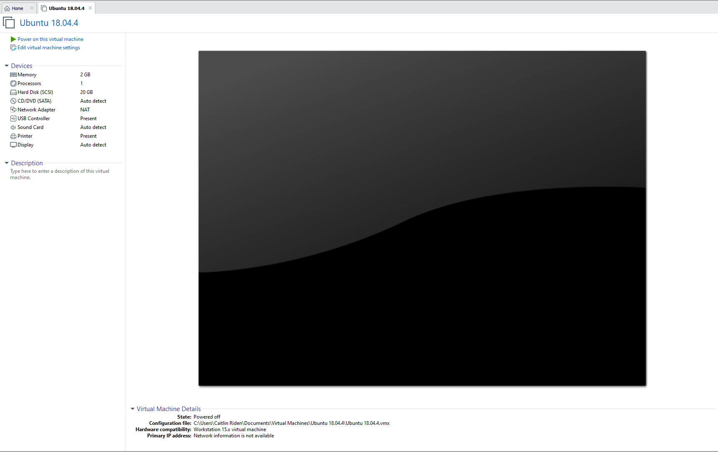
Screenshot H: Showing the summary page of the VM

Screenshot I: Showing the .iso file to be installed as the VM’s OS

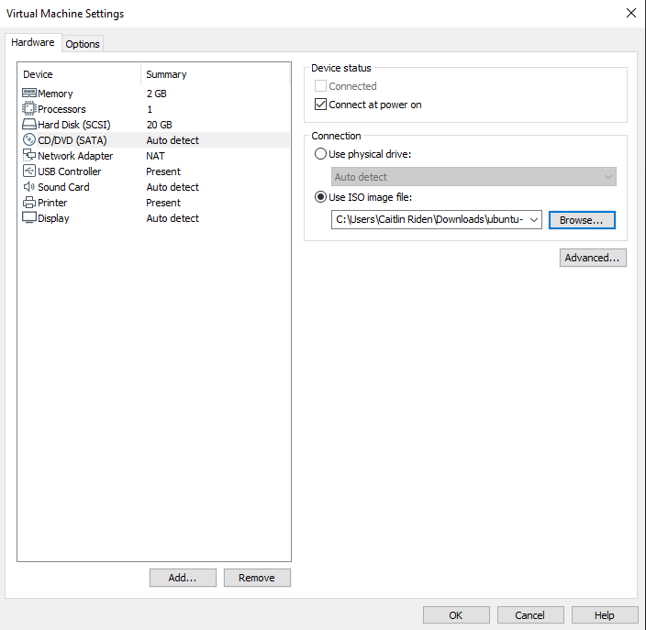

Screenshot J: Showing the creation of a user profile for the VM

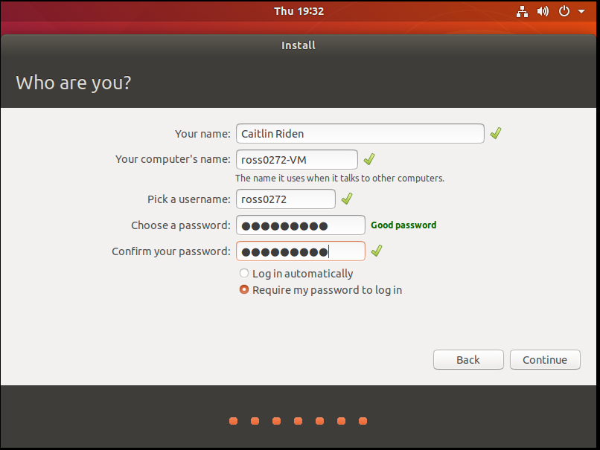

Screenshots K: Showing the VM before and after login
