Lab 4a

- Please confirm which version of VMWare Workstation have you installed.
I have VMWare Workstation 15.5 Pro installed.
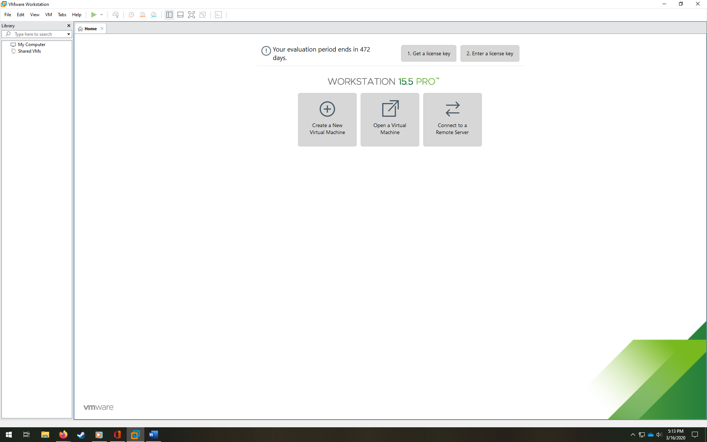
- Take a screen shot of Step 30 (entire screen) and submit in the document.

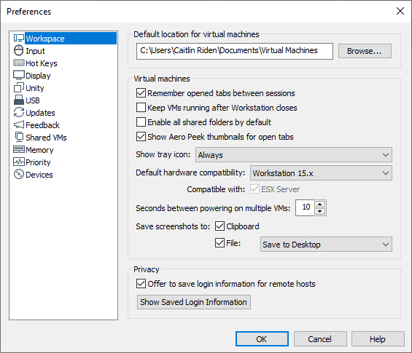
- Select ‘Edit’drop down menu and choose preferences. Just take a screen shot and submit.

- Mention your experience to install VMWare Workstation 15. Mention if there were any difficulty and how did you solve it.
I found the process fairly simple, although the number of restarts required was slightly annoying. Luckily, when I switched machines earlier in the term (I am now using a more powerful gaming desktop which was a wedding gift from my husband’s friends, since my husband needed the machine I was using for his projects) I had the forethought to back up the installation file on my external hard drive, so I didn’t have to re-download the setup wizard. I remember it being a particularly large file for our rural wireless internet.

