CST8101: Lab 2 (4%)
This assignment relates to the following Course Learning Requirements:
CLR 3: Understand the importance of backups and file retention both for the PC/laptop and for the
company/organization. Perform basic backups on alternate media and using online resources.

Objective of this Assignment:
To Implement and test a backup system.

Pre-Assignment Instructions:

Access the Control Panel by right-clicking on the Start button in the bottom left-hand corner and selecting Control Panel from the menu. You may also type "Control Panel" into the search box and select Control Panel from the results.
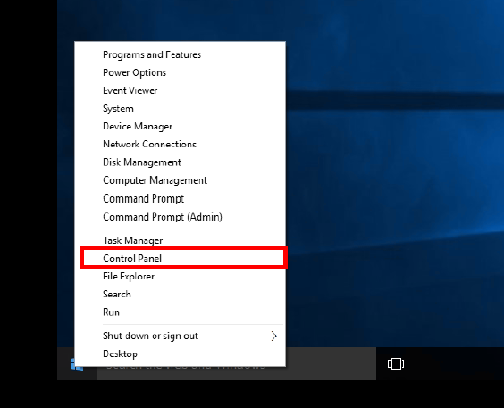

Click Backup and Restore (Windows 7).
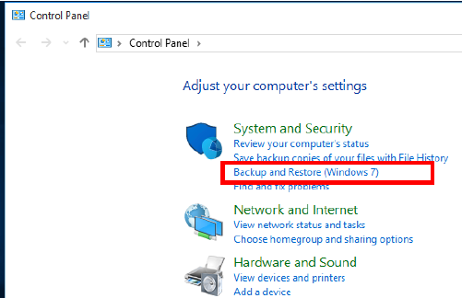

Click Set up backup and wait for Windows Backup to start.
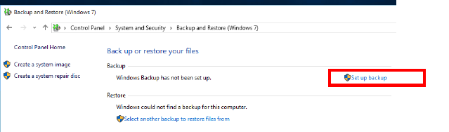
Select a destination for your backups

Next, select the Let Me Choose radio button so that you can specify exactly what you want to backup.

Check any folder that you would like to backup.
Ensure that you choose any folders in your C:drive that you would also like to backup (ie. your school projects, work files, resume, tax files, etc).
Do not include a system image of your system as this will take a considerable amount of time and space. A system image can be created and stored separately.
Ensure that you DO NOT backup your virtual machine storage area. If you do, your backup drive will quickly run out of space.

Create a schedule for when you wish your backups to take place. Make sure that the backup schedule occurs when the PC will be turned on and when the destination drive will be connected.

The first full backup will occur when you have completed all of the steps. This process may take some time so ensure that you can wait until the process completes before having to move your laptop.

When the backup completes successfully, answer the following questions in Microsoft Word.
Assignment Tasks:
What type of Backup Solution does Windows 10 implement? (Full, Differential, Incremental)
Where did you find this information?
When will Windows 10 perform a full back up? When will it do interim backups?
What is the output file type for your backup?
Can you view the backup files on Disk? Do you receive a warning message?
Why would you want to restrict access to backup files?
How do you restore files using the windows 10 backup system?
If no data loss has occurred; why might you want to restore a copy of your backup?
Restore a copy of your backup to a folder called Restored Files on a hard drive. This does not have to be done on your source disk. Make absolutely sure that you restore your backup to the Restored Files directory so that you do not accidentally overwrite the files in your source directory.
Take a screen grab of a File Explorer window showing the contents of the Restored Files directory and append it to the bottom of your word document.
When you have completed the lab upload your answer file to the submission link. Ensure that your answers are accurate and in your own words. Ensure that your answer file is in docx format.

