CST2355 Assignment 5
Data Warehouses & Business Intelligence
Caitlin Ross
# 040750891

Contents
System Diagram 2
Data Model 2
Database Design: Database 3
Database Design: Data Warehouse 5
Database Design: Business Intelligence 5

System Diagram

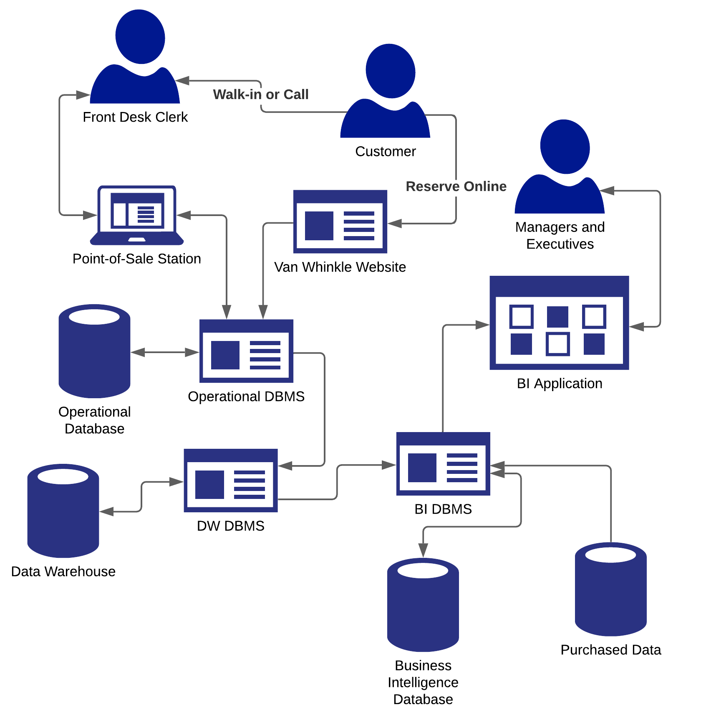

Used Azure Enterprise shapes on LucidChart

Data Model

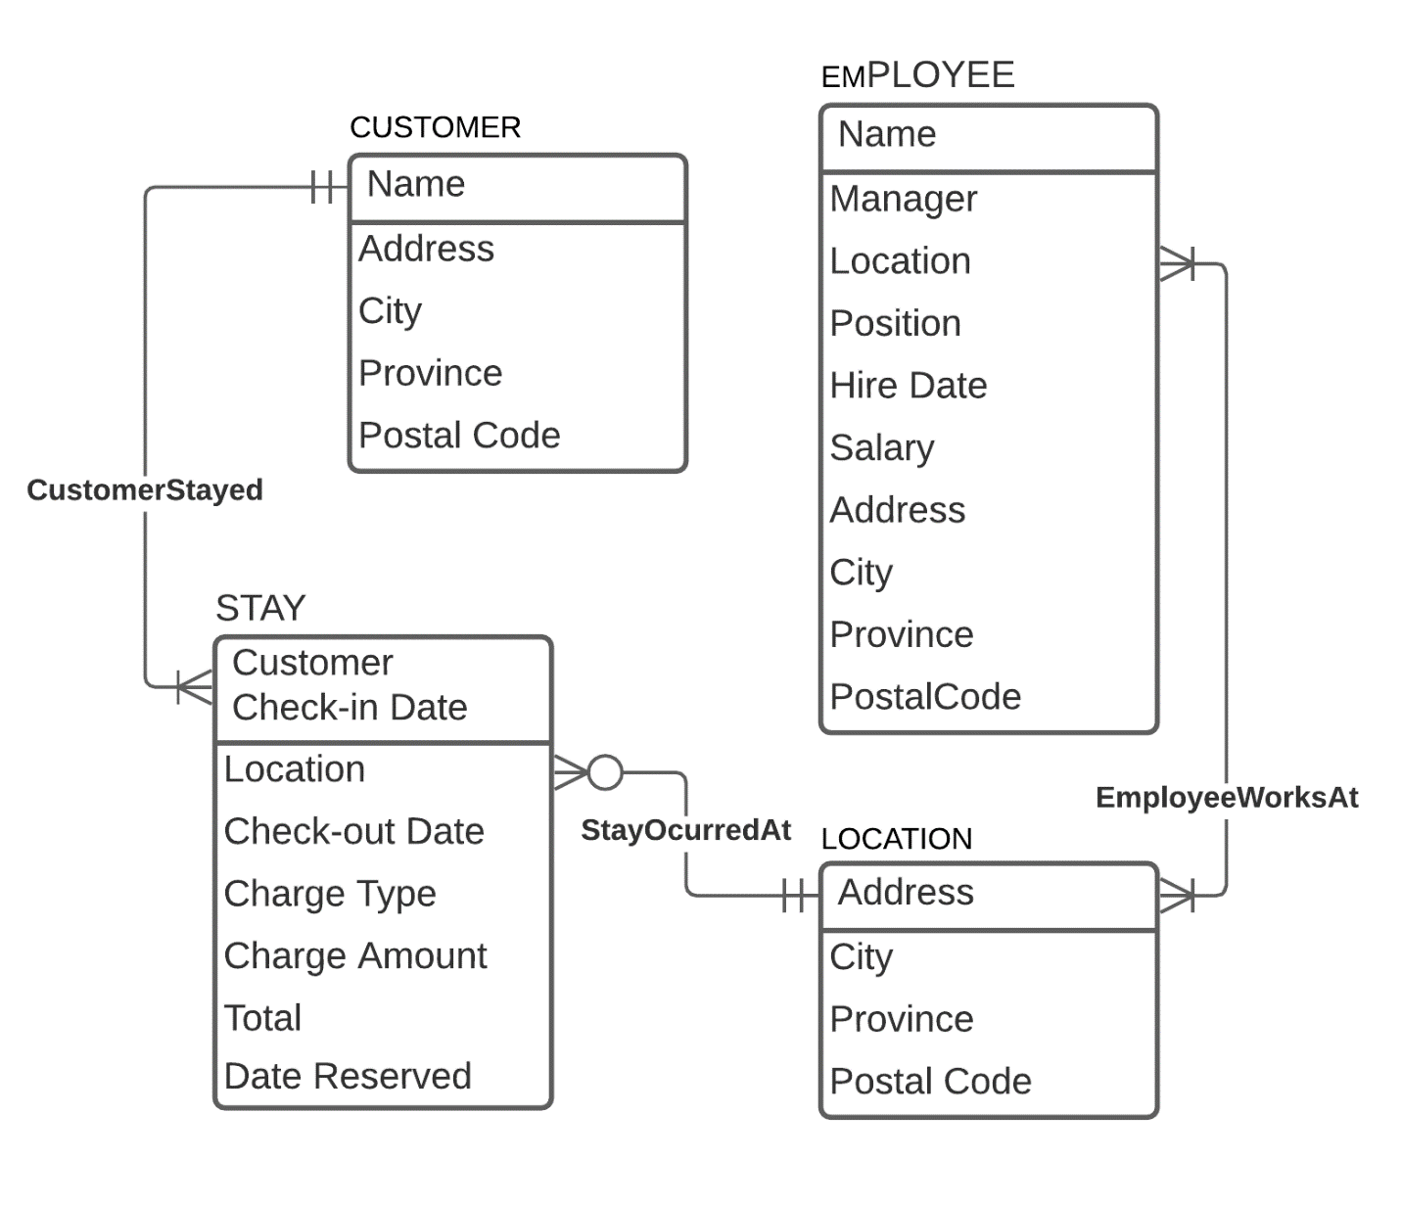
Added LOCATION entity to connect EMPLOYEE entity to rest of database, and because Van Whinkle plans on buying more locations.

Database Design: Operational Database

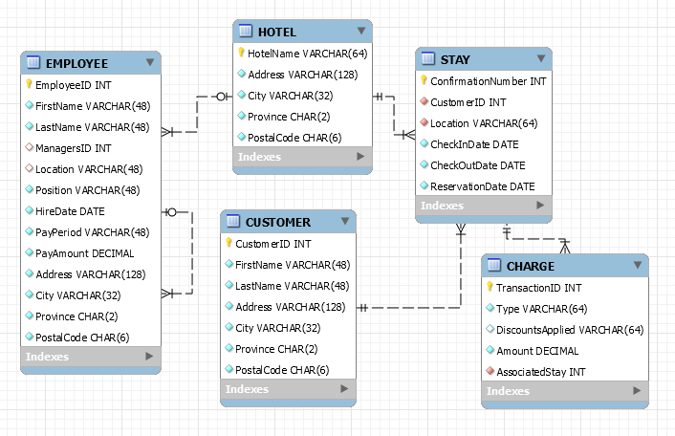

Database Design: Data Warehouse

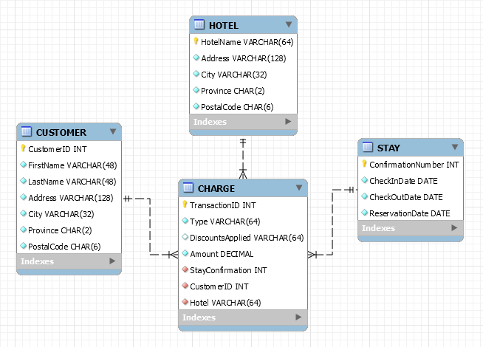

Measure(s):
- CHARGE.Amount
Dimension(s):
- CHARGE.AssociatedStay
- CHARGE.CustomerID
- CHARGE.Location
- CHARGE.Type
- CHARGE.DiscountsApplied

Dimension Descriptor(s):
- CUSTOMER.FirstName
- CUSTOMER.LastName
- CUSTOMER.Address
- CUSTOMER.City
- CUSTOMER.Province
- CUSTOMER.PostalCode
- HOTEL.Address
- HOTEL.City
- HOTEL.Province
- HOTEL.PostalCode
- STAY.CheckInDate
- STAY.CheckOutDate
- STAY.ReservationDate

Database Design: Business Intelligence

