Caitlin Ross #040750891
ross0272@algonquinlive.com
Assignment #2: Data Modeling and Design
CST2355 Database Systems
Section 451

Contents
Data Model 3
Transformation Decisions 4
Table Characteristics 5
EMPLOYEE Table 5
EMPLOYEE_SKILL Table 5
CUSTOMER Table 5
ADDRESS Table 6
PURCHASE Table 6
PRODUCT Table 6
Report Queries 7
Employee Salary Report 7
Employee is Customer Report 8
Latest Year Monthly Purchases Report 9
Competency Tracking Report 10
Microsoft SQL Server Database Design 11
Database Design Diagram 11
Tables and Data 12
EMPLOYEE Table 12
EMPLOYEE_SKILL Table 13
CUSTOMER Table 13
ADDRESS Table 14
PRODUCT Table 15
PURCHASE Table 16
Oracle Database Design 17
Database Design Diagram 17
Tables and Data 18
EMPLOYEE Table 18
EMPLOYEE_SKILL Table 19
CUSTOMER Table 20
ADDRESS Table 21
PRODUCT Table 22
PURCHASE Table 23
MySQL Database Design 24
Database Design Diagram 24
Tables and Data 25
EMPLOYEE Table 25
EMPLOYEE_SKILL Table 26
CUSTOMER Table 26
ADDRESS Table 27
PRODUCT Table 28
PURCHASE Table 29
Appendix 1: Misc. Assumptions and Notes 30
Data Cleanup and Analysis 30
Creating and Populating Databases 30
Other 30

Data Model

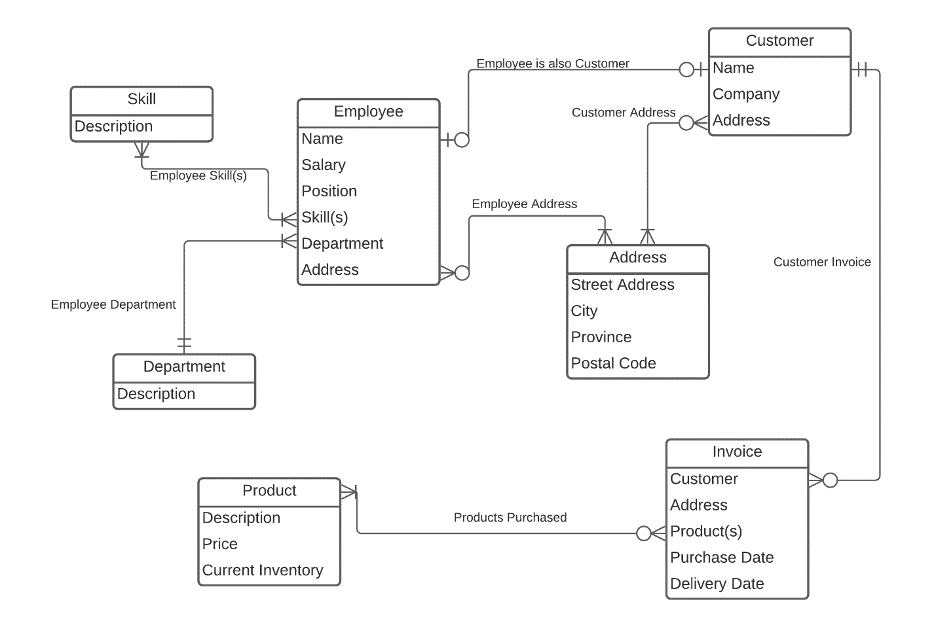
- Note: I chose not to use identifiers in the data model in order to keep it conceptual. Identifiers will be chosen or created later when creating the database design.
- Assumption: Similar to other e-commerce websites, I assumed that customers (and employees) could have multiple address and multiple invoices. I also assumed that a customer could be created before purchasing anything. These would have to be validated by the business requirements.
- Assumption: While employees can have many skills, I assumed they must have at least one in order to be hired. I also assumed that the business would not need to track skills that no employees have. Similarly, I assumed that all departments must have at least one employee, but employees can only belong to one department. These assumptions would have to be validated by the business requirements.

Transformation Decisions

Entity/Relationship | Table/Relationship | Explanation
Employee | Employee | Add EmployeeID as surrogate key
Customer | Customer | Add CustomerID as surrogate key
Address | Address | Add AddressID as surrogate key
Invoice | None | Invoices don’t seem to be relevant to this business, simplify to just Products Purchased
Product | Product | Add SKU as surrogate key
Skill | EmployeeSkill | Simplify from entity AND relation to just the relation
Department | Employee | Add to Employee table as a field, use constraints to prevent update anomalies
Employee is also Customer | None | Find Name + Address matches, no relation needed
Employee Skill(s) | EmployeeSkill | Use name of skill as identifier, use constraints to prevent update anomalies
Employee Department | Employee | Add to Employee table as a field, use constraints to prevent update anomalies
Employee Address | None | Use AddressID in Employee table
Customer Address | None | Use AddressID in Customer table
Provincial Tax Rate | None | No relation needed, province can be PK in Tax table and FK in Address table
Customer Invoice | None | Not needed without Invoice entity
Products Purchased | Purchase | Encompasses the Invoice entity as well, address not needed here

Table Characteristics

EMPLOYEE Table
Column | Key | NULL? | Default | Oracle Data Type | SQL Server Data Type | MySQL Data Type
EmployeeID | PK | No | Auto Increment | NUMBER (12,0) | SmallInt | SMALLINT (4)
FirstName |  | No |  | VARCHAR2 (50) | Varchar (50) | VARCHAR (50)
LastName |  | No |  | VARCHAR2 (50) | Varchar (50) | VARCHAR (50)
Salary |  | No | 0.00 | NUMBER (12,2) | Small Money | DECIMAL (8,2)
Position |  | No |  | VARCHAR2 (50) | Varchar (50) | VARCHAR (50)
Department |  | No |  | VARCHAR2 (50) | Varchar (50) | VARCHAR (50)
AddressID | FK | No |  | NUMBER (12,0) | SmallInt | SMALLINT (4)

EMPLOYEE_SKILL Table
Column | Key | NULL? | Default | Oracle Data Type | SQL Server Data Type | MySQL Data Type
EmployeeID | FK | No | Auto Increment | NUMBER (12,0) | SmallInt | SMALLINT (4)
Skill |  | No |  | VARCHAR2 (50) | Varchar (50) | VARCHAR (50)

CUSTOMER Table
Column | Key | NULL? | Default | Oracle Data Type | SQL Server Data Type | MySQL Data Type
CustomerID | PK | No | Auto Increment | NUMBER (12,0) | SmallInt | SMALLINT (4)
FirstName |  | No |  | VARCHAR2 (50) | Varchar (50) | VARCHAR (50)
LastName |  | No |  | VARCHAR2 (50) | Varchar (50) | VARCHAR (50)
Company |  | Yes |  | VARCHAR2 (128) | Varchar (128) | VARCHAR (128)
AddressID | FK | No |  | NUMBER (12,0) | SmallInt | SMALLINT (4)

ADDRESS Table
Column | Key | NULL? | Default | Oracle Data Type | SQLServer Data Type | MySQL Data Type
AddressID | PK | No | Auto Increment | NUMBER (12,0) | SmallInt | SMALLINT (4)
StreetAddress |  | No |  | VARCHAR2 (128) | Varchar (128) | VARCHAR (128)
City |  | No |  | VARCHAR2 (50) | Varchar (50) | VARCHAR (50)
Province | FK | No |  | CHAR (2) | Char (2) | CHAR (2)
PostalCode |  | No |  | CHAR (6) | Char (6) | CHAR (6)

PURCHASE Table
Column | Key | NULL? | Default | Oracle Data Type | SQL Server Data Type | MySQL Data Type
CustomerID | FK | No |  | NUMBER (12,0) | SmallInt | SMALLINT (4)
SKU | FK | No |  | NUMBER (12,0) | SmallInt | SMALLINT (5)
PurchaseDate |  | No |  | DATE | Date | DATE
DeliveryDate |  | Yes |  | DATE | Date | DATE

PRODUCT Table
Column | Key | NULL? | Default | Oracle Data Type | SQL Server Data Type | MySQL Data Type
SKU | PK | No | Auto Increment | NUMBER (12,0) | SmallInt | SMALLINT (5)
Name |  | No | ‘Unknown” | VARCHAR2 (50) | Varchar (50) | VARCHAR (50)
Price |  | No | 0.00 | NUMBER (12,2) | Small Money | DECIMAL (6,2)
CurrentInventory |  | No | 0 | NUMBER (12,0) | SmallInt | SMALLINT (3)

Report Queries

Employee Salary Report
ANSI SQL Statement
SELECT
CONCAT_WS(‘ ‘, EMPLOYEE.FirstName, EMPLOYEE.LastName)
AS FullName,
CONCAT('$', FORMAT(EMPLOYEE.Salary, 2))
AS Salary,
CONCAT('$', FORMAT((DAYOFYEAR(CURDATE())/365) * EMPLOYEE.Salary, 2))
AS YTDEarnings,
CONCAT('$', FORMAT((DAYOFYEAR(CURDATE())/365) * EMPLOYEE.Salary*a.TaxRate, 2))
AS YTDTaxDeducted,
CONCAT_WS(‘, ‘, a.StreetAddress, a.City, a.Province, a.PostalCode)
AS FullAddress,
EMPLOYEE.Department
FROM EMPLOYEE
INNER JOIN
(SELECT
ADDRESS.AddressID,
ADDRESS.StreetAddress,
ADDRESS.City,
ADDRESS.Province,
ADDRESS.PostalCode,
TAX.TaxRate
FROM ADDRESS
INNER JOIN TAX
ON ADDRESS.Province = TAX.Province
) a
ON EMPLOYEE.AddressID = a.AddressID;
MySQL Differences
- None
Oracle Differences
- Lines 13, 22, 23: Add ASSIGN_2. before all table names
- Line 2: Use concatenation operator instead of CONCAT_WS function: EMPLOYEE.FirstName||' '||EMPLOYEE.LastName
- Line 4: Use TO_CHAR instead of CONCAT and FORMAT functions: TO_CHAR(EMPLOYEE.Salary, '$9,999,999.99')
- Line 6: Same changes as Line 4. Also, use SYSDATE and TRUNC functions to prorate the salaray: TO_CHAR((SYSDATE-(TRUNC(SYSDATE, 'YYYY')))/365*EMPLOYEE.Salary, '$9,999,999.99')
- Line 8: Same changes as Line 6: TO_CHAR((SYSDATE-(TRUNC(SYSDATE, 'YYYY')))/365*EMPLOYEE.Salary*a.TaxRate, '$9,999,999.99')
- Line 10: Same changes as Line 2: a.StreetAddress||', '||a.City||' '||a.Province||', '||a.PostalCode
SQL Server Differences
- Line 4: Drop the CONCAT function and just use the FORMAT function for currency: FORMAT(EMPLOYEE.Salary, 'C', 'en-us')
- Line 6: Same changes as line 4. Also, use GETDATE, YEAR and DATEFROMPARTS functions to get the first day of the current year, use DATEDIFF to return the number of days since Jan 1st, then use in the equation to prorate the salary: ((DATEDIFF(day, DATEFROMPARTS(YEAR(GETDATE()), 1, 1), GETDATE())/365)*EMPLOYEE.Salary, 'C', 'en-us')
- Line 8: Same changes as Line 6: FORMAT((DATEDIFF(day, DATEFROMPARTS(YEAR(GETDATE()), 1, 1), GETDATE())/365)*EMPLOYEE.Salary*a.TaxRate, 'C', 'en-us')
- Note: Values in YTDEarnings and YTDTaxDeducted columns are returning $0.00 in SQL Server, probably a casting or order of operations error

Employee is Customer Report
ANSI SQL Statement
SELECT
emp.FullName,
custpurch.Name AS Product,
custpurch.Price,
COUNT(custpurch.Name) AS NumberPurchased
FROM
(SELECT
CUSTOMER.CustomerID,
CUSTOMER.AddressID,
prod.Name,
prod.Price,
prod.SKU
FROM
(SELECT
PRODUCT.SKU,
PRODUCT.Name,
PRODUCT.Price,
PURCHASE.CustomerID
FROM PURCHASE
INNER JOIN PRODUCT
ON PURCHASE.SKU = PRODUCT.SKU
) prod
INNER JOIN CUSTOMER
ON prod.CustomerID = CUSTOMER.CustomerID
) custpurch
INNER JOIN
(SELECT
CONCAT_WS(' ', FirstName, LastName) AS FullName,
AddressID
FROM EMPLOYEE) emp
ON custpurch.AddressID = emp.AddressID
GROUP BY emp.FullName, custpurch.Name, custpurch.Price
ORDER BY emp.FullName;
MySQL Differences
- None
Oracle Differences
- Lines 8, 9, 15- 21, 23, 24, 30: Add ASSIGN_2. before all table names
- Line 28: Use concatenation operator instead of CONCAT_WS function: FirstName||' '||LastName
SQL Server Differences
- None

Latest Year Monthly Purchases Report
ANSI SQL Statement
SELECT
AllSales.Province,
AllSales.Name,
COUNT(JanSales.PurchaseDate) AS 'Jan Sales',
COUNT(FebSales.PurchaseDate) AS 'Feb Sales',
COUNT(MarSales.PurchaseDate) AS 'Mar Sales',
COUNT(AprSales.PurchaseDate) AS 'Apr Sales',
COUNT(MaySales.PurchaseDate) AS 'May Sales',
COUNT(JunSales.PurchaseDate) AS 'Jun Sales',
COUNT(JulSales.PurchaseDate) AS 'Jul Sales',
COUNT(AugSales.PurchaseDate) AS 'Aug Sales',
COUNT(SepSales.PurchaseDate) AS 'Sep Sales',
COUNT(OctSales.PurchaseDate) AS 'Oct Sales',
COUNT(NovSales.PurchaseDate) AS 'Nov Sales',
COUNT(DecSales.PurchaseDate) AS 'Dec Sales',
COUNT(AllSales.PurchaseDate) AS 'Total Sales'
FROM
(SELECT destination.Province, sales.Name, sales.PurchaseDate
FROM
(SELECT CUSTOMER.CustomerID, ADDRESS.Province
FROM CUSTOMER RIGHT JOIN ADDRESS
ON CUSTOMER.AddressID = ADDRESS.AddressID
) destination
JOIN
(SELECT PURCHASE.CustomerID, PRODUCT.Name, PURCHASE.PurchaseDate
FROM PRODUCT LEFT JOIN PURCHASE
ON PRODUCT.SKU = PURCHASE.SKU
) sales
ON destination.CustomerID = sales.CustomerID
) AllSales
LEFT JOIN
(SELECT PURCHASE.CustomerID, PURCHASE.PurchaseDate
FROM PURCHASE WHERE MONTH(PURCHASE.PurchaseDate)=1
) JanSales
ON AllSales.PurchaseDate = JanSales.PurchaseDate
LEFT JOIN
(SELECT PURCHASE.CustomerID, PURCHASE.PurchaseDate
FROM PURCHASE WHERE MONTH(PURCHASE.PurchaseDate)=2
) FebSales
ON AllSales.PurchaseDate = FebSales.PurchaseDate
LEFT JOIN
(SELECT PURCHASE.CustomerID, PURCHASE.PurchaseDate
FROM PURCHASE WHERE MONTH(PURCHASE.PurchaseDate)=3
) MarSales
ON AllSales.PurchaseDate = MarSales.PurchaseDate
LEFT JOIN
(SELECT PURCHASE.CustomerID, PURCHASE.PurchaseDate
FROM PURCHASE WHERE MONTH(PURCHASE.PurchaseDate)=4
) AprSales
ON AllSales.PurchaseDate = AprSales.PurchaseDate
LEFT JOIN
(SELECT PURCHASE.CustomerID, PURCHASE.PurchaseDate
FROM PURCHASE WHERE MONTH(PURCHASE.PurchaseDate)=5
) MaySales
ON AllSales.PurchaseDate = MaySales.PurchaseDate
LEFT JOIN
(SELECT PURCHASE.CustomerID, PURCHASE.PurchaseDate
FROM PURCHASE WHERE MONTH(PURCHASE.PurchaseDate)=6
) JunSales
ON AllSales.PurchaseDate = JunSales.PurchaseDate
LEFT JOIN
(SELECT PURCHASE.CustomerID, PURCHASE.PurchaseDate
FROM PURCHASE WHERE MONTH(PURCHASE.PurchaseDate)=7
) JulSales
ON AllSales.PurchaseDate = JulSales.PurchaseDate
LEFT JOIN
(SELECT PURCHASE.CustomerID, PURCHASE.PurchaseDate
FROM PURCHASE WHERE MONTH(PURCHASE.PurchaseDate)=8
) AugSales
ON AllSales.PurchaseDate = AugSales.PurchaseDate
LEFT JOIN
(SELECT PURCHASE.CustomerID, PURCHASE.PurchaseDate
FROM PURCHASE WHERE MONTH(PURCHASE.PurchaseDate)=9
) SepSales
ON AllSales.PurchaseDate = SepSales.PurchaseDate
LEFT JOIN
(SELECT PURCHASE.CustomerID, PURCHASE.PurchaseDate
FROM PURCHASE WHERE MONTH(PURCHASE.PurchaseDate)=10
) OctSales
ON AllSales.PurchaseDate = OctSales.PurchaseDate
LEFT JOIN
(SELECT PURCHASE.CustomerID, PURCHASE.PurchaseDate
FROM PURCHASE WHERE MONTH(PURCHASE.PurchaseDate)=11
) NovSales
ON AllSales.PurchaseDate = NovSales.PurchaseDate
LEFT JOIN
(SELECT PURCHASE.CustomerID, PURCHASE.PurchaseDate
FROM PURCHASE WHERE MONTH(PURCHASE.PurchaseDate)=12
) DecSales
ON AllSales.PurchaseDate = DecSales.PurchaseDate
WHERE YEAR(AllSales.PurchaseDate) = YEAR(CURDATE())
GROUP BY AllSales.Province, AllSales.Name
ORDER BY AllSales.Province, AllSales.Name;
MySQL Differences
- None
Oracle Differences
- Lines
SQL Server Differences
- Line 91: Use GETDATE function instead of CURDATE: WHERE YEAR(AllSales.PurchaseDate) = YEAR(GETDATE())

Competency Tracking Report
ANSI SQL Statement
SELECT
Skill,
COUNT(EmployeeID)
AS 'Number of Employees'
FROM EMPLOYEE_SKILL
GROUP BY Skill;
MySQL Differences
- None
Oracle Differences
- Line 4: Use double quotes instead of single for alias: AS “Number of Employees”
- Line 5: Add ASSIGN_2. before all table names: FROM ASSIGN_2.EMPLOYEE_SKILL
SQL Server Differences
- None

Microsoft SQL Server Database Design

Database Design Diagram

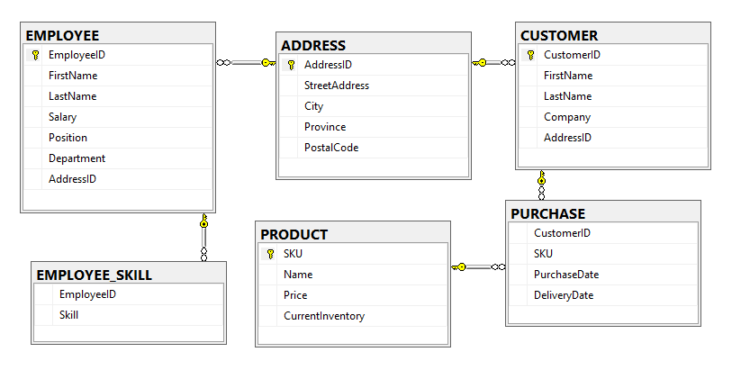

Tables and Data

EMPLOYEE Table
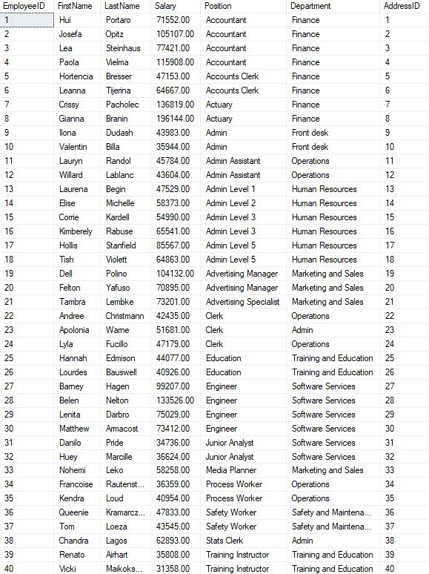

EMPLOYEE_SKILL Table
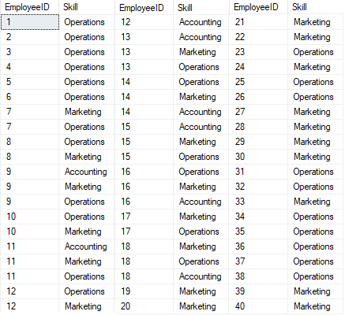

CUSTOMER Table
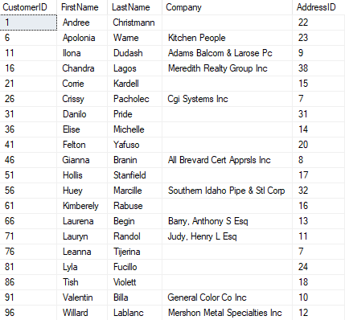

ADDRESS Table
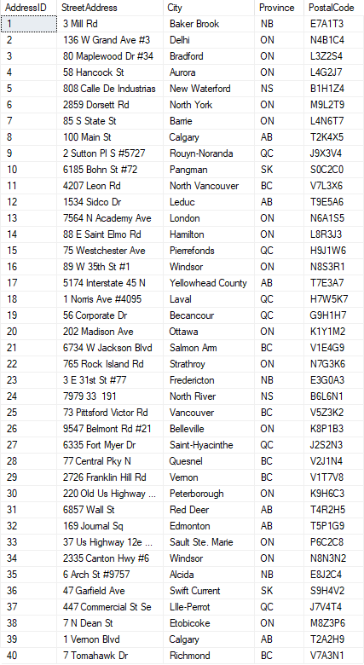

PRODUCT Table
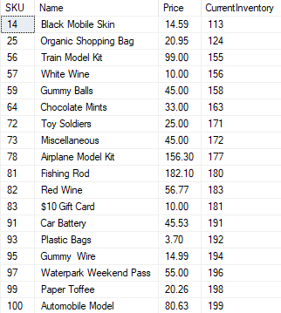

PURCHASE Table
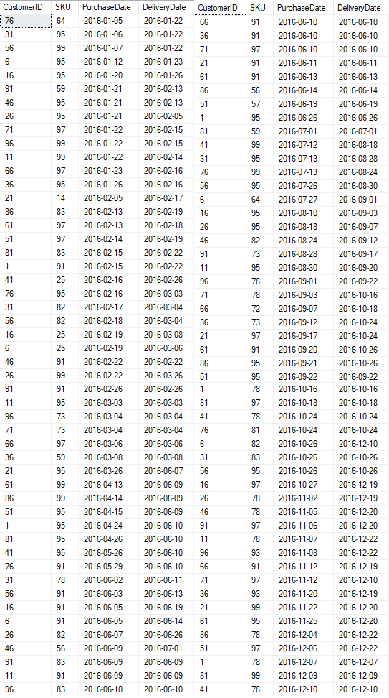

Oracle Database Design

Database Design Diagram

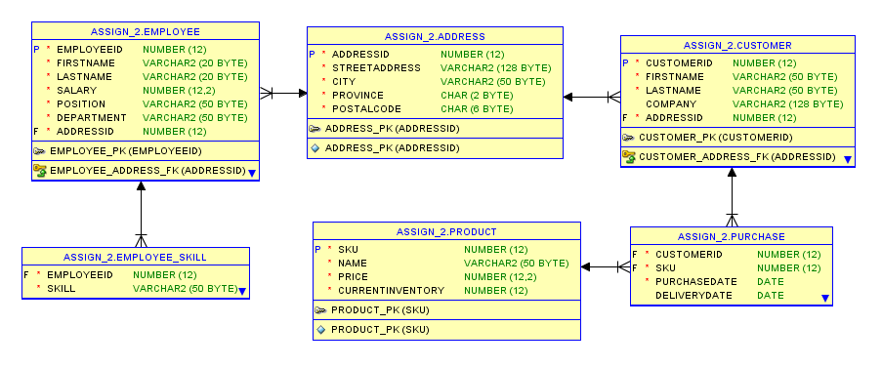

Tables and Data

EMPLOYEE Table
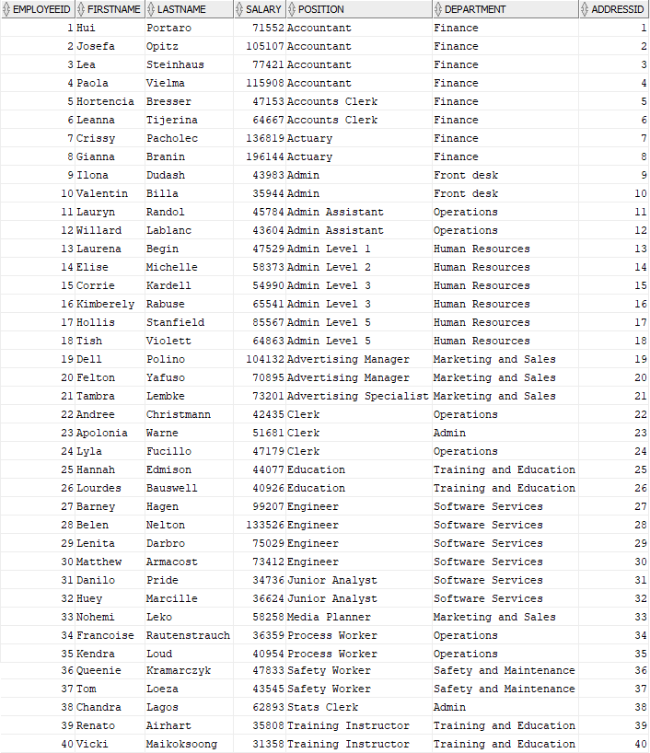

EMPLOYEE_SKILL Table
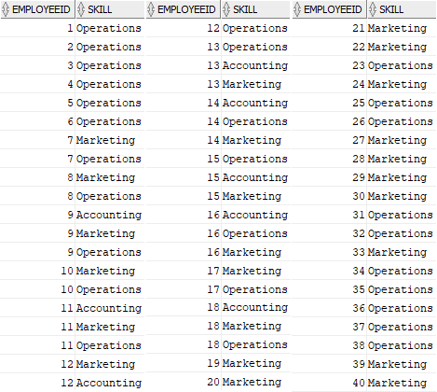

CUSTOMER Table
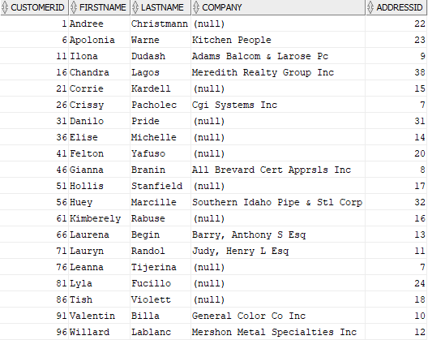

ADDRESS Table
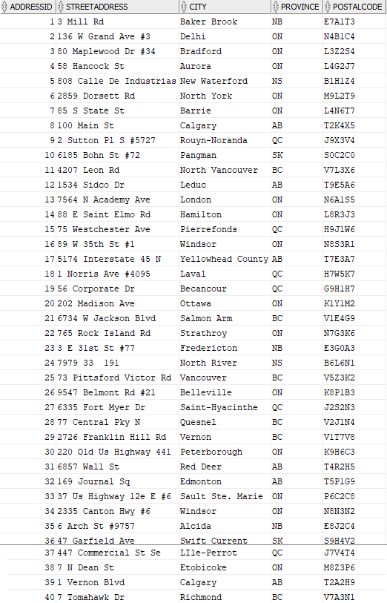

PRODUCT Table
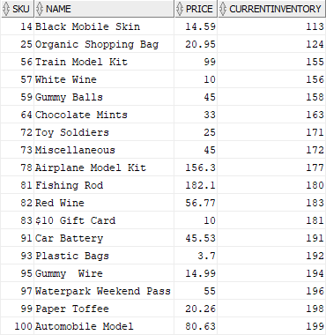

PURCHASE Table
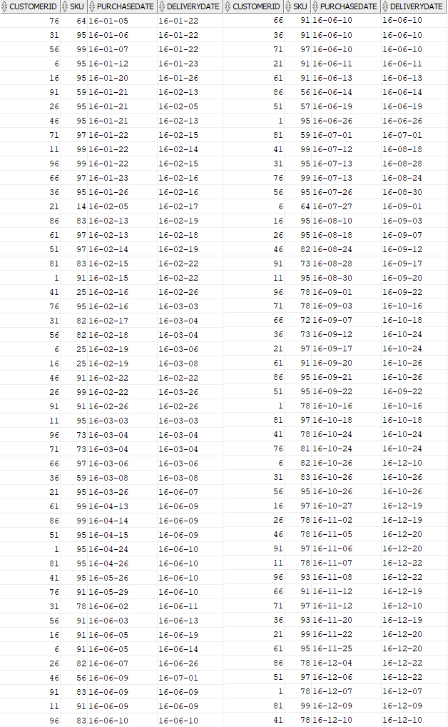

MySQL Database Design

Database Design Diagram

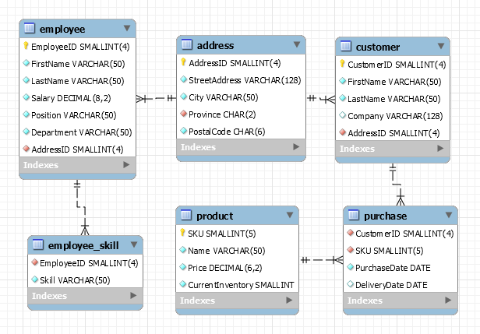

Tables and Data

EMPLOYEE Table
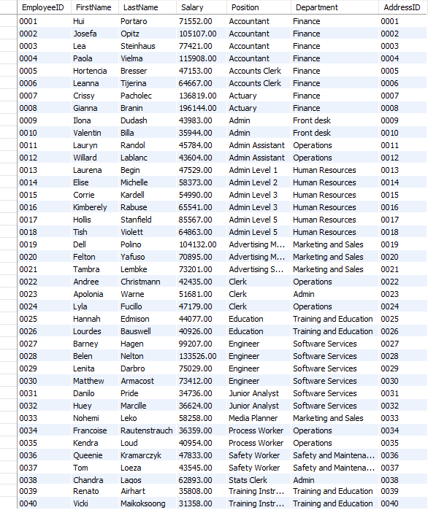

EMPLOYEE_SKILL Table
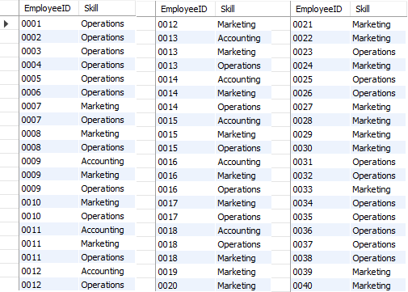

CUSTOMER Table
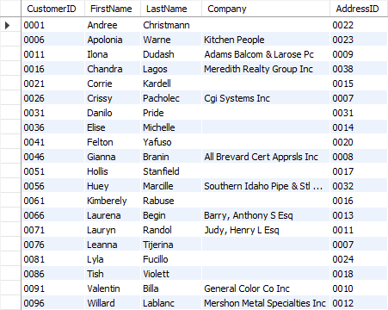

ADDRESS Table
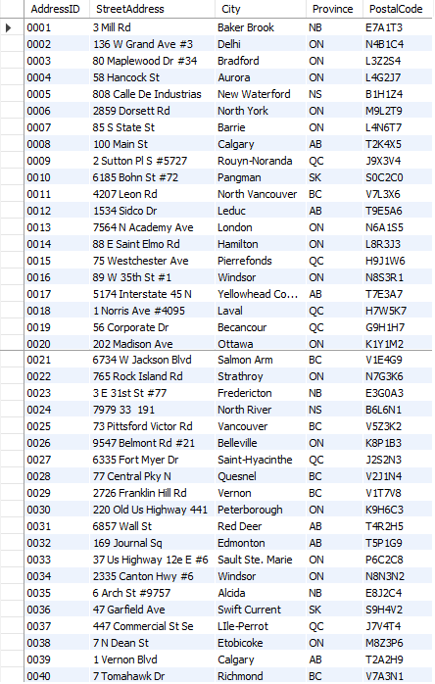

PRODUCT Table
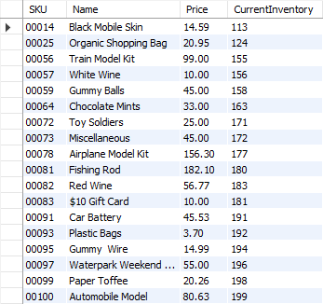

PURCHASE Table
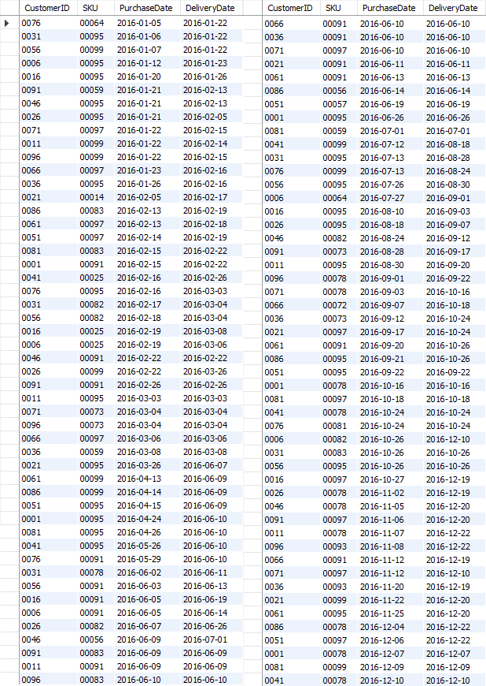

Appendix 1: Misc. Assumptions and Notes

Data Cleanup and Analysis
- Assumption: Since the address in the Employee and Purchase sheets match but have different names (though similar, as if heard wrong), I assumed that the names were correct in the Employee table and adjusted the Purchase table accordingly. I chose the Employee table to be the reference because Violett is a more likely last name than Purple (Tish Violett / Tish Purple). Alternative solution would be to store the names as is and assume that only one employee or customer could live at a given address. This would create problems if two people from the same household were both customers or employees.
- Note: One purchase of Paper Toffee has completely different price from all other purchases of Paper Toffee. Price does not match any other product either. Solution unclear.
- Note: Much of the data was informally analyzed during cleanup, which was done manually in Excel by sorting and looking for repeats. Sorting by Skill, Position, and Department helped with cleaning/analyzing the Employee data. Sorting by Customer (before splitting into First Name, Last Name, and Company) and Product helped with cleaning/analyzing the Purchase data. After the first cleanup (proper case, removing duplicates, fixing spelling, matching names between Employee and Purchase sheets, streamlining department names) the address and name columns were split into their constituent parts.
- Note: While not necessary for the queries given, I split Name into First and Last for the sake of future expandability.
- Note: In future, importing data directly into MySQL (the DBMS I’m most familiar with) would potentially be faster, then cleaning it up using SQL statements. This would be done first by sorting by various columns (such as Department) then using UPDATE statements to correct the data. This could correct multiple records at once if a particular error occurs multiple times. With larger datasets this would be more efficient than manually cleaning the spreadsheet (although Excel has some good data cleaning tools).

Creating and Populating Databases
- Note: I forgot to configure MySQL to use upper case for table names, and to configure Oracle to use proper case for column names.
- Note: Auto-incrementing the surrogate keys was implemented in MySQL, but I don’t know how to do it in SQL Server or Oracle. Luckily I was able to populate MySQL with the data first, then import that data into SQL Server and Oracle.

Other
- Note: I didn’t notice until quite late that the TAX table shouldn’t be included in the model or database designs. I removed it from all tables and diagrams, but may have missed something.

