Van Whinkle Database Design

  - Caitlin Ross
  - ross0272@algonquinlive.com
  - Student Number 040750891
  - Assignment #1
  - Course Code CST2355 Section 451

Table of Contents

Table Data (MySQL) 3
SQL Queries 5
Databases 20
MySQL 20
Oracle Database 23
SQL Server 26
Appendix: Assumptions and Notes 29

Table Data (MySQL)

ADDRESS Table
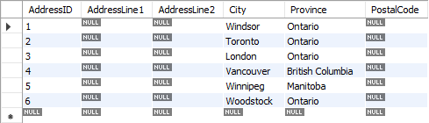
CHARGE Table
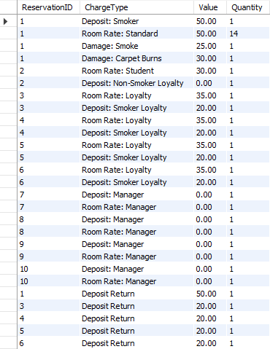

CUSTOMER Table
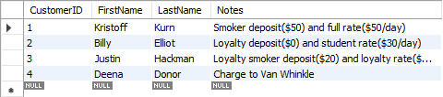
CUSTOMERADDRESS Table
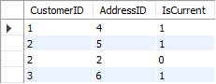
EMPLOYEE Table
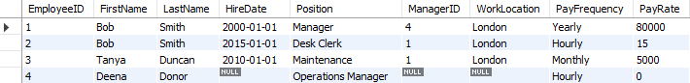
EMPLOYEEADDRESS Table
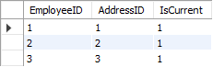
EMPLOYEECUSTOMER Table
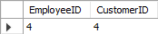
RESERVATION Table
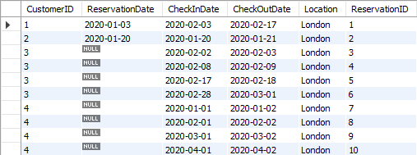

SQL Queries

Any blank fields in CUSTOMER table, sorted Z-A on last name
SELECT *
FROM CUSTOMER
WHERE
CustomerID IS NULL
OR FirstName IS NULL
OR LastName IS NULL
OR Notes IS NULL
ORDER BY LastName DESC;
Differences in SQL Syntax
- MySQL
  - No change
- SQL Server
  - No change
- Oracle
  - Replace CUSTOMER with ASSIGN_1.CUSTOMER on line 2

Any blank fields in CUSTOMER table, sorted A-Z on first name
SELECT *
FROM CUSTOMER
WHERE CustomerID IS NULL
OR FirstName IS NULL
OR LastName IS NULL
OR Notes IS NULL
ORDER BY FirstName ASC;
Differences in SQL Syntax
- MySQL
  - No change
- SQL Server
  - No change
- Oracle
  - Replace CUSTOMER with ASSIGN_1.CUSTOMER on line 2

Show customers who have had 2+ day stays
SELECT
CUSTOMER.FirstName,
CUSTOMER.LastName,
Stay.Quantity AS LengthOfStay
FROM CUSTOMER
JOIN
(SELECT
CHARGE.Quantity,
RESERVATION.CustomerID
FROM RESERVATION
JOIN CHARGE
ON RESERVATION.ReservationID=CHARGE.ReservationID
) AS Stay
ON CUSTOMER.CustomerID = Stay.CustomerID
WHERE Stay.Quantity>=2;
Differences in SQL Syntax
- MySQL
  - No change
- SQL Server
  - No change
- Oracle
  - Replace CUSTOMER with ASSIGN_1.CUSTOMER on line 5
  - Replace RESERVATION with ASSIGN_1.RESERVATION on line 10
  - Replace CHARGE with ASSIGN_1.CHARGE on line 11
  - Remove AS keyword on line 13

Show customers who have had 4-day stays
SELECT
CUSTOMER.FirstName,
CUSTOMER.LastName,
Stay.Quantity AS LengthOfStay
FROM CUSTOMER
JOIN
(SELECT
CHARGE.Quantity,
RESERVATION.CustomerID
FROM RESERVATION
JOIN CHARGE
ON RESERVATION.ReservationID=CHARGE.ReservationID
) AS Stay
ON CUSTOMER.CustomerID = Stay.CustomerID
WHERE Stay.Quantity=4;
Differences in SQL Syntax
- MySQL
  - No change
- SQL Server
  - No change
- Oracle
  - Replace CUSTOMER with ASSIGN_1.CUSTOMER on line 5
  - Replace RESERVATION with ASSIGN_1.RESERVATION on line 10
  - Replace CHARGE with ASSIGN_1.CHARGE on line 11
  - Remove AS keyword on line 13

Show customers who have had 6+ day stays
SELECT
CUSTOMER.FirstName,
CUSTOMER.LastName,
Stay.Quantity AS LengthOfStay
FROM CUSTOMER
JOIN
(SELECT
CHARGE.Quantity,
RESERVATION.CustomerID
FROM RESERVATION
JOIN CHARGE
ON RESERVATION.ReservationID=CHARGE.ReservationID
) AS Stay
ON CUSTOMER.CustomerID = Stay.CustomerID
WHERE Stay.Quantity >=6;
Differences in SQL Syntax
- MySQL
  - No change
- SQL Server
  - No change
- Oracle
  - Replace CUSTOMER with ASSIGN_1.CUSTOMER on line 5
  - Replace RESERVATION with ASSIGN_1.RESERVATION on line 10
  - Replace CHARGE with ASSIGN_1.CHARGE on line 11
  - Remove AS keyword on line 13

Find stays costing over $50
SELECT
CUSTOMER.FirstName,
CUSTOMER.LastName,
RESCOST.ChargeType,
RESCOST.Fee,
RESCOST.TotalCost
FROM CUSTOMER
JOIN
(SELECT
RESERVATION.CustomerID,
STAY.ChargeType,
STAY.Fee,
STAY.TotalCost
FROM RESERVATION
JOIN
(SELECT
CHARGE.ReservationID,
CHARGE.ChargeType,
CHARGE.Value*CHARGE.Quantity AS Fee,
STAYTOTAL.TotalCost
FROM CHARGE
JOIN
(SELECT
ReservationID,
SUM(Value*Quantity) AS TotalCost
FROM CHARGE
GROUP BY ReservationID
) AS STAYTOTAL
ON CHARGE.ReservationID=STAYTOTAL.ReservationID
) AS STAY
ON RESERVATION.ReservationID=STAY.ReservationID
) AS RESCOST
ON CUSTOMER.CustomerID=RESCOST.CustomerID
WHERE RESCOST.TotalCost>=50.00
ORDER BY RESCOST.Fee DESC;
Differences in SQL Syntax
- MySQL
  - No change
- SQL Server
  - No change
- Oracle
  - Replace CUSTOMER with ASSIGN_1.CUSTOMER on line 7
  - Replace RESERVATION with ASSIGN_1.RESERVATION on line 14
  - Replace CHARGE with ASSIGN_1.CHARGE on line 21 and line 26
  - Remove AS keyword from lines 28, 30 and 32
Find stays where extra fees cost over $50
SELECT
CUSTOMER.FirstName,
CUSTOMER.LastName,
RESCOST.ChargeType,
RESCOST.Fee,
RESCOST.TotalCost
FROM CUSTOMER
JOIN
(SELECT
RESERVATION.CustomerID,
STAY.ChargeType,
STAY.Fee,
STAY.TotalCost
FROM RESERVATION
JOIN
(SELECT
CHARGE.ReservationID,
CHARGE.ChargeType,
CHARGE.Value*CHARGE.Quantity AS Fee,
STAYTOTAL.TotalCost
FROM CHARGE
JOIN
(SELECT
ReservationID,
SUM(Value*Quantity) AS TotalCost
FROM CHARGE
WHERE CHARGE.ChargeType NOT LIKE '%Room Rate%'
GROUP BY ReservationID
) AS STAYTOTAL
ON CHARGE.ReservationID=STAYTOTAL.ReservationID
) AS STAY
ON RESERVATION.ReservationID=STAY.ReservationID
) AS RESCOST
ON CUSTOMER.CustomerID=RESCOST.CustomerID
WHERE
RESCOST.TotalCost>=50.00
AND RESCOST.ChargeType NOT LIKE '%Room Rate%'
ORDER BY RESCOST.Fee DESC;

Differences in SQL Syntax
- MySQL
  - No change
- SQL Server
  - No change
- Oracle
  - Replace CUSTOMER with ASSIGN_1.CUSTOMER on line 7
  - Replace RESERVATION with ASSIGN_1.RESERVATION on line 14
  - Replace CHARGE with ASSIGN_1.CHARGE on line 21 and line 26
  - Remove AS keyword from lines 29, 31 and 33

Display employee table with manager’s info
SELECT
EMPMAN.FirstName,
EMPMAN.LastName,
EMPADDRESS.City,
EMPMAN.ManagersFirstName,
EMPMAN.ManagersLastName,
MANADDRESS.City
FROM
(SELECT
emp.FirstName,
emp.LastName,
man.FirstName AS ManagersFirstName,
man.LastName AS ManagersLastName,
emp.EmployeeID AS empID,
man.EmployeeID AS manID
FROM EMPLOYEE emp
LEFT JOIN EMPLOYEE man
ON emp.ManagerID=man.EmployeeID
) AS EMPMAN
LEFT JOIN
(SELECT
ADDRESS.City,
EMPLOYEEADDRESS.EmployeeID
FROM EMPLOYEEADDRESS
LEFT JOIN ADDRESS
ON ADDRESS.AddressID=EMPLOYEEADDRESS.AddressID
) AS EMPADDRESS
ON EMPMAN.empID=EMPADDRESS.EmployeeID
LEFT JOIN
(SELECT
ADDRESS.City,
EMPLOYEEADDRESS.EmployeeID
FROM EMPLOYEEADDRESS
LEFT JOIN ADDRESS
ON ADDRESS.AddressID=EMPLOYEEADDRESS.AddressID
) AS MANADDRESS
ON EMPMAN.manID=MANADDRESS.EMPLOYEEID;

Differences in SQL Syntax
- MySQL
  - No change
- SQL Server
  - No change
- Oracle
  - Replace EMPLOYEE with ASSIGN_1.EMPLOYEE on lines 16 and 17
  - Replace EMPLOYEEADDRESS with ASSIGN_1.EMPLOYEEADDRESS on lines 24 and 33
  - Replace ADDRESS with ASSIGN_1.ADDRESS on lines 25 and 34
  - Remove AS keyword from lines 19, 27 and 36

Show all employees and customers from London and Winnipeg
SELECT
CUSTOMER.FirstName AS FirstName,
CUSTOMER.LastName AS LastName,
C_ADDRESS.City AS City
FROM
(SELECT
CUSTOMERADDRESS.CustomerID,
ADDRESS.City,
CUSTOMERADDRESS.IsCurrent
FROM ADDRESS
JOIN CUSTOMERADDRESS
ON CUSTOMERADDRESS.AddressID = ADDRESS.AddressID
WHERE CUSTOMERADDRESS.IsCurrent > 0
) AS C_ADDRESS
RIGHT JOIN CUSTOMER
ON C_ADDRESS.CustomerID = CUSTOMER.CustomerID
WHERE City IN ('Winnipeg', 'London')
UNION
SELECT
EMPLOYEE.FirstName AS FirstName,
EMPLOYEE.LastName AS LastName,
E_ADDRESS.City AS City
FROM
(SELECT
EMPLOYEEADDRESS.EmployeeID,
ADDRESS.City,
EMPLOYEEADDRESS.IsCurrent
FROM ADDRESS
JOIN EMPLOYEEADDRESS
ON EMPLOYEEADDRESS.AddressID = ADDRESS.AddressID
WHERE EMPLOYEEADDRESS.IsCurrent > 0
) AS E_ADDRESS
RIGHT JOIN EMPLOYEE
ON E_ADDRESS.EmployeeID = EMPLOYEE.EmployeeID
WHERE City IN ('Winnipeg', 'London');

Differences in SQL Syntax
- MySQL
  - No change
- SQL Server
  - No change
- Oracle
  - Replace ADDRESS with ASSIGN_1.ADDRESS on lines 10 and 28
  - Replace CUSTOMERADDRESS with ASSIGN_1.CUSTOMERADDRESS on line 11
  - Replace CUSTOMER with ASSIGN_1.CUSTOMER on line 15
  - Replace EMPLOYEEADDRESS with ASSIGN_1.EMPLOYEEADDRESS on line 29
  - Replace EMPLOYEE with ASSIGN_1.EMPLOYEE on line 33
  - Remove AS keyword from lines 14 and 32

Show which customers and employees are from each city
SELECT
CUSTOMER.FirstName AS FirstName,
CUSTOMER.LastName AS FirstName,
C_ADDRESS.City AS City
FROM
(SELECT
CUSTOMERADDRESS.CustomerID,
ADDRESS.City,
CUSTOMERADDRESS.IsCurrent
FROM ADDRESS
JOIN CUSTOMERADDRESS
ON CUSTOMERADDRESS.AddressID = ADDRESS.AddressID
WHERE CUSTOMERADDRESS.IsCurrent > 0
) AS C_ADDRESS
RIGHT JOIN CUSTOMER
ON C_ADDRESS.CustomerID = CUSTOMER.CustomerID
WHERE City IS NOT NULL
UNION
SELECT
EMPLOYEE.FirstName AS FirstName,
EMPLOYEE.LastName AS LastName,
E_ADDRESS.City AS City
FROM
(SELECT
EMPLOYEEADDRESS.EmployeeID,
ADDRESS.City,
EMPLOYEEADDRESS.IsCurrent
FROM ADDRESS
JOIN EMPLOYEEADDRESS
ON EMPLOYEEADDRESS.AddressID = ADDRESS.AddressID
WHERE EMPLOYEEADDRESS.IsCurrent > 0
) AS E_ADDRESS
RIGHT JOIN EMPLOYEE
ON E_ADDRESS.EmployeeID = EMPLOYEE.EmployeeID
WHERE City IS NOT NULL;

Differences in SQL Syntax
- MySQL
  - No change
- SQL Server
  - No change
- Oracle
  - Replace ADDRESS with ASSIGN_1.ADDRESS on lines 10 and 28
  - Replace CUSTOMERADDRESS with ASSIGN_1.CUSTOMERADDRESS on line 11
  - Replace CUSTOMER with ASSIGN_1.CUSTOMER on line 15
  - Replace EMPLOYEEADDRESS with ASSIGN_1.EMPLOYEEADDRESS on line 29
  - Replace EMPLOYEE with ASSIGN_1.EMPLOYEE on line 33
  - Remove AS keyword from lines 14 and 32

Display the employees who are also customers
SELECT
emp.CustomerID,
emp.EmployeeID,
emp.FirstName,
emp.LastName,
emp.Notes
FROM EMPLOYEE
JOIN
(SELECT
EMPLOYEECUSTOMER.EmployeeID,
CUSTOMER.CustomerID,
CUSTOMER.FirstName,
CUSTOMER.LastName,
CUSTOMER.Notes
FROM CUSTOMER
JOIN EMPLOYEECUSTOMER
ON CUSTOMER.CustomerID=EMPLOYEECUSTOMER.CustomerID
) AS emp
ON EMPLOYEE.EmployeeID=emp.EmployeeID;
Differences in SQL Syntax
- MySQL
  - No change
- SQL Server
  - No change
- Oracle
  - Replace EMPLOYEE with ASSIGN_1.EMPLOYEE on line 7
  - Replace CUSTOMER with ASSIGN_1.CUSTOMER on line 15
  - Replace EMPLOYEECUSTOMER with ASSIGN_1.EMPLOYEECUSTOMER on line 16
  - Remove AS keyword from line 18

Show all employees who are customers if their last name starts with M or contains a C
SELECT
emp.CustomerID,
emp.EmployeeID,
emp.FirstName,
emp.LastName,
emp.Notes
FROM EMPLOYEE
JOIN
(SELECT
EMPLOYEECUSTOMER.EmployeeID,
CUSTOMER.CustomerID,
CUSTOMER.FirstName,
CUSTOMER.LastName,
CUSTOMER.Notes
FROM CUSTOMER
JOIN EMPLOYEECUSTOMER
ON CUSTOMER.CustomerID=EMPLOYEECUSTOMER.CustomerID
) AS emp
ON EMPLOYEE.EmployeeID=emp.EmployeeID
WHERE
emp.LastName LIKE 'm%'
OR emp.LastName LIKE '%c%';
Differences in SQL Syntax
- MySQL
  - No change
- SQL Server
  - No change
- Oracle
  - Replace EMPLOYEE with ASSIGN_1.EMPLOYEE on line 7
  - Replace CUSTOMER with ASSIGN_1.CUSTOMER on line 15
  - Replace EMPLOYEECUSTOMER with ASSIGN_1.EMPLOYEECUSTOMER on line 16
  - Remove AS keyword from line 18

Databases

MySQL

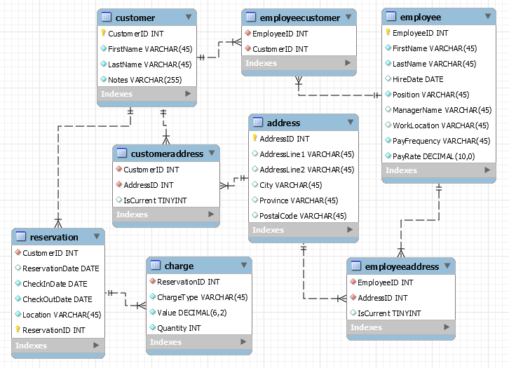
MySQL Database Design Diagram

MySQL Table Fields
ADDRESS Table
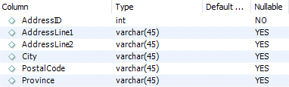
CHARGE Table
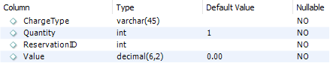
CUSTOMER Table
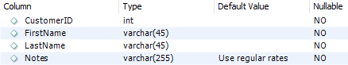
CUSTOMERADDRESS Table
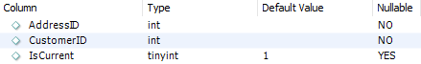
EMPLOYEE Table
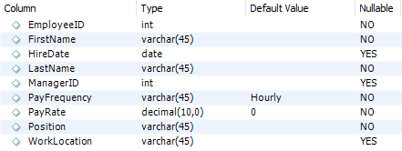
EMPLOYEEADDRESS Table
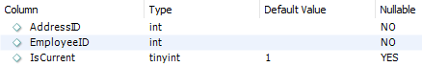

EMPLOYEECUSTOMER Table
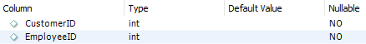
RESERVATION Table
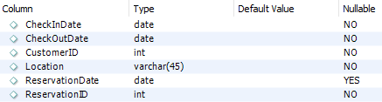

Oracle Database

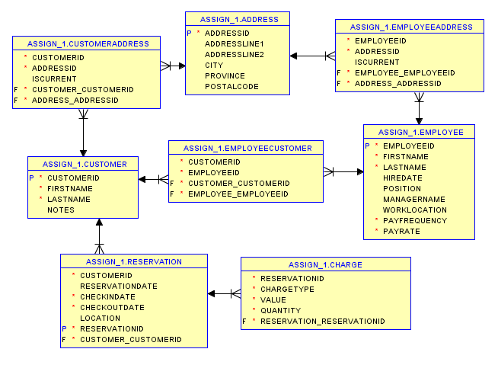
Oracle Database Design Diagram

Oracle Table Fields
ADDRESS Table
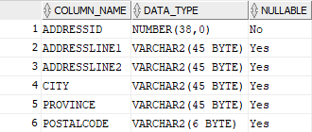
CHARGE Table
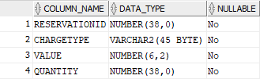
CUSTOMER Table
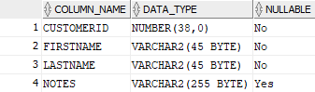
CUSTOMERADDRESS Table
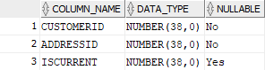
EMPLOYEE Table
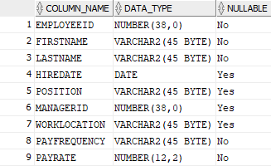

EMPLOYEEADDRESS Table
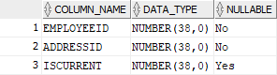
EMPLOYEECUSTOMER Table
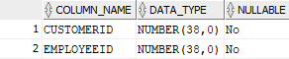
RESERVATION Table
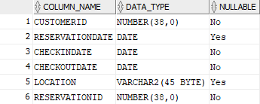

SQL Server

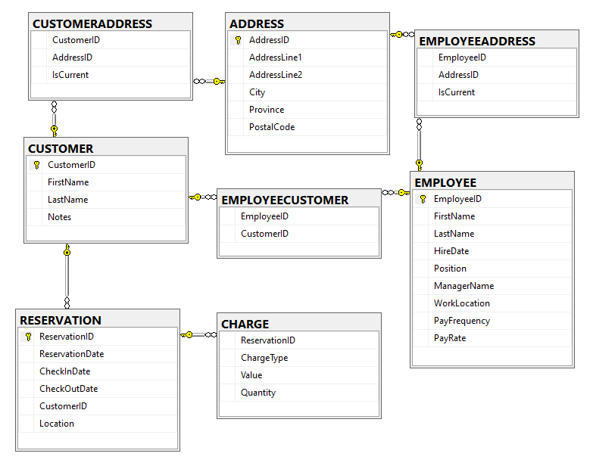
SQL Server Database Design Diagram

SQL Server Table Fields
ADDRESS Table
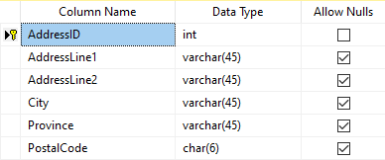
CHARGE Table
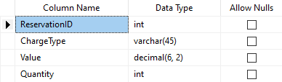
CUSTOMER Table
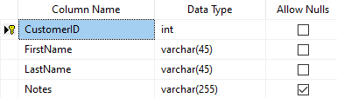
CUSTOMERADDRESS Table
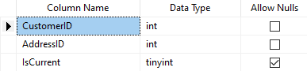

EMPLOYEE Table
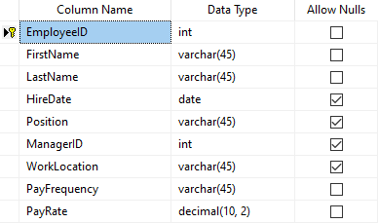
EMPLOYEEADDRESS Table
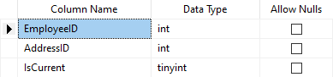
EMPLOYEECUSTOMER Table
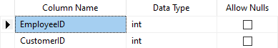
RESERVATION Table
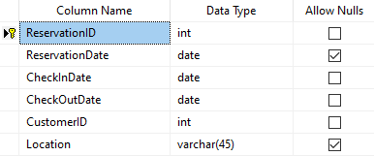

Appendix: Assumptions and Notes
- Started with MySQL, since it’s the only DBMS I have experience with
- I tried to make the table names all caps, but MySQL wouldn’t allow capitals in table names
- MySQL wouldn’t let me use BOOLEAN datatype for the IsCurrent columns in the CUSTOMERADDRESS and EMPLOYEEADDRESS tables, so I used TINYINT datatype instead
- ADDRESS table contains more fields than strictly needed for the information given, but for robust design and expandability Van Whinkle should be gathering full addresses for their customers and employees rather than just cities
- By the same token, there should be more contact info for both customers and employees that I didn’t include, such as Phone Number and Email Address
- Eventually Van Whinkle would need to start collecting billing info for customers and direct deposit info for employees
- To reduce repetition, I referenced the same Toronto record in the ADDRESS table for both Bob Smith (desk clerk) and Billy Elliot, even though their addresses would be different in reality
- Neither BOOLEAN nor TINYINT were options in Oracle, so I used SMALLINT in hopes that it would be close enough
- Changed EMPLOYEE.ManagerName to EMPLOYEE.ManagerID after diagrams were complete, I updated the table and data screenshots but not the diagrams
- Did not set default values for columns in Oracle or SQL Server

