COMP 2805 Assignment 1

1.1 M= (Q, Σ, δ, q, F)
Q = {q0, q1, q2, q3, q4, q5}
q0 = start state, no ones or zeros have been read
q1 = 1 one has been read
q2 = 2 ones have been read
q3 = 3 ones have been read
q4 = 4 ones have been read
q5 = 5 ones have been read, accept state
Σ = {0, 1}
δ =
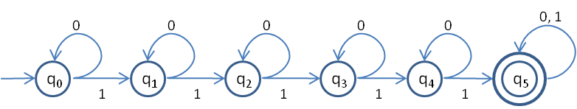
q = q0
F = {q5}

1.2 M= (Q, Σ, δ, q, F)
Q = {q0, q1, q2, q3, q4 }
q0 = start state, substring 1011 has not been read
q1 = 1 has been read
q2 = 10 has been read
q3 = 101 has been read
q4 = 1011 has been read, accept state
Σ = {0, 1}
δ =
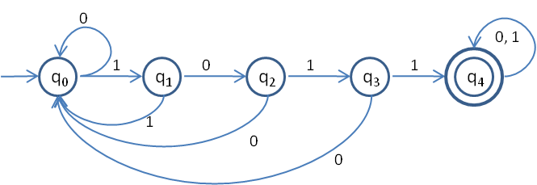
q = q0
F = {q4}

1.3 M= (Q, Σ, δ, q, F)
Q = {q0, q1, q2, q3, q4, q5, q6, q7, q8, q9}
q0 = start state, no ones or zeros have been read
q1 = 1 zero has been read
q2 = 1 one has been read
q3 = 2 zeros have been read
q4 = 1 one and 1 zero has been read, in any order
q5 = 2 ones have been read, accept state
q6 = 2 zeros and 1 one has been read, in any order
q7 = 2 ones and 1 zero has been read, in any order
q8 = 2 ones and 2 zeros have been read, in any order, accept state
q9 = more than 2 zeros have been read, cannot be accepted
Σ = {0, 1}
δ =
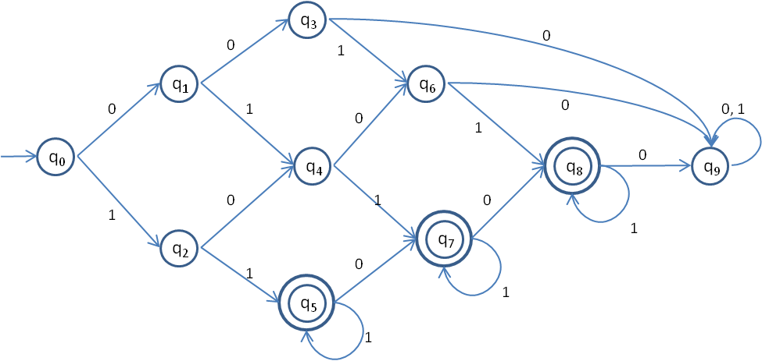
q = q0
F = {q9}

1.4 M= (Q, Σ, δ, q, F)
Q = {q0, q1, q2, q3, q4, q5, q6, q7}
q0 = start state, an even number of ones and no zeros have been read, accept state
q1 = an odd number of ones and no zeros have been read
q2 = an even number of ones and 1 zero have been read, accept state
q3 = an odd number of ones and 1 zero have been read
q4 = an even number of ones and 2 zeros have been read, accept state
q5 = an odd number of ones and 2 zeros have been read, accept state
q6 = an even number of ones and more than 2 zeros have been read, accept state
q7 = an odd number of ones and more than 2 zeros have been read
Σ = {0, 1}
δ =
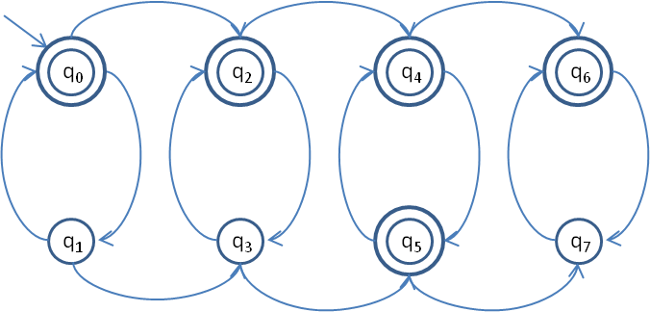
q = q0
F = {q0, q2, q4, q5, q6}

2.1 M= (Q, Σ, δ, q, F)
Q = {q0, q1, q2}
q0 = start state, any number of ones or zeros have been read
q1 = 1 has been read as second last symbol
q2 = 10 been read as last two symbols, accept state
Σ = {0, 1}
δ =
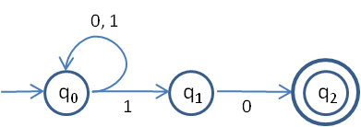
q = q0
F = {q2}

2.2 M= (Q, Σ, δ, q, F)
Q = {q0, q1, q2, q3, q4 }
q0 = start state, any number of ones or zeros have been read
q1 = 1 has been read
q2 = 10 has been read
q3 = 101 has been read
q4 = 1011 has been read, any number of symbols can be read after, accept state
Σ = {0, 1}
δ =
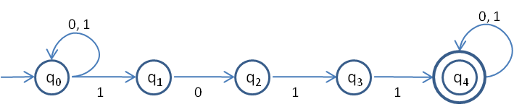
q = q0
F = {q4}

2.3 M= (Q, Σ, δ, q, F)
Q = {q0, q1, q2, q3, q4, q5}
q0 = start state, no symbols have been read
q1 = assume there will be exactly 2 zeros, 0 or more ones have been read
q2 = one zero has been read, 0 or more ones have been read
q3 = exactly two zeros have been read, no more can be read, 0 or more ones have been read, accept state
q4 = an odd number of ones have been read, 0 or more zeros have been read, accept state
q5 = an even number of ones have been read, 0 or more zeros have been read
Σ = {0, 1}
δ =
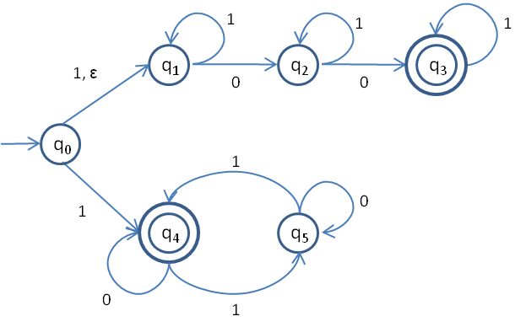
q = q0
F = {q5}

3 Assume that there exists a DFA/NFA that accepts language A. All accept states in the automaton can be changed into non-accept states, which can then read the empty string to go to a single accept state. This single accept state would have no transitions leaving itself, thereby ensuring that it would be the final state, and only accessible through former accept states.

4 Given that A is regular, there exists an NFA M such that A = L(M). This can be modified by creating an NFA M’ with a single accept state, as demonstrated in question 3. After this is accomplished, the accept state can be the new start state (and no longer an accept state), and the former start state can be the new accept state. By reversing every transition, M’ now becomes an NFA such that A^{R} = L(M’).

5 Given the DFA M, where M = (Q, Σ, δ, q, F),
N is an NFA, where N = (Q’, Σ, δ’, q’, F’).
Q’ = P(Q) = {ε, {1}, {2}, {3}, {1, 2}, {1, 3}, {2, 3}, {1, 2, 3}}
Σ = Σ
δ’ =
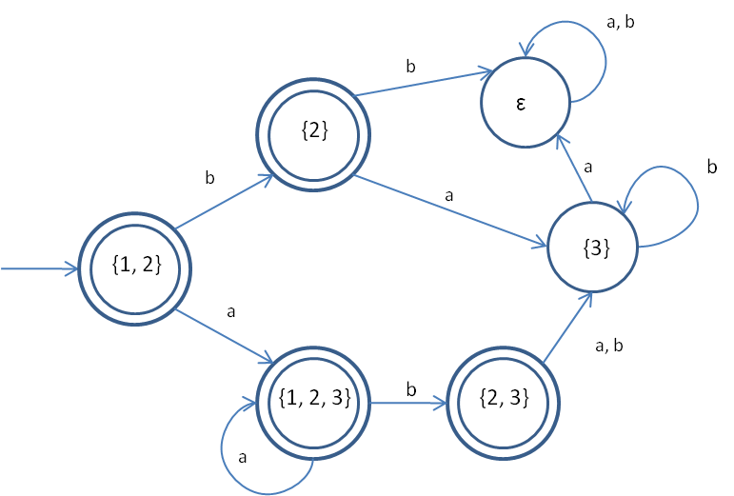
q' = C_{ε}({q}) = C_{ε}({1}) = {1, 2}
F’ = {{1}, {2}, {1, 2}, {1, 3}, {2, 3}, {1, 2, 3}}

