Caitlin Ross
100735219

COMP 2805 Assignment 2

  - 1.1
(0 U 1)* 1 (0 U 1)* 1 (0 U 1)* 1 (0 U 1)* 1 (0 U 1)* 1 (0 U 1)*
  - 1.2
(1* 0 1 1 1*) U (1* 1 0 1 1*) U (1* 1 1 0 1*)
  - 1.3
(0* 1 0* 1 0*)* U (1* 0 1* 0 1*)

  - 2
NFA M₁ = (Q, Σ, δ, q, F), accepts regular expression 10
Q = {q₀, q₁, q₂}
q₀ = No symbols have been read, start state
q₁ = 1 one has been read
q₂ = 10 has been read, accept state
Σ = {1, 0}
δ =
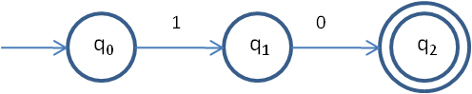
q = q₀
F = {q₂}

NFA M₂ = (Q, Σ, δ, q, F), accepts regular expression (10)*
Q = {q₀, q₁, q₂, q₃}
q₀ = No symbols have been read, start state
q₁ =(10)* has been read
q₂ = (10)* 1 has been read, accept state
q₃ = (10)* has been read, accept state
Σ = {1, 0}
δ =
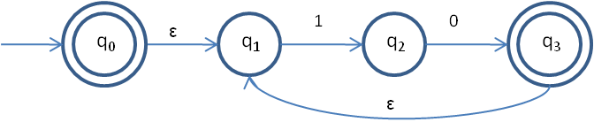
q = q₀
F = {q₂}

NFA M₃ = (Q, Σ, δ, q, F), accepts regular expression (10)* 00
Q = {q₀, q₁, q₂, q₃, q₄, q₅}
q₀ = No symbols have been read, start state
q₁ = (10)* has been read
q₂ = (10)* 1 has been read
q₃ = (10)* has been read
q₄ = (10)* has been read
q₅ = (10)* 0 has been read
q₆ = (10)* 00 has been read
Σ = {1, 0}

δ =
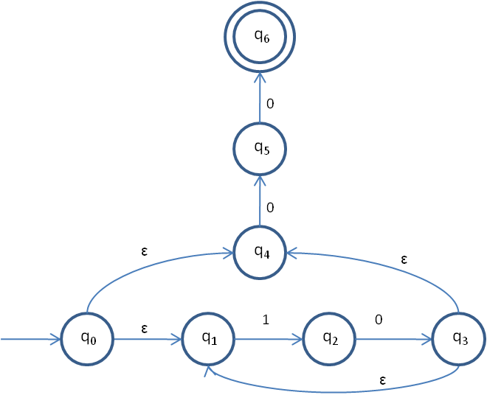
q = q₀
F = {q₆}

NFA M₄ = (Q, Σ, δ, q, F), accepts regular expression ((10)* 00) U 10
Q = {q₀, q₁, q₂, q₃, q₄, q₅}
q₀ = No symbols have been read, start state
q₁ = No symbols have been read, assume (10)* 00 will be read
q₂ = (10)* has been read
q₃ = (10)* 1 has been read
q₄ = (10)* has been read
q₅ = (10)* has been read
q₆ = (10)* 0 has been read
q₇ = (10)* 00 has been read, accept state
q₈ = No symbols have been read, assume 10 will be read
q₉ = 1 has been read
q₁₀ = 10 has been read, accept state
Σ = {1, 0}
δ =
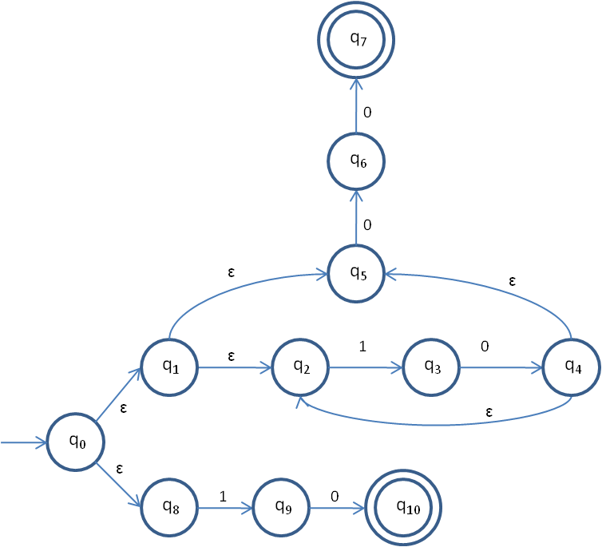
q = q₀
F = {q₇, q₁₀}

NFA M₅ = (Q, Σ, δ, q, F), accepts regular expression (((10)* 00) U 10)*
Q = {q₀, q₁, q₂, q₃, q₄, q₅}
q₀ = (((10)* 00) U 10)* has been read, start state, accept state
q₁ = (((10)* 00) U 10)* has been read, assume (10)* 00 will be read
q₂ = (((10)* 00) U 10)* (10)* has been read
q₃ = (((10)* 00) U 10)* (10)* 1 has been read
q₄ = (((10)* 00) U 10)* (10)* has been read
q₅ = (((10)* 00) U 10)* (10)* has been read
q₆ = (((10)* 00) U 10)* (10)* 0 has been read
q₇ = (((10)* 00) U 10)* (10)* 00 has been read
q₈ = (((10)* 00) U 10)* has been read, assume 10 will be read
q₉ = (((10)* 00) U 10)* 1 has been read
q₁₀ = (((10)* 00) U 10)* 10 has been read
Σ = {1, 0}
δ =
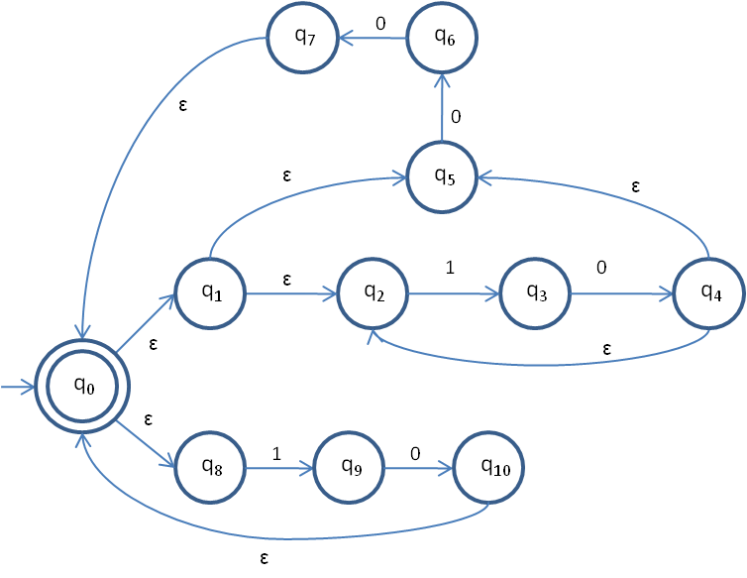
q = q₀
F = {q₀}

  - 3
(a) L₁ = ε U (a L₁) U (b L₂)
(b) L₂ = (a L₃) U (b L₂)
(c) L₃ = (a L₃) U (b L₁)
Using Lemma 2.8.2 with L₃, let L = L₃, B = a and C = (b L₁)
(d) L₃ = L = B* C = a* b L₁
Substitute (d) into (b)
(e) L₂ = (a a* b L₁) U (b L₂)
Using Lemma 2.8.2 with L₁, let L = L₁, B = a, C = (ε U b L₂)
(f) L₁ = a* (ε U b L₂)
= a* U a* bL₂
Substitute (f) into (e)
(g) L₂ = a a* b (a* U a* b L₂) U b L₂
= a a* b a* U a a* b a* b L₂ U b L₂
= a a* b a* U L₂ (a a* b a* b U b)
Using Lemma 2.8.2 with L₂, let L = L₂, B = (a a* b a* b U b), C = (a a* b a*)
(h) L₂ = L = B* C = (a a* b a* b U b)* a a* b a*
Therefore, the language accepted by the DFA is (a a* b a* b U b)* a a* b a*.

4.1
Assume that the language A = {a^{n}b^{m}c^{n+m} : n>= 0, m>=0} is regular. Let p = n+m be the pumping length. Let s=a^{n}b^{m}c^{n+m}. |s| = 2p >=p. Therefore s can be written as s=xyz. For |xy| to be less than or equal to p, y contains either 1) only ‘b’s or 2) ‘a’s and ‘b’s. Considering case 1, xyyz cannot be an element of A, because then s would be of the form s = a^{n}b^{2m}c^{n+m}. If the number of ‘b’s is increased, the number of ‘c’s must be increased as well. Considering case 2, if a string of ‘a’s and ‘b’s is repeated within the string, it does not follow the pattern at all, and cannot be an element of A. Therefore, A is not a regular language.

4.3
Assume that the language A = {a^{2n} : n >= 0} is regular. Take the string s = a^{2p}, |s| = 2^{p} > p, for all p>=1. Therefore s can be written as s = xyz, such that |y| >=1. This means that x = a^{q}, y = a^{r}, z = a^{s}, where q+r <=p and q+r+s = 2^{p}. This satisfies the second requirement. However, there is no guarantee that q+r^{i}+s=2^{p}. For example, if r=1 and i=2, suddenly there is an odd number of ‘a’s in the string, which definitely isn’t a power of 2. Therefore, A is not a regular language.
  - 4.4
Assume that the language A = {a^{n}b^{m}c^{l} : n, m, l >=0, n² + m² = l²} is regular. Take the strings s = a^{n}b^{m}c^{l}, where p = n+m. Since |s| = n+m+l >= p, s can be written as s = xyz. The only way for y to be repeated in such a way for s to still be an element of A is if x = a^{n}, y = b^{q}, and z = b^{r} c^{l}, where q+r=m and q>=1. However, if q is increased to satisfy the third requirement of the pumping lemma, there is no guarantee that n² + (q^{i} + r)² = l². Therefore, A is not a regular language.

5
p, the pumping length, is 1. Take all strings s with length of at least 1, and express them as s=xyz.
Case 1 (s is in the first part of the union): Since |y| must be >=1 to satisfy the first requirement, |xy| must be 1 to satisfy the second requirement. That means that x must be the empty string, and y = a. That leaves z to equal b^{j}c^{j}. The third requirement states that s = xy^{i}z must be in A for all i>=0. That could also be written as s = a^{i}b^{j}c^{j}, after replacing x with the empty string, y with a, and z with b^{j}c^{j}. All such strings are elements of A.
Case 2 (s is in the second part of the union): Since |y| must be >=1 to satisfy the first requirement, |xy| must be 1 to satisfy the second requirement. This means x must be the empty string, and either 2.1) y = b or 2.2) y = c.
2.1: Since x = the empty string and y = b, z must be an undefined number of ‘b’s and ‘c’s. s = xyz can be rewritten as s = b b^{n} c^{m}, where n, m >=0. The third requirement states that s = xy^{i}z must be an element in A for all i>=0. s= b^{i} b^{n} c^{m} is still an element of A.
2.2: Since x = the empty string and y = c, z must be an undefined number of ‘c’s. s = xyz can be rewritten as s = c c^{n}, where n >=0. The third requirement states that s = xy^{i}z must be an element in A for all i>=0. s= c^{i} c^{n} is still an element of A.
Since all cases end with strings that are elements of A, the pumping lemma holds for p=1.

