- a) R is reflexive, because of the equals part of the ≤ relation between elements. R is also anti-symmetric because the only way an integer can be less than or equal to another is if the two are equal. R is transitive because if a ≤ b, and b ≤ c, then a must be ≤ c. Finally, R is a partial order because it is reflexive, anti-symmetric and transitive.

b) R is reflexive because if a²=b², then a=b. R is also symmetric because a and b can be switched without having an effect on the relation. R is transitive because if a²=b² and b²=c², then, by putting the 2 equations together, a²=c². Since R is reflexive, symmetric and transitive, R is an equivalence relation.

c) R is anti-symmetric because if 2a=b, 2b doesn’t equal a unless a and b both equal 0.

d) R is reflexive because if b is replaced with a, the statement a²≥0 is still true. R is symmetric because if ab≥0, then ba≥0 too. Also, R is transitive because if ab≥0, then both variables have the same sign. If bc≥0, then b and c must have the same sign, making c have the same sign as a too. Since a and c have the same sign, ac≥0, making R transitive. Since R is reflexive, symmetric and transitive, R must be an equivalence relation.

e) R is reflexive because a=b, which is the definition of a reflexive relation. It is also symmetric because if (a,b) is in the relation, so is (b,a), because they are the same thing. It is also anti-symmetric because every time both (a,b) and (b,a) are both in the relation, b=a. R is transitive, because if a=b, and b=c, then a=c. Since R is reflexive, transitive, and both symmetric and anti-symmetric, R is both an equivalence relation and a partial order.

f) R is anti-symmetric because if a > 2b + b², then b is not > 2a + a².

- a) There are |A x A| = 12² = 144 possible elements in any one relation. Since each relation is a subset of A x A, there are 2¹⁴⁴ possible relations.

b) There are 144-1 = 143 possible elements as well as (d,3) in any relation containing (d,3). This means there are 2¹³³ possible relations containing (d,3).

c) There are 144-1 = 143 possible elements to choose from where (d,3) is not in the relation. This means there are 2¹³³ possible relations not containing (d,3).

d) Since there are 12¹² possible functions (for each element in A, there are |A| possibilities for it to map to, making |A|^{|A|} possible functions), and 2¹⁴⁴ possible relations, there are 2¹⁴⁴-12¹² possible relations that aren’t functions.

e) There are 12 elements that must be in the relation, because it’s reflexive, leaving 12²-12 = 144-12 = 132 possible elements to choose from. This means there are 2¹³² possible relations that are reflexive.

f) After removing the 12 reflexive elements, there are 12¹²-12 = 144-12 = 132 possible elements to choose from. Since if one is chosen, the opposite must be chosen, there are 132/2 = 66 possible choices. This means that there are 2⁶⁶ possible relations that are symmetric.

- Since R is symmetric, R² is going to only have reflexive elements. This happens because if R contains a symmetric pair such as (a,b) and (b,a), then R² will contain (a,a) and (b,b). Every multiple of R after that will have only reflexive elements, because taking the transitive closure of a reflexive element only gives itself. This means that R⁵ is symmetric, because if it only contains reflexive elements, then if (a,b) is in the relation, so is (b,a) because b=a.

- Disproving by example that R³ is not reflexive:
A= {1,2,3}, R = {(1,2) , (2,3) , (3,1)}
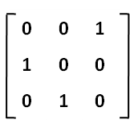
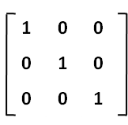
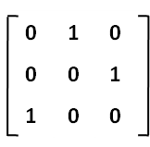
R = R²= R³ =

Since R³ is reflexive in this example, the statement that R³ is not reflexive when R is not reflexive is false.

- a) R₁: W = {(a,c), (b,c), (c,a), (c,b), (d,b), (e,d), (f,f), (e,f)}
W_{a} = W U {(c,c)}
W_{b} = W_{a} U {(c,c), (d,c)}
W_{c} = W_{b} U {(a,a), (b,a), (c,a), (d,a), (a,b), (b,b), (c,b), (d,b)}
W_{d} = W_{c} U {(a,e), (b,e), (c,e)}
W_{e} = W_{d} U {(a,d), (a,f), (b,d), (b,f), (c,d), (c,f)}
W_{f} = W_{e} U {}
R₁ = W U W_{a} U W_{b} U W_{c} U W_{d} U W_{e} U W_{f}
R₁ = {(a,a), (a,b), (a,c), (a,d), (a,e), (a,f), (b,a), (b,b), (b,c), (b,d), (b,e), (b,f), (c,a), (c,b), (c,c), (c,d), (c,e), (c,f), (d,a), (d,b), (d,c), (e,d), (e,f), (f,f)}

R₂: W = {(a,b), (b,c), (c,a), (e,f), (d,f), (f,f), (d,d)}
W_{a} = W U {(c,b)}
W_{b} = W_{a} U {(c,c)}
W_{c} = W_{b} U {(b,a), (b,b), (b,c)}
W_{d} = W_{c} U {}
W_{e} = W_{d} U {}
W_{f} = W_{e} U {(d,e)}
R₂ = W U W_{a} U W_{b} U W_{c} U W_{d} U W_{e} U W_{f}
R₂ = {(a,b), (b,a), (b,b), (b,c), (c,a), (c,b), (c,c), (e,f), (d,d), (d,e), (d,f), (f,f)}
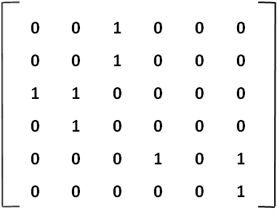
b) R₁ =

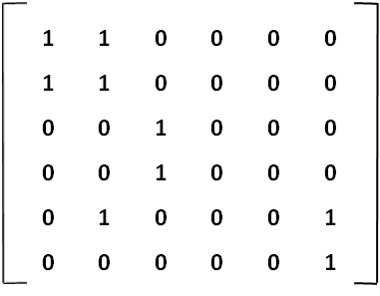
R₁² = X =

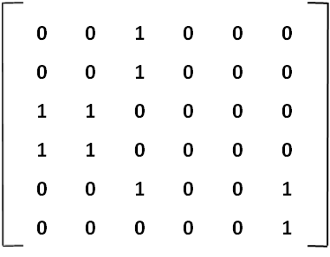
R₁³ = X =

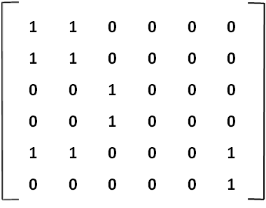
R₁⁴ = X =

R₁⁵ = X =

R₁⁶ = X =

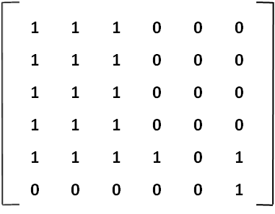
Transitive closure of R₁ =

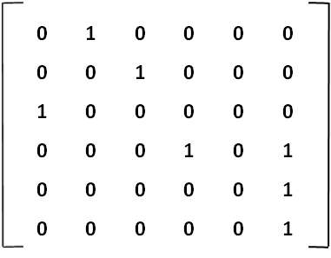
R₂ =

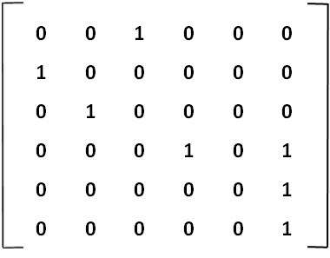
R₂² = X =

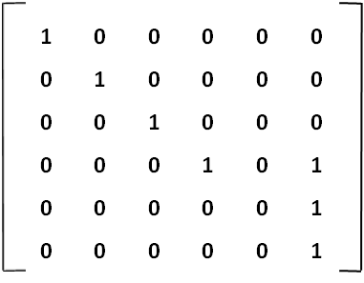
R₂³ = X =

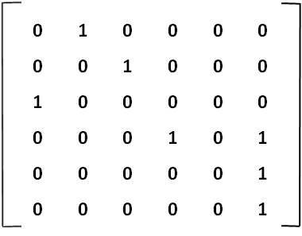
R₂⁴ = X =

R₂⁵ = X =

R₂⁶ = X =

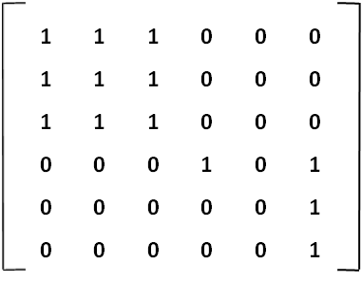
Transitive closure of R₂ =

- Reflexive: If a=b, and c=d, then a + c = a + c, so the relation is reflexive.
Symmetric: If a and b are switched, and c and d are switched, the statement b + d = a + c is still true.
Transitive: a + c =b + d, and c + e = d + f. Subtracting the second equation from the first,
a – e = b – f. Since this statement is still true, The relation is transitive.
Since the relation is reflexive, symmetric and transitive, it must be an equivalence relation.

- Reflexive: If two strings are the same, then they start with the same three bits.
Symmetric: If string A starts with the same 3 bits as string B, then string B starts with the same 3 bits as string A.
Transitive: If strings A and B start with the same 3 bits, and strings B and C start with the same 3 bits, then strings A and C must start with the same 3 bits.
Since the relation is reflexive, symmetric and transitive, it must be an equivalence relation.
00000 00000 00000 00000 00000
00100 00000 00000 00000 00000
01000 00000 00000 00000 00000
10000 00000 00000 00000 00000
01100 00000 00000 00000 00000
10100 00000 00000 00000 00000
11000 00000 00000 00000 00000
11100 00000 00000 00000 00000
The above are each from different equivalence classes.

- a) e, a and u all have no elements above them that they connect to. (b has m above it, c has e above it, d has a above it, f has k above it, g has r above it, h has o above it, i has a above it, j has m above it, k has t above it, l has c above it, m has e above it, n has f above it, o has g above it, p has j above it, r has s above it, s has t above it, and t has u above it.)

b) h has no element below it that it connects to. (a has d below it, b has m below it, c has m below it, d has k below it, e has m below it, f has n below it, g has o below it, i has s below it, j has p below it, k has f below it, l has k below it, m has j below it, n has o below it, o has h below it, p has h below it, r has g below it, s has r below it, t has s below it, and u has t below it.)

c) There is no greatest element, because there is more than one maximal element.

d) The least element is h because it is the only minimal element.

e) The upper bound of m is {m, e, c, l, a}. The upper bound of k is {k, l, t, a, c, e, u}. The upper bound of s is {s, t, I, a, u}. The intersection of these three sets is {a}, which is the upper bound of the set {m, k, s}.

f) The lower bound of c is {c, m, l, b, j, k, p, f, h, n, o}. The lower bound of d is {d, k, f, j, n, p, h, o}. The lower bound of t is {t, s, r, g, o, h, k, f, n, o, h, j, p}. The intersection of these three sets is {k, f, j, n, p, o, h}, which is the lower bound of the set {c, d, t}.

g) The lower bound of u is {u, d, k, j, p, h, f, n, o, t, s, r, g, o}. The lower bound of k is {k, j, p, h, f, n, o}. The lower bound of m is {m, b, j, p, h}. The intersection of these three sets is {j, p, h}. Of these three elements, j has no elements above it, making it a maximal element. Element p has j above it, and h has p above it, so the only maximal element is j, making it the greatest lower bound of {u, k, m}.

h) The upper bound of b is {b, m, e, c, l, a}. The upper bound of k is {k, l, c, e, d, a, t, u}. The upper bound of t is {t, u}. The intersection of these three sets is the empty set, so there is no least upper bound of {b, k, t}.

- Since h is the least element, list must start with h. {h}. After h is removed from the diagram, p and o are the only minimal elements, so add p, o to the list.{h, p, o}. Now, minimal elements are j, n and g, so add them to the list. {h, p, o, j, n, g}. Now, b, f and r are the minimal elements, add them to the list. {h, p, o, j, n, g, b, f, r}. Elements m, k and s are now the minimal elements, so add them. {h, p, o, j, n, g, b, f, r, m, k, s}. The minimal elements are now l, d, i and t, so add them. {h, p, o, j, n, g, b, f, r, m, k, s, l, d, i, , t}. Element c is a minimal element, so add that. {h, p, o, j, n, g, b, f, r, m, k, s, l, d, i, t, c}. Now e is a minimal, add that. {h, p, o, j, n, g, b, f, r, m, k, s, l, d, i, t, c, e}. Elements a and u are both minimal elements, so add them both to the list. {h, p, o, j, n, g, b, f, r, m, k, s, l, d, i, t, c, e, a, u}. There are no elements left, so {h, p, o, j, n, g, b, f, r, m, k, s, l, d, i, t, c, e, a, u} is a topological sort of figure 1.

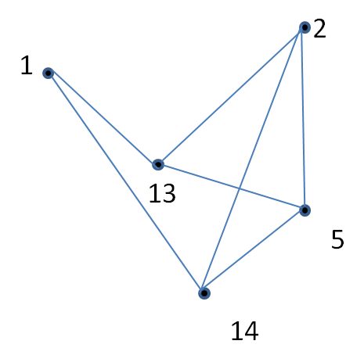
- a)

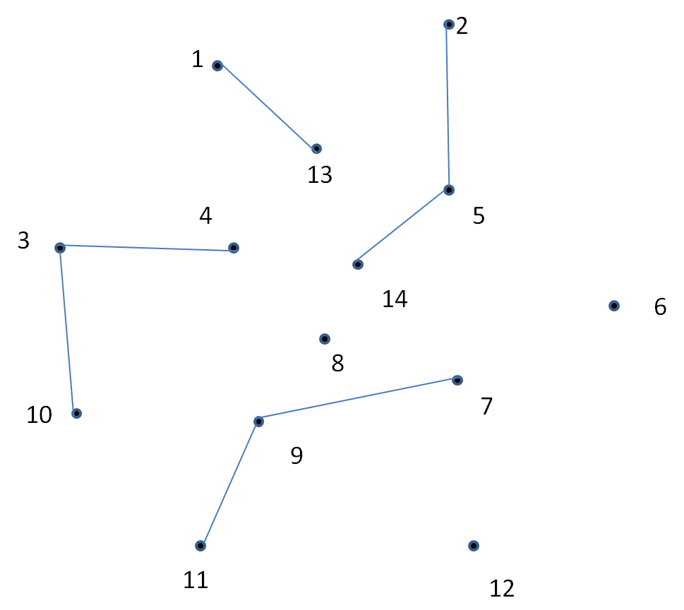
b)

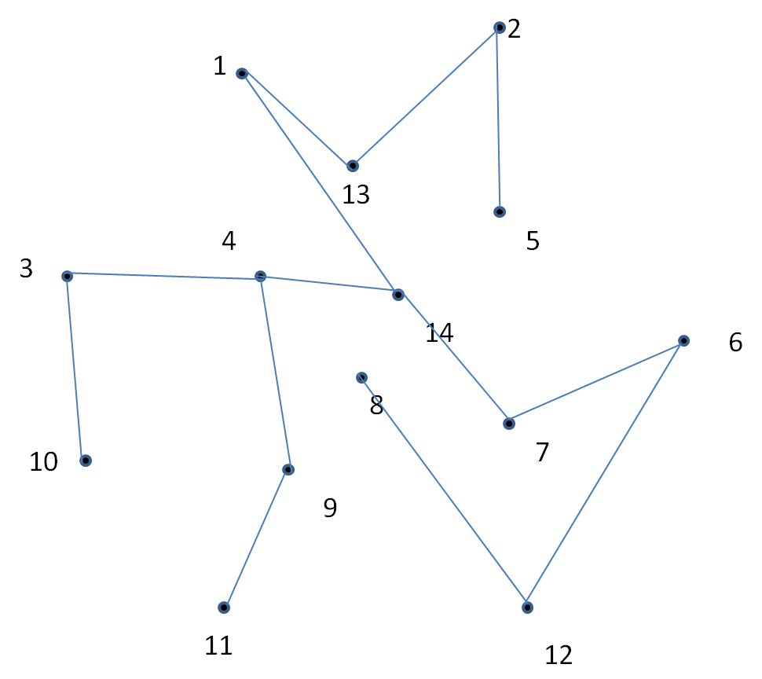

c)

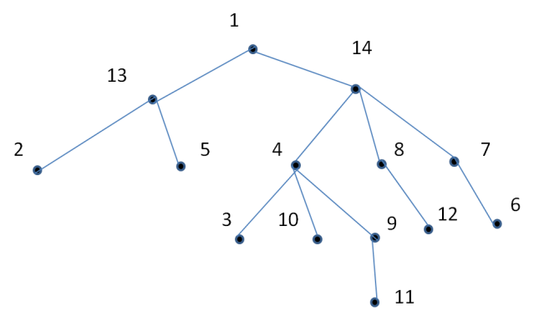
d)

e) The only cut edge in figure 2 is the edge between 9 and 11. The following table shows how the rest of the edges can be avoided
Endpoints of the edge | Path to avoid the edge
1, 13 | 1, 14, 5, 13
1, 14 | 1, 13, 5, 14
2, 5 | 2, 14, 5
2, 13 | 2, 5, 13
2, 14 | 2, 5, 14
3, 4 | 3, 10, 4
3, 9 | 3, 4, 9
3, 10 | 3, 4, 10
4, 8 | 4, 14, 8
4, 9 | 4, 3, 9
4, 10 | 4, 3, 10
4, 14 | 4, 8, 14
5, 13 | 5, 2, 13
5, 14 | 5, 2, 14
6, 7 | 6, 12, 8, 7
6, 12 | 6, 7, 8, 12
7, 8 | 7, 14, 8
7, 9 | 7, 14, 4, 9
7, 14 | 7, 8, 14
8, 12 | 8, 7, 6, 12
8, 14 | 8, 7, 14
9, 11 | No path possible

f) Vertices 9 and 14 are cut vertices. If 9 is removed, There is no possible path between 11 and the other vertices. If 14 is removed, there is no possible path between 5 and 8.

g) Vertex 4 is the only vertex of degree 5. (Degree 1: 11. Degree 2: 1, 6, 10, 12. Degree 3: 2, 3, 5, 13. Degree 4: 7, 8, 9. Degree 6: 14)

h) Path 10, 4, 8, 12, 6 avoids vertex 9 and vertex 7.

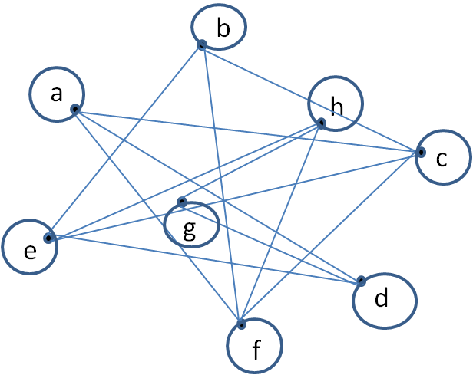
- Diagram of the complement of figure 3:
Adjacency matrix of the complement of figure 3:
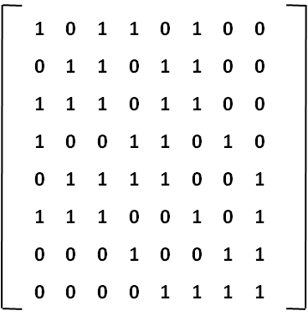

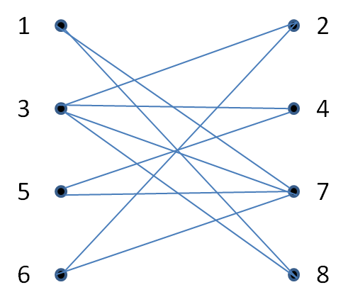
- Yes, figure 4 is a bipartite.

