- a) A(x) = x has a racket
B(x) = x is a tennis player
Universe of Discourse: All people
Premise: ∀x (C(x) -> B(x))
¬A(Mary)
A(John)
Conclusion: ¬B(Mary) v C(John)
Using modus tollens, we know that ¬C(Mary) is true. Then, using Domination laws, we know that since ¬C(Mary) is true, the statement ¬C(Mary) v C(John) must be true. Therefore, the argument is valid.

b) A(x) = x loves fries
B(x) = x loves burgers
C(x) = x is a vegetarian
Universe of Discourse: All Carleton University students
Premise: A(x) -> B(x)
B(x) -> ¬C(x)
∃x ( A(x) )
Conclusion: ∃x ( ¬C(x) )
Using modus ponens and the first premise, we know that ∃x ( B(x) ). Using modus ponens again, and the second premise, we know that ∃x ( ¬C(x) ), which is the conclusion. Therefore, the argument is valid.

c) A(x) = x took discrete math
B(x) = x understands logic
Universe of Discourse: All people
Premise: A(x) -> B(x)
A(John)
B(Steve)
Conclusion: A(John) ^ A(Steve)
We cannot prove that Steve took discrete math. Even if the conclusion of an inference is true, we know nothing about the validity of the premise of the inference. Also, since the conclusion of the argument involves and “and”, both A(John) and A(Steve) must be true, but we don’t know if A(Steve) is true. Therefore, the argument is invalid.

d) A(x) = x made money
B(x) = x bought Nortel stock
C(x) = x bought Google stock
Universe of Discourse: All people
Premise: A(Tom)
¬A(Steve)
B(x) -> ¬A(x)
C(x) -> A(x)
Conclusion: B(Steve) ^ C(Tom)
If both an inference and the conclusion of the inference is true, we know nothing about the validity of the premise. Because of this, we don’t know if Steve bought Nortel stock, or if Tom bought Google stock. Therefore, the argument is invalid.

e) A(x) = x can play badminton
B(x) = x can play squash
C(x) = x owns a squash racket
Universe of Discourse: All people
Assuming being able to play squash is the same as playing it,
Premise: A(John) -> B(John)
B(x) -> C(x)
Conclusion: A(John) -> C(John)
Using hypothetical syllogism, [ (p -> q) ^ (q -> r) ] -> (p -> r), and substituting John for x in the second part of the premise, we know that the conclusion is true. Therefore, the argument is valid.

- Using x=2 and y=1/2, we can disprove the statement that if x and y are rational, x^{y} is rational.
If we assume that √2 is rational, then:
√2 = a / b
2 = a² / b²
2b² = a² , which means a² is even. Since a² is even, a must be even too, which means a=2k, where k is an integer.
2b² = a²
2b² = (2k)²
2b² = 4k²
b² = 2k² , which means b² is even. Since b² is even, b must be even too, which means a and b have a common factor. This means √2 is irrational. Since √2 is irrational, x^{y} is not always rational.
- Let x and y to be any two rational numbers, represented by:
x = p / q
y = (p+1) / q
However, we can always find another rational number between x and y, represented by z.
z = (2p +1) / 2q
Therefore, between any two rational numbers, there is a rational number.
- If we assume that √7 is rational, then:
√7 = a / b
7 = a² / b²
7b² = a² , which means a² is divisible by 7. Since a² is divisible by 7, a must be divisible by 7 too, which means a=7k, where k is an integer.
7b² = a²
7b² = (7k)²
7b² = 49k²
b² = 7k² , which means b² is divisible by 7. Since b² is divisible by 7, b must be divisible by 7 too, which means a and b have a common factor. This means √7 is irrational.

- a) { x | x is a negative integer and x² < 50} = {-1, -2, -3, -4, -5, -6, -7}
b) { x | x is the cube of an integer and 0 ≤ x < 101} = {0, 1, 8, 27, 64}

- a)
A | B | A ⊕ B | A - B | B - A | (A - B) ∪ (B - A)
1 | 1 | 0 | 0 | 0 | 0
1 | 0 | 1 | 1 | 0 | 1
0 | 1 | 1 | 0 | 1 | 1
0 | 0 | 0 | 0 | 0 | 0

Therefore the equality is valid.
b)
A | B | A ∩ B | A - B | B - A | (A – B) ∪ (B – A)
1 | 1 | 0 | 0 | 0 | 0
1 | 0 | 1 | 1 | 0 | 1
0 | 1 | 1 | 0 | 1 | 1
0 | 0 | 1 | 0 | 0 | 0

Therefore the equality is invalid.
c)
A | B | C | C - A | B - A | (C – A) ∩ (B – A) | C ∩ B | (C ∩ B) ∩ A
1 | 1 | 1 | 0 | 0 | 0 | 1 | 0
1 | 1 | 0 | 0 | 0 | 0 | 0 | 0
1 | 0 | 1 | 0 | 0 | 0 | 0 | 0
1 | 0 | 0 | 0 | 0 | 0 | 0 | 0
0 | 1 | 1 | 1 | 1 | 1 | 1 | 1
0 | 1 | 0 | 0 | 1 | 0 | 0 | 0
0 | 0 | 1 | 1 | 0 | 0 | 0 | 0
0 | 0 | 0 | 0 | 0 | 0 | 0 | 0

Therefore the equality is valid.
- a) (A ∪ B) ∩ C

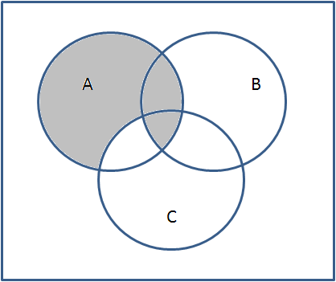
b) (A) ∩ (C – B)

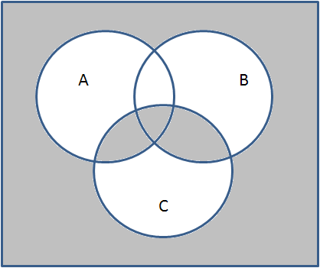
c) (C) ⊕ (A ∪ B)

d) (B ∪ C) ∩ (A ∪ B)
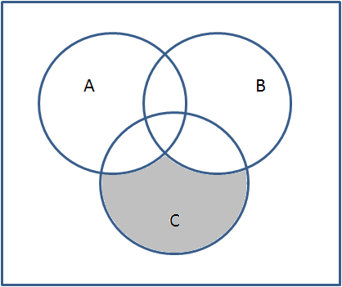

- a) f: A -> D
f(c) = 1, f(a) = 1, f(t) = 1
This works because in the codomain, 1 element has more than 1 element from the domain mapping to it, but there is also an element that has no elements mapping to it.

b) f: B -> D
f(d) = 1, f(o) = 2, f(g) = 1
This works because each element in the codomain has at either 1 or 2 elements from the domain mapping to it.

c) f: A -> C
f(c) = s, f(a) = e, f(t) = a
This works because each element in the codomain has at either 1 or 0 elements from the domain mapping to it.

d) f: A -> B
f(c) = g, f(a) = o, f(t) = d
This works because each element in the codomain has exactly 1 element from the domain mapping to it.

- a) f(x) = -x is a bijection.
y=-x (replace f(x) with y)
x=-y (isolate x)
y = -x (switch x and y)
Therefore, f⁻¹(x) = -x.

b) f(x) = 2x is a bijection.
y=2x (replace f(x) with y)
x=y/2 (isolate x)
y=x/2 (switch x and y)
Therefore, f⁻¹(x) = x / 2.

c) f(x) = |7x³ - 6| is not a bijection, because of the absolute value sign.
f(1) = |7(1)³ - 6|
f(1) = |7 - 6|
f(1) = 1
However,
1=|7x³ - 6|
1=-(7x³ - 6)
1= 6 – 7x³
7x³ = 5
x³ = 5/7
x = ³√5/7
Which means f(1) = f(³√5/7), so the function isn’t a bijection.

d) f(x) = 3x² - 12x + 1 is not a bijection because of the x².
f(3) = 3(3)² - 12(3) + 1
f(3) = 27 – 36 + 1
f(3) = -8
However,
f(1) = 3(1)² - 12(1) + 1
f(1) = 3 – 12 + 1
f(1) = -8
Which means f(3) = f(1), so the function isn’t a bijection.

e) f(x) = 2x³ - 9 is a bijection.
y = 2x³ - 9 (replace f(x) with y)
2x³ = y + 9
x³ = (y + 9) / 2
x = ³√(y + 9) / 2 (isolate x)
y = ³√(x + 9) / 2 (switch x and y)
Therefore, f⁻¹(x) = ³√(x + 9) / 2

- a) f(g(x)) = f(2x²-1)
f(g(x)) = 2x² - 1 – 5
f(g(x)) = 2x² - 6
b) g(f(x)) = g(x-5)
g(f(x)) = 2(x-5)² - 1

c) f(g(f(x))) = f(g(x-5))
f(g(f(x))) = f(2(x-5)² - 1)
f(g(f(x))) = 2(x-5)² - 1 – 5
f(g(f(x))) = 2(x-5)² - 6

- S₁ ∩ S₂ ∩ S₃ contains point a
S₁ ∩ S₂ ∩ S₄ contains point b
S₁ ∩ S₃ ∩ S₄ contains point c
S₂ ∩ S₃ ∩ S₄ contains point d

S₁ contains triangle abc
S₂ contains side ab of triangle abc
S₃ contains side ac of triangle abc
S₄ contains side bc of triangle abc

Since each square has at least 2 vertices, there must be part of the triangle that is contained in all 4 squares, being part of the set S₁ ∩ S₂ ∩ S₃ ∩ S₄.

