Fingerless Gloves
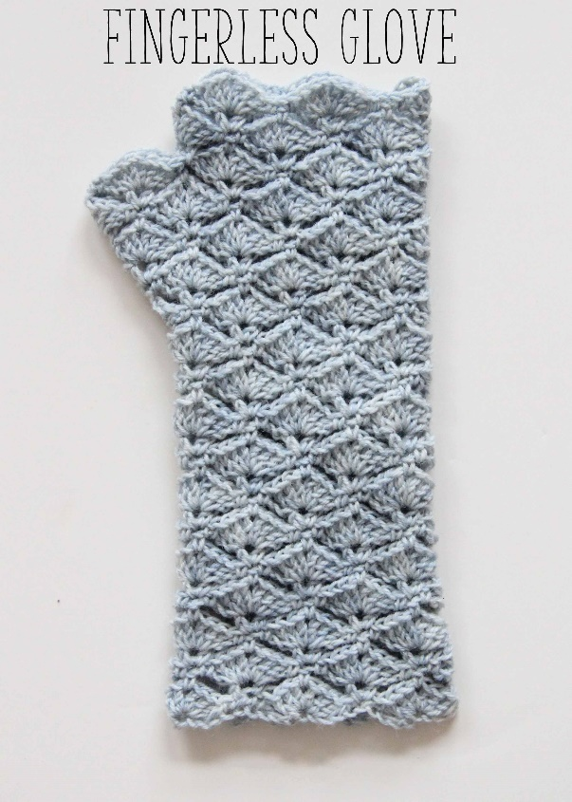
Beautiful fingerless gloves that will keep your hands and wrists nice and warm this Winter – and they are great for gifts too!
This pattern works in the round is based on a stitch count of 10. For these fingerless gloves, casting on 50 stitches gave me a nicely fitting glove, however you might want to add or loose 10 stitches for a better fit. Please note that this glove is worked entirely in the round and the stitch count for the thumb part is designed for this exact combination of yarn weight, hook size and stitch count. Have a look here for the pattern of a chunky version of these gloves which just leave a gap for the thumb.
Let’s get started!
US start. Chain 50 and join into a ring with slip stitch in first chain. Make sure not to twist the chain when you join.
US row 1. *in the first chain: single crochet. Chain 1, skip one, 1 single crochet in the next. skip 3 stitches. In the next stitch make 3 double crochet, 1 chain, 3 double crochet. skip 3 stitches*. Repeat between * all around. Join with slip stitch in first single crochet.
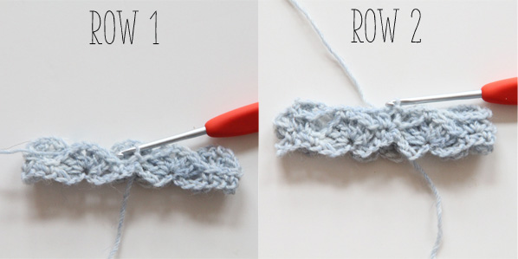
US row 2. in the chain 1 loop of row 1: 1 single crochet, chain 3, 1 half double crochet. *chain 3, 1 single crochet in the chain gap on top of the ‘shell’, chain 3, in the next chain 1 loop: 1 half double crochet, chain 1, 1 half double crochet *. Repeat between * all around. End with chain 3, join with slip stitch in the second begin chain.

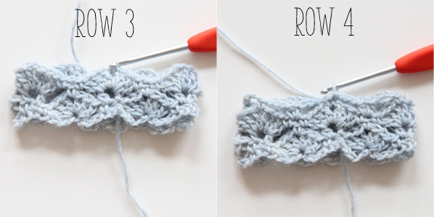
US row 3. in the gap between the half double crochet stitches of row 2: 1 single crochet, chain 3, 3 double crochet. *single crochet just before the single crochet of row 2, chain 1, single crochet just after the single crochet of row 2. In the next gap between the half double crochet stitches: 3 double crochet, chain 1, 3 double crochet*. Repeat between * all around. End with 2 double crochet in the first gap, join with slip stitch in second begin chain.
US row 4. *single crochet in the gap on the top of the shell, chain 3, in the next chain gap: half double crochet, chain, half double crochet, chain 3*. Repeat between * all around. End with chain 3 and join with slip stitch in the first single crochet.
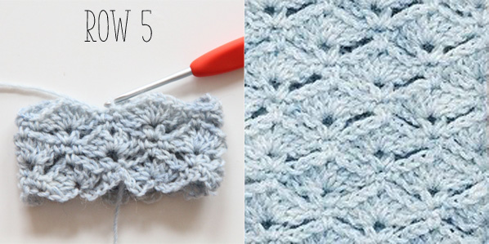
US row 5. chain 2, single crochet in the loop of chain 3 of row 4. *in the next gap between the half double crochet stitches of row 4: 3 double crochet, chain, 3 double crochet. Single crochet just before the single crochet of row 4, chain 1, single crochet just after the single crochet of row 4*. Repeat between * all around. End with 3 double crochet, chain 1, 3 double crochet and join with slip stitch in the first chain.
US continue. Repeat rows 2 to 5 until you’ve finished row 21, which equals 11 rows of shell stitches. As of row 22 you will be making room for your thumb. That’s why they are referred to as the ‘thumb rows’. Please note that the pattern from here on works for a similar yarn-hook-stitch count. Of you increased or decreased stitches in the beginning, it will affect the thumb measurements. As an alternative you could leave a thumb gap like in this pattern.

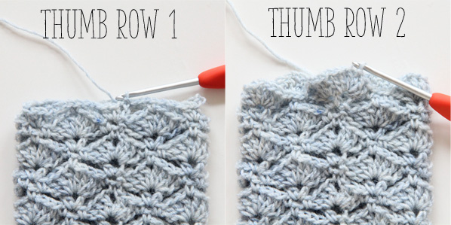
US thumb start + row 1. to increase for the thumb, you’ll be making 2 loops for a scallop in the next row. In the chain 1 loop: single crochet like you’re used to do in row 2, chain 3, 2 half double crochet, chain 1, half double crochet. continue the row as normal with chain 3, single crochet on top of the shell etc. exactly like row 2. End with chain 3, close with slip stitch in second begin chain.
US thumb row 2. In the chain 1 loop: single crochet, chain 3, 3 double crochet. Chain 1. Make a second shell in the next chain 1 loop. Continue with a repeat of what’s in between * and * in row 3. End with 2 double crochet, close with a slip stitch in the second begin chain.
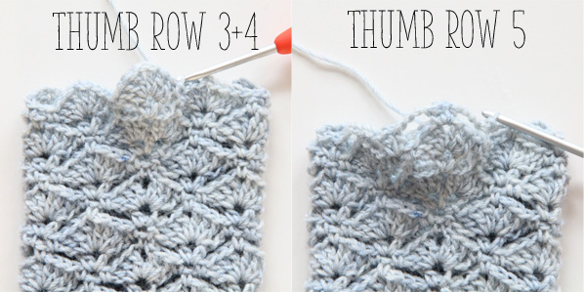
US thumb row 3. Single crochet in the chain 1 loop of thumb row 2. Chain 3, in the next chain 1 loop in between the shells: half double crochet, chain 1, half double crochet. Chain 3 and continue with a repeat of what’s in between * and * in row 4. End with slips stitch in the first single crochet.
US thumb row 4. repeat row 5.
US thumb row 5. repeat row 2 and make a combination of half double crochet, chain 1, half double crochet in top of the second shell as shown in the picture above.
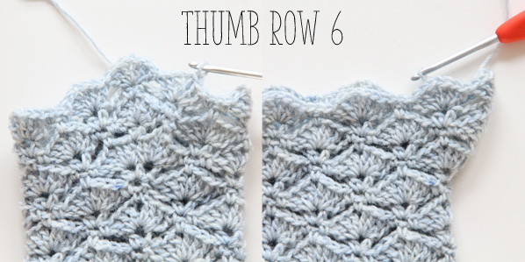
US thumb row 6. repeat row 3: 1 single crochet, chain 3, 3 double crochet. Continue straight with 2 more shells as shown in the left picture above. Continue with the repeat of row 3 between *. End with 2 double crochet in the first gap, join with slip stitch in 2nd begin chain.
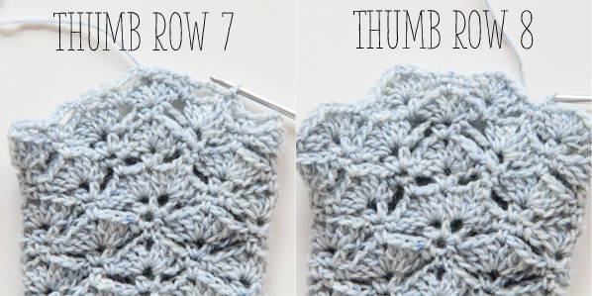
US thumb row 7. repeat row 4. Start with single crochet, chain 3. In between the shells: half double crochet, chain, half double crochet. Chain 3, single crochet in top of shell, chain 3. In between the next shells: half double crochet, chain, half double crochet. Chain 3. Repeat row 4 in between *, close with slip stitch in first single crochet.
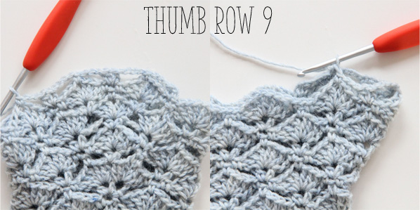
US thumb row 8. repeat row 5.
.
US thumb row 9. repeat row 2 until you make a single crochet in the third shell top. Your work looks like the left image. Now slip stitch in the single crochet on top of the first shell. Like in the right image.

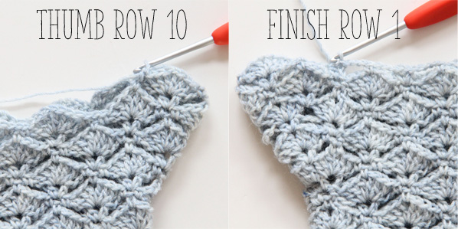
US thumb row 10. Turn your work. Make 2 shells and in between them: single crochet in the loop, single crochet in the next loop (without the chain 1 in between). End with slip stitch in single crochet. This is the last row of your thumb.
US finish row 1. From now on you’ll leave the thumb out in your rows. Like row 2, starting with chain 3, in the next chain 1 loop: half double crochet, chain, half double crochet, etc. End with chain 3, slip stitch in second begin chain of thumb row 9.

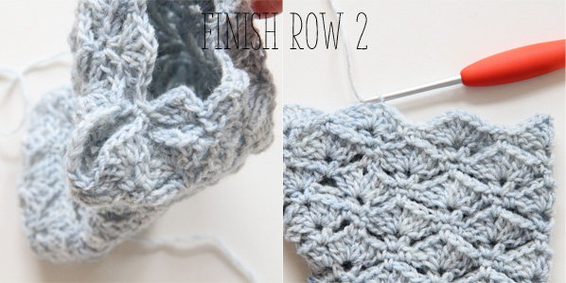
US finish row 2. Repeat row 3. After the first half shell: single crochet in the thumb, like in the left image. Continue with the second shell and finish the row.

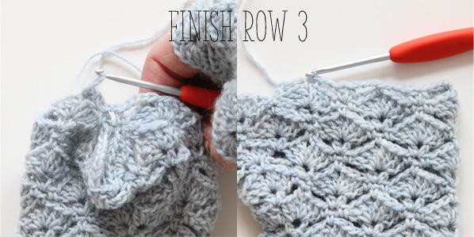
US finish row 3. Repeat row 4. After the first chain 3: half double crochet around the chain 3 loop of finish row 1, chain 1, half double crochet around the next chain 3 of finish row 1. See the left image for details. Finish row.

US finish row 4. repeat row 5.
US finish row 5. repeat row 2.
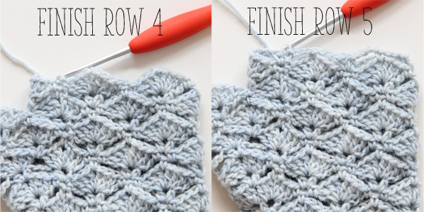
US finish row 6. repeat row 3, leaving out the chain stitch in between the single crochet stitches.
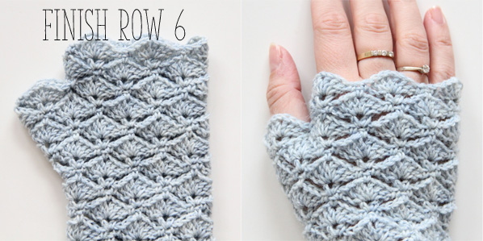
US finish. Weave in ends, wear your gloves and make yourself your favourite cup of coffee or tea, sit back and relax. You deserve it!

